FOR IMMEDIATE RELEASE
AUGUST 6, 2021

Galantis, David Guetta & Little Mix:
“Heartbreak Anthem” (Clean Bandit Remix) Out Now

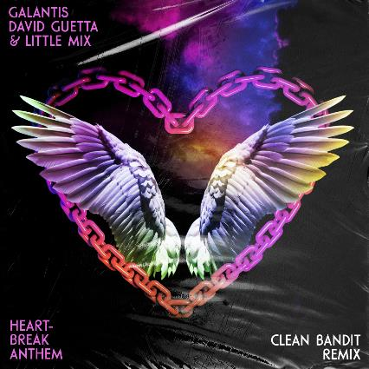
DOWNLOAD HIGH-RES IMAGES/ARTWORK

STREAM “HEARTBREAK ANTHEM” (CLEAN BANDIT REMIX): https://youtu.be/5eCrfWewTz0
WATCH “HEARTBREAK ANTHEM” VIDEO: https://youtu.be/HIv3ClkEhrA

Internationally-acclaimed collaborative project Galantis, superstar DJ/producer David Guetta & global pop superstars Little Mix have joined forces with multi-platinum UK collective Clean Bandit for an energetic summer-ready take on their smash collaborative single “Heartbreak Anthem” – available now via Big Beat Records.

To date, “Heartbreak Anthem” has proved a global sensation having amassed over 165 million streams worldwide, over 24 million video views & spending 10 weeks on the Billboard Global 200 chart. The single also currently holds the #2 position on both the overall UK Radio chart & US Dance Radio chart (having already reached #1 on the former) and the #7 spot this week on Billboard’s Hot Dance/Electronic Songs chart.

The explosive track arrived earlier this summer alongside a striking music video directed by Samuel Douek, who recently teamed up with Little Mix for their buzzworthy “Confetti” visual. Contrary to its title, “Heartbreak Anthem” proves a declaration of resilience – fusing the jaunty productions of the powerhouse producers with the impeccable harmonies of the world’s biggest girl band.

CONNECT WITH GALANTIS:
WeAreGalantis.com | Twitter | Facebook | YouTube | Instagram | Assets

CONTACT:
Ted Sullivan (Atlantic Records) | Ted.Sullivan@atlanticrecords.com

