FOR IMMEDIATE RELEASE
NOVEMBER 15, 2019

GALANTIS TO EMBARK ON ‘CHURCH OF GALANTIS’ TOUR

Explosive New single “Faith” with Dolly Parton & Mr. Probz
debuts at #1 on Billboard Dance/Electronic Chart

third studio album Church Due next year via big beat records

‘Church of Galantis’ tickets available now

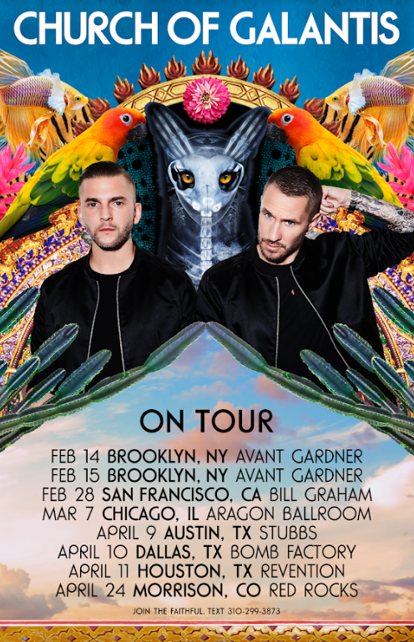

Watch “FAITH” MUSIC VIDEO: https://Galantis.lnk.to/FAITHPR/youtube
STREAM “faith”: https://Galantis.lnk.to/FAITHPR

Internationally-acclaimed, GRAMMY-nominated duo Galantis are set to embark on their highly anticipated 2020 headline Church of Galantis tour, with tickets on sale 10a local time today via ChurchOfGalantis.com. The routing kicks off with back-to-back performances at Brooklyn, NY’s Avant Gardner on February 14th & 15th, continuing through April with a final stop at Morrison, CO’s legendary Red Rocks Amphitheatre on April 24th.

The Church of Galantis tour announce follows the duo’s explosive collaborative single “Faith” with country music icon Dolly Parton and Dutch singer-songwriter Mr. Probz – available now via Big Beat Records. Praised as “a life-affirming dancefloor jam” by Entertainment Weekly upon release, “Faith” saw a #1 debut on Billboard’s Dance/Electronic Chart last week and has quickly amassed over 5.6 million streams and over 1.7 million music video views. The single has seen an outpour of support from Rolling Stone, Good Morning America, Entertainment Tonight, NPR, Huffington Post & more – in addition to being performed by Parton earlier this week as part of her show-stopping 2019 CMA Awards medley.

Galantis have also announced their forthcoming third studio album Church, the follow-up to 2015’s Pharmacy & 2017’s The Aviary, arriving early 2020. “It’s important for us to have meaning behind our music” explained Galantis. “Our album ‘Church’ doesn’t necessarily refer to a building or specific religion, but instead to people banded together in similar belief for a better humanity. Whether it’s advocating peace, change, or just lifting each other up – that is our ‘Faith’ and ‘Church.’”

‘CHURCH OF GALANTIS’ TOUR:
February 14 – Brooklyn, NY – Avant Gardner @ Great Hall
February 15 – Brooklyn, NY – Avant Gardner @ Great Hall
February 28 – San Francisco, CA - Bill Graham Civic Auditorium
March 7 – Chicago, IL – Aragon Ballroom
April 9 – Austin, TX – Stubb’s Austin
April 10 – Dallas TX – The Bomb Factory
April 11 – Houston, TX – Revention Music Center
April 24 — Morrison, CO - Red Rocks
***

Setting a new standard for songwriting in dance music, Galantis is a collaborative project between Christian Karlsson (aka Bloodshy, one-third of Miike Snow) and Linus Eklöw (aka Style of Eye). Their debut album Pharmacy reached No. 1 on the Billboard Dance album chart on the strength of RIAA gold certified single “Peanut Butter Jelly” and platinum certified smash “Runaway (U & I)” – the latter of which earned GRAMMY nominations for “Best Dance Recording” and “Best Remixed Recording” – while their 2017 sophomore album The Aviary (featuring platinum certified single “No Money”) saw a top 10 debut in 23 countries. The duo have received over 3 billion cumulative worldwide streams, and over 1 billion video views to date.

2019 has seen a steady stream of tracks from Galantis, including “Bones” featuring OneRepublic, “Spaceship” featuring Uffie and “Satisfied” featuring MAX. Recent collaborations have also included “We Can Get High” with Yellow Claw, “Roots” with Valerie Broussard and “I Found U” with Passion Pit.

The story of Galantis started back in 2009. Working as Bloodshy, Karlsson’s songwriting collaborations have included Madonna, Kylie Minogue, Katy Perry and Britney Spears (whose “Toxic” earned a GRAMMY for “Best Dance Recording”). After reaching out to Eklöw (who produced Icona Pop’s hit single “I Love It” as Style of Eye) to remix Miike Snow’s “Animal,” the two continued to collaborate until ultimately Galantis was born. Following their blockbuster performance debut at 2014’s Coachella Valley Music and Arts Festival, the duo quickly rose become one of dance music’s most dynamic and in-demand live performers.

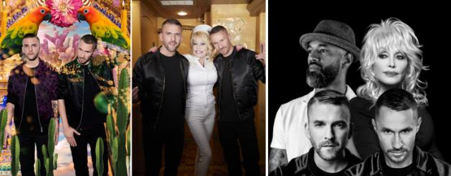
DOWNLOAD HIGH-RES IMAGES

CONNECT:
WeAreGalantis.com | Twitter | Facebook | YouTube | Instagram | Press Assets

CONTACT:
Ted Sullivan | Ted.Sullivan@atlanticrecords.com

