GALANTIS RETURNS WITH TWO NEW SONGS AHEAD OF THE DUO’S UPCOMING FESTIVAL & LIVE APPEARANCES ACROSS THE GLOBE!

+ OFFICIAL MUSIC VIDEO FOR “SATISFIED” FT MAX

Performing at Lollapalooza, Imagine Music Festival + more!

Galantis “Satisfied” (feat. MAX)
WATCH/POST: https://youtu.be/WBn8UBci5cA
BUY/STREAM: https://BigBeat.lnk.to/SMAY/PR

Galantis “Mama Look At Me Now”
LISTEN/POST: https://youtu.be/t0LSUxncYaM
BUY/STREAM: https://BigBeat.lnk.to/SMAY/PR

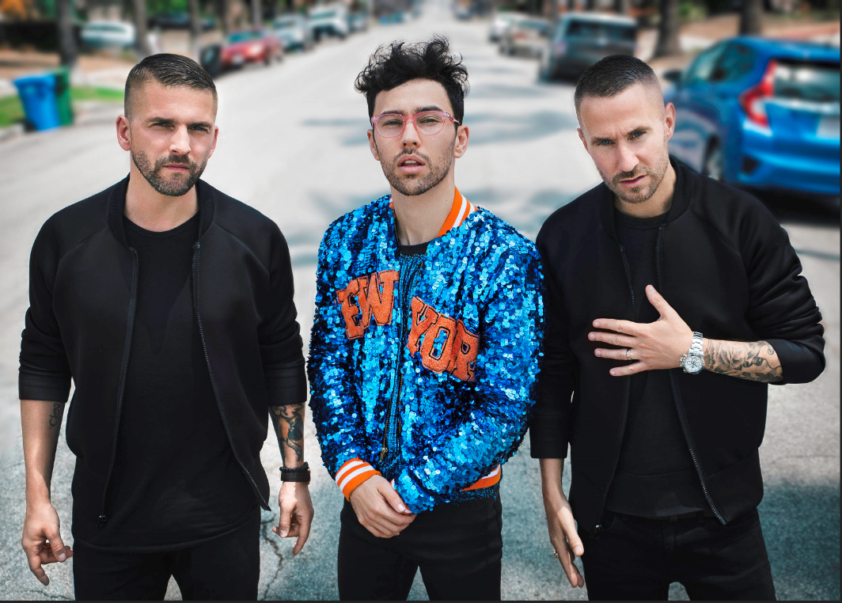
[Christian Karlsson, MAX, Linus Eklöw - Credit: Jordan Pulmano

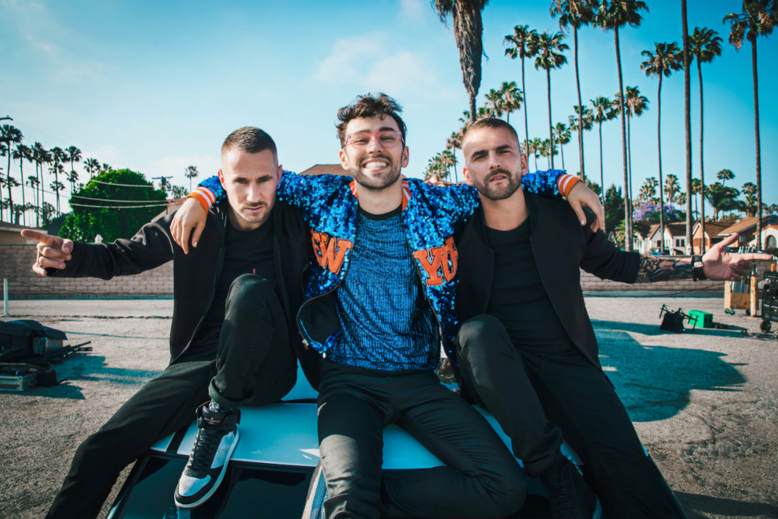
[Linus Eklöw, MAX, Christian Karlsson - Credit: Jordan Pulmano

"The second the Galantis guys sent me this song I was OBSESSED! It's an energy that we both share and are so in love with and their production is just out of this world. I'm honored to be the voice on such a magnificent summer jam!” -MAX on “Satisfied”

“We love this song! It is a true testament to Galantis' ambition and drive to find that fresh, feel good music and continue to expand the Galantis soundscape on all levels! On top of that, MAX delivered a piece of pure vocal magic that we just could not resist. Put your dancing shoes on folks! Let’s go! :D” -GALANTIS on “Satisfied”
“The lyric is pretty self explanatory. Since the early days this has been an emotional journey for us, and in many ways this is a ”thank you” to those who always believed in us when no one else did.”
-GALANTIS on “Mama Look At Me Now”

The GRAMMY-nominated, chart-topping production duo Galantis is fresh off racking up over a billion streams from their 2017 sophomore album The Aviary and now the duo is channeling the summer heat by releasing not one, but two new songs, both of which are officially out today through Big Beat Records. “Satisfied” starts as a minimal, bouncy affair driven by an elastic bassline and features the rising singer MAX – watch the official music video HERE! In the official music video, catch Galantis gallivant through the streets as they hitch a ride with MAX, their sequin-clad Lyft driver. By the time the hook-laden chorus kicks in, you’ll be more than satisfied - but there’s more! Galantis has also shared “Mama Look At Me Now,” a soulful, anthemic track that perfectly highlights their dynamic, genre-defying production skills. It’s a song we’re sure that both of their respective mamas are proud of.” Listen HERE!

After the release of The Aviary last year, Galantis followed it up in May with a superstar collaboration with Uffie called “Spaceship” (WATCH HERE), which has racked up over 6.5 million streams in the last month alone thanks to massive radio and playlist support worldwide. Fresh off live shows at Hangout Fest in Alabama, Governor’s Ball in New York City, and Wish Outdoor Festival in Mexico, Galantis isn’t slowing down anytime soon, with tour dates that span the entire globe announced through the end of August. Their tour, listed below, includes major festival stops at Lollapalooza, Electric Forest, Ultra Europe, Weekend Festival in Finland and more, in addition to their monthly Las Vegas shows at Encore Beach Club and XS Las Vegas. Stay tuned for some more major international tour dates coming your way soon!

Galantis is the Swedish production duo Christian Karlsson (also of Bloodshy & Avant and Miike Snow) and Linus Eklöw (Style of Eye). The group’s second album The Aviary debuted as a top 10 album in 23 countries and received widespread critical praise. The New Yorker proclaimed, “Galantis sends crowds soaring with reliably mammoth melodies,” while NYLON raved, “Everything Galantis touches is gold.” Additionally, their debut album, Pharmacy, reached No. 1 on the Billboard Dance Chart and spawned hit singles “Peanut Butter Jelly” and “Runaway (U&I),” the latter of which is RIAA certified gold in seven countries and earned Grammy nominations for “Best Dance Recording” and “Best Remixed Recording” through Kaskade’s remix of the song.

A boy from Hell’s Kitchen equally enamored by the bright lights of Broadway and the booming spirit of everyone from Billy Joel to James Brown quietly grows into a platinum-selling pop force of nature clad in a sequin jacket as loud as his voice. That is MAX. His Big Apple stomping grounds invariably impacted a meteoric rise from busking in Central Park with a ukulele to electrifying late-night television and stages worldwide. At the onset of his dynamic career, he made headlines in a Dolce & Gabbana ad campaign alongside Madonna and appeared in films such as the Beach Boys biopic, Love & Mercy, in addition to Law & Order: SVU, Crisis, and more. Meanwhile, he graced tracks for everyone from 3Lau, Audien, Whethan, Illenium, Noah Cyrus and Matoma and has toured with the likes of Fall Out Boy and Wiz Khalifa. He had his breakout success with “Gibberish” [feat. Hoodie Allen] and his 2016 full-length debut, Hell’s Kitchen Angel [DCD2 Records/Crush Music/RED MUSIC]. The album yielded an inescapable smash in the form of “Lights Down Low” [feat. gnash]. Not only did the single generate a half-billion streams within two years, but it also earned a platinum plaque from the RIAA, featured as a Snapchat lens, and soared to #23 on the Billboard Hot 100 chart, Top 5 at Top 40 radio, #1 on Shazam, and #1 on the Billboard Adult Pop Radio Airplay Chart.

GALANTIS LIVE
July 13 - Las Vegas, NV – XS Nightclub
July 14 - Las Vegas, NV – Encore Beach Club
July 20 - Norway, Tønsberg - Slottsfjell Festival
July 21 - Belgium, Boom - Tomorrowland Festival
July 22 – Germany, Weeze - Parookaville Festival
July 27 - Norway, Bodo - Opptur Festival
July 28 - Spain, Barcelona - UNITE Festival
Aug 2 - Chicago, IL - Lollapalooza
Aug 3 - Kansas City, MO – KC Live!
Aug 4 - Las Vegas, NV – XS Nightclub
Aug 5 - Las Vegas, NV – Encore Beach Club
Aug 11 - Las Vegas NV – Encore Beach Club
Aug 12 - Baltimore, MD – Moonrise Festival
Aug 17 - Estonia, Pamu - Weekend Festival
Aug 18 - Finland, Helsinki - Weekend Festival
Aug 25 - UK, London - SW4 Festival
Aug 25 - UK, Halton – Creamfields Festival
Aug 26 - Haarlemmermeer, Netherlands - Mysteryland Festival
Sept 1 – Las Vegas, NV – Encore Beach Club
Sept 6 – Las Vegas, NV – Encore Beach Club
Sept 21 – Hampton, GA – Imagine Music Festival
Sept 22- Las Vegas, NV - Life Is Beautiful Festival
Sept 23 – Las Vegas, NV – Encore Beach Club
Sept 30 – Las Vegas, NV – Encore Beach Club

FOLLOW GALANTIS:
www.wearegalantis.com
www.twitter.com/wearegalantis
www.facebook.com/wearegalantis
www.youtube.com/user/galantistv
www.instagram.com/wearegalantis
Snapchat: @wearegalantis

CONTACT:
Ted Sullivan | Ted.Sullivan@atlanticrecords.com

Press tools: http://press.wearebigbeat.com/artists/galantis/

