GALANTIS RELEASE NEW TRACK
“EMOJI” ALONGSIDE OFFICIAL MUSIC VIDEO
+ FORTHCOMING NORTH AMERICAN LIVE DATES

WATCH/POST: https://BigBeat.lnk.to/EmojiPR/youtube
BUY/STREAM: https://BigBeat.lnk.to/EmojiPR

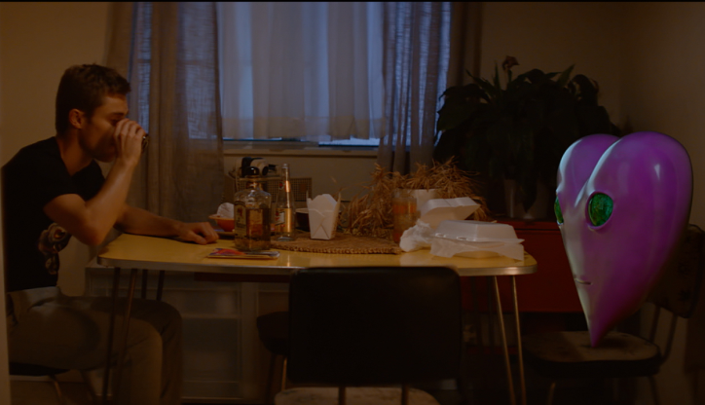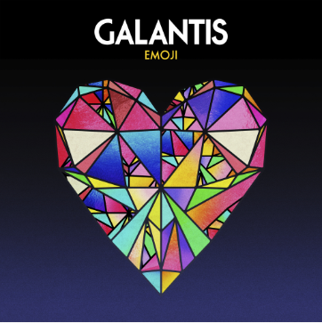

Internationally-acclaimed superstar production duo Galantis are back again. The Swedish act releases a new single “Emoji,” a contemplative cut, with an equally fun official music video that is sure to change the way you look at emojis – WATCH HERE!

Known for their over-the-top live performances, Christian Karlsson (also of Bloodshy & Avant and Mike Snow) and Linus Eklöw (Style of Eye) will return to San Francisco’s legendary Bill Graham Civic Auditorium on Friday, November 16th! This marks their triumphant return to the venue after a sold-out show at the iconic venue last year. Tickets are going fast, so act fast before you get left out! Galantis will also be ringing in the New Year December 30th and 31st at Aragon Ballroom in Chicago. Tickets and more info HERE!

The group’s second album The Aviary debuted as a top 10 album in 23 countries and received widespread critical praise. The New Yorker proclaimed, “Galantis sends crowds soaring with reliably mammoth melodies,” while NYLON raved, “Everything Galantis touches is gold.” Additionally, their debut album, Pharmacy, reached No. 1 on the Billboard Dance Chart and spawned hit singles “Peanut Butter Jelly” and “Runaway (U&I),” the latter of which is RIAA certified gold in seven countries and earned GRAMMY nominations for “Best Dance Recording” and “Best Remixed Recording” through Kaskade’s remix of the song.

GALANTIS LIVE DATES:
Fri Nov 16 - San Francisco, CA - Bill Graham Civic Auditorium [TICKETS]
Sun Dec 30 – Chicago, IL – Aragon Ballroom [TICKETS]
Mon Dec 31 – Chicago, IL – Aragon Ballroom [TICKETS]

FOLLOW GALANTIS:
www.wearegalantis.com
www.twitter.com/wearegalantis
www.facebook.com/wearegalantis
www.youtube.com/user/galantistv
www.instagram.com/wearegalantis
Snapchat: @wearegalantis

PRESS TOOLS: http://press.wearebigbeat.com/artists/galantis/

CONTACT:
Ted Sullivan | Ted.Sullivan@atlanticrecords.com

