FOR IMMEDIATE RELEASE
SEPTEMBER 27, 2019

GALANTIS PREMIERE NEW TRACK & VIDEO “Holy Water”

Grammy-nominated duo to perform back-to-back sold out
headline shows at Los Angeles’ shrine auditorium, October 18th + 19th

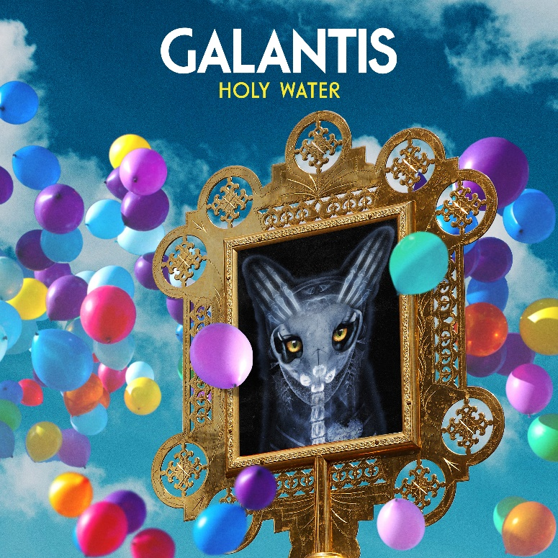

Watch/stream “holy Water”: https://BigBeat.lnk.to/HolyWaterPR

Internationally-acclaimed, GRAMMY-nominated duo Galantis have premiered their latest track “Holy Water” – available now via Big Beat Records alongside a Jason Lester-directed music video. The visual features hypnotizing choreography from synchronized swimming team Aqualilies, paired perfectly with Galantis’ signature anthemic instrumental and perfectly distorted vocals.

The past year has seen a steady stream of tracks from Galantis, including “Bones” featuring OneRepublic, “Spaceship” featuring Uffie and “Satisfied” featuring MAX. Recent collaborations have also included “We Can Get High” with Yellow Claw, “Roots” with Valerie Broussard and “I Found U” with Passion Pit. The duo is set to continue their extensive touring schedule through the fall, including two back-to-back sold out headline shows at Los Angeles’ Shrine Auditorium in October.
***

Setting a new standard for songwriting in dance music, Galantis is a collaborative project between Christian Karlsson (aka Bloodshy, one-third of Miike Snow) and Linus Eklöw (aka Style of Eye). Their debut album Pharmacy reached No. 1 on the Billboard Dance album chart on the strength of RIAA gold certified single “Peanut Butter Jelly” and platinum certified smash “Runaway (U & I)” – the latter of which earned GRAMMY nominations for “Best Dance Recording” and “Best Remixed Recording” – while their 2017 sophomore album The Aviary (featuring platinum certified single “No Money”) saw a top 10 debut in 23 countries. The duo have received over 3 billion cumulative worldwide streams, and over 1 billion video views to date.

The story of Galantis started back in 2009. Working as Bloodshy, Karlsson’s songwriting collaborations included Madonna, Kylie Minogue, Katy Perry and Britney Spears (whose “Toxic” earned a GRAMMY for “Best Dance Recording”). After reaching out to Eklöw (who produced Icona Pop’s hit single “I Love It” as Style of Eye) to remix Miike Snow’s “Animal,” the two continued to collaborate until ultimately Galantis was born. Following their blockbuster performance debut at 2014’s Coachella Valley Music and Arts Festival, the duo quickly rose become one of dance music’s most dynamic and in-demand live performers.

GALANTIS LIVE:
Oct 18 – Los Angeles, CA – Shrine Auditorium *SOLD OUT*
Oct 19 – Los Angeles, CA – Shrine Auditorium *SOLD OUT*
Nov 22 – Charlotte, NC – The Fillmore

CONNECT:
WeAreGalantis.com | Twitter | Facebook | YouTube | Instagram | Press Assets

CONTACT:
Ted Sullivan | Ted.Sullivan@atlanticrecords.com

