GALANTIS’ NEW SINGLE “SPACESHIP” FEATURING UFFIE DEBUTS TODAY
ON TOUR NOW WITH PERFORMANCES AT LOLLAPALOOZA, GOVERNORS BALL, ELECTRIC FOREST, ULTRA EUROPE
AND MORE

WATCH/POST: HERE
BUY/STREAM: HERE
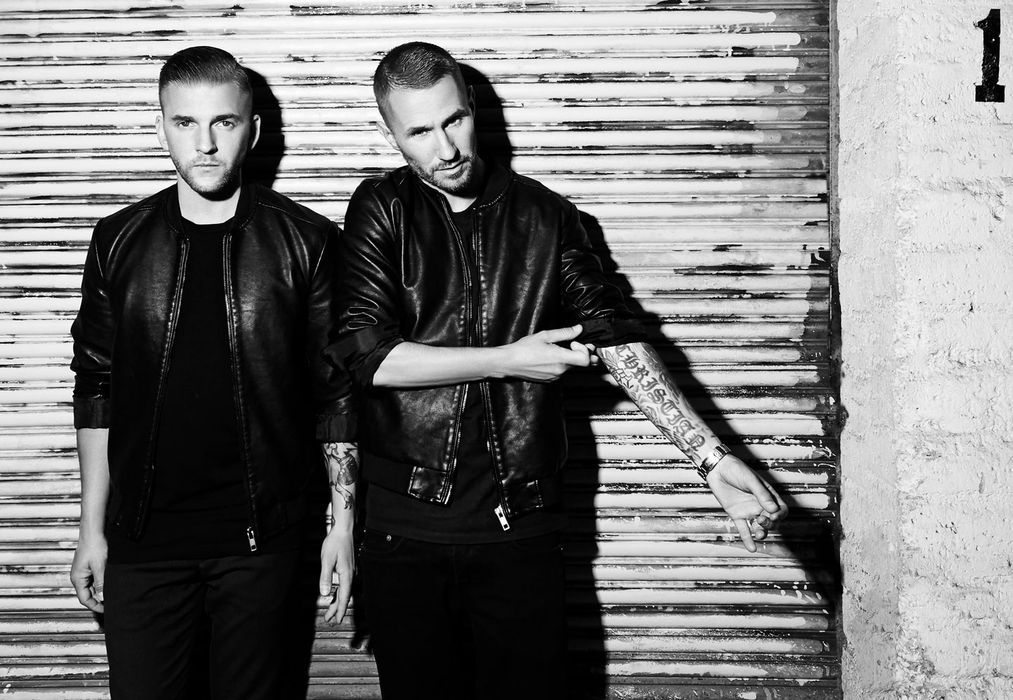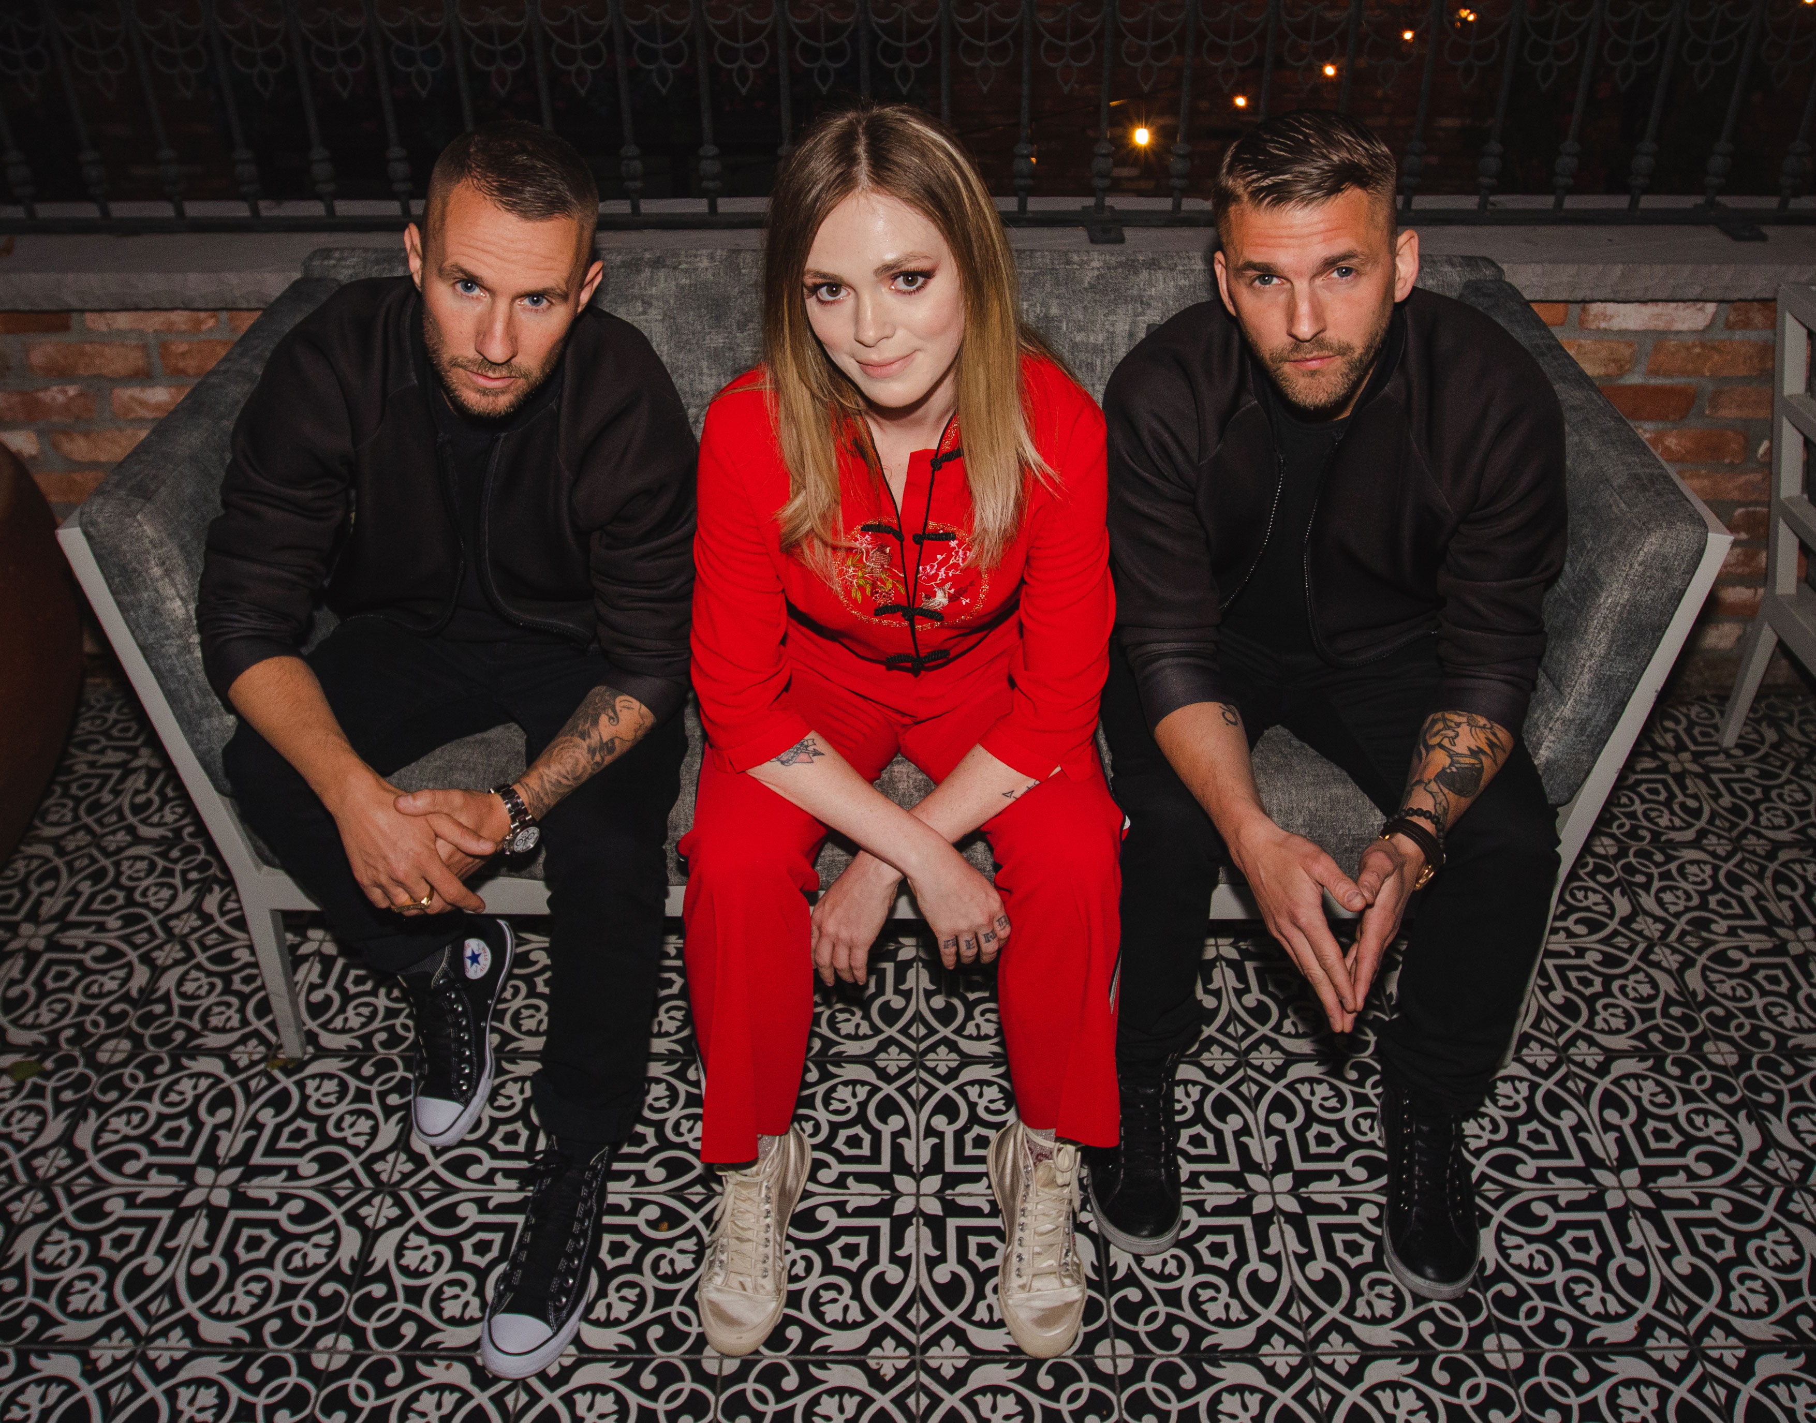
Photo credit: Jimmy Fontaine Photo Credit: Jordan Pulmano
Following the release of their acclaimed album The Aviary, which stacked up over a billion streams in 2017, Grammy-nominated duo Galantis debut their new single “Spaceship” featuring Uffie today on Big Beat Records; watch/share the official music video for the track here.
Of the collaboration, Galantis notes, “After The Aviary World Tour, we were so pumped to get back out there with new music for the dance floor.‎ ‘Spaceship’ takes us to the core of Galantis and our love for dance music. We couldn't be more excited to join forces with Uffie. The first time we heard ‘Pop The Glock,’ it blew our minds... and since then, Uffie’s music has always stuck with us.” while Uffie adds, “Spaceships and summer are like milk and cookies…it’s just so right! I am thrilled to collaborate with the very talented Galantis duo on a track I love so much. It leaves me pining for the dance floor every time.”
Galantis has confirmed select headline summer tour dates including major festival performances at Lollapalooza, Governors Ball, Electric Forest and Ultra Europe. See below for a complete list of tour dates.
Galantis is the Swedish production duo Christian Karlsson (also of Bloodshy & Avant and Miike Snow) and Linus Eklöw (Style of Eye). The group’s second album The Aviary debuted as a top 10 album in 23 countries and received widespread critical praise. The New Yorker proclaimed, “Galantis sends crowds soaring with reliably mammoth melodies,” while NYLON furthered, “Everything Galantis touches is gold.” Additionally, their debut album, Pharmacy, reached No. 1 on the Billboard Dance Chart and spawned hit singles “Peanut Butter Jelly” and “Runaway (U&I),” the latter of which is RIAA certified gold in seven countries and earned Grammy nominations for “Best Dance Recording” and “Best Remixed Recording” via the Kaskade remix.
Uffie is a Los Angeles-based songwriter, musician, and fashion designer. She first made international waves via Paris with her first single “Pop the Glock” in 2006. In 2010 she released her debut album Sex Dreams and Denim Jeans, featuring the likes of Pharrell Williams, to critical acclaim. Following her feature on Charli XCX’s “Babygirl,” she headlined the Viva Phoenix festival and performed at Hard Festival 2017. Uffie is currently working on her new album in Los Angeles with executive producer Ammar Malik, J Kash and Andrew Wells; the record’s first single set for summer 2018.
GALANTIS LIVE
May 18—Gulf Shores, AL—Hangout Festival
May 26—Monterrey, Mexico—Wish Outdoor Mexico
June 1—Washington, DC—Echostage
June 2—New York, NY—Governors Ball
June 15—Stockholm, Sweden—Summerburst Festival
June 21—Rothbury, MI—Electric Forest
June 22—Las Vegas, NV—Encore Beach Club
June 23—Toronto, Canada—Dreams Festival
July 6—Split, Croatia—Ultra Europe
July 13—Las Vegas, NV—XS Las Vegas
July 14—Las Vegas, NV—Encore Beach Club
July 19—Tonsberg, Norway—Slottsfjell
July 27—Bodo, Norway—Opptur Festival
July 28—Barcelona, Spain—Unite with Tomorrowland
August 2—Chicago, IL—Lollapalooza
August 4—Las Vegas, NV—XS Las Vegas
August 5— Las Vegas, NV—Encore Beach Club
August 12—Las Vegas, NV—XS Las Vegas
August 17—Helsinki, Finland—Weekend Festival
August 18—Parnu, Estonia—Weekend Festival Baltic
August 23—London, UK—Creamfields
August 25—London, UK—South West Four

www.wearegalantis.com
www.twitter.com/wearegalantis
www.facebook.com/wearegalantis
www.youtube.com/user/galantistv
www.instagram.com/wearegalantis
Snapchat: @wearegalantis

CONTACT:
Ted Sullivan | Ted.Sullivan@atlanticrecords.com

