CONTACT:
Ted Sullivan | Ted.Sullivan@atlanticrecords.com
GALANTIS FOLLOW SOLD OUT SF SHOW WITH
NEW SINGLE “SAN FRANCISCO”
FEATURING SOFIA CARSON!

ALONGSIDE OFFICIAL MUSIC VIDEO OUT TODAY

GALANTIS TO PLAY 2 NEW YEAR’S EVE SHOWS IN CHICAGO

“SAN FRANCISCO” FT. SOFIA CARSON:
WATCH/POST: https://youtu.be/WxEbxHoZ650
BUY/STREAM: https://BigBeat.lnk.to/SFCPR
(Big Beat Records)

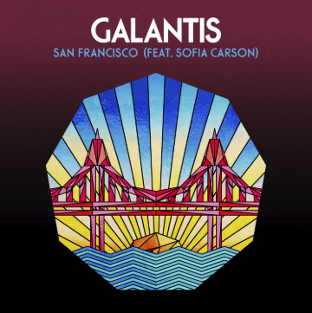

Swedish duo Galantis releases new track + video for “San Francisco” featuring singer and actress Sofia Carson, replete with a dazzling piano melody and accentuated with tasteful brass that builds into one of the duo’s signature drops. The hook-laden song celebrates the internationally-acclaimed superstar production duo’s triumphant SOLD OUT return to San Francisco’s Bill Graham Civic Auditorium last month – with a massive chorus, especially when paired with Carson’s sticky-sweet vocals. The neon-lit video takes place in a Galantis-themed karaoke dive bar, and stars none other than Sofia Carson on the karaoke stage, performing to… well, you’ll have to tune in to what unfolds – WATCH HERE!

Known for their over-the-top live performances, Christian Karlsson (also of Bloodshy & Avant and Miike Snow) and Linus Eklöw (Style of Eye) will ring in the New Year December 30th and 31st at Aragon Ballroom in Chicago. Tickets and more info HERE! The group’s second album The Aviary debuted as a top 10 album in 23 countries and received widespread critical praise. The New Yorker proclaimed, “Galantis sends crowds soaring with reliably mammoth melodies,” while NYLON raved, “Everything Galantis touches is gold.” Additionally, their debut album, Pharmacy, reached No. 1 on the Billboard Dance Chart and spawned hit singles “Peanut Butter Jelly” and “Runaway (U&I),” the latter of which is RIAA certified gold in seven countries and earned GRAMMY nominations for “Best Dance Recording” and “Best Remixed Recording” through Kaskade’s remix of the song.

In the world of entertainment, SOFIA CARSON is a force of nature, rising to the top of all she endeavors with grace and style. Sofia’s foray into mainstream radio kicked off with the release of her first solo effort, the infectious “Love Is The Name.” This single zoomed up the Top 40 radio charts. Sofia’s past four singles, “Love Is The Name”, “Back To Beautiful”, “Ins and Outs” and “Rumors” have combined views of over 200 million. Sofia is currently in the studio recording new music to be released in 2019. She has already received award nominations, among them nods for Teen Choice Awards’ Next Big Thing, Premios Juventud for Producer’s Choice Award and RDMA’s Best Song. She is signed to Hollywood Records and Republic Records. She also stars in the upcoming Freeform television series “Pretty Little Liars: The Perfectionists” and “Descendants 3,” the final movie of the successful franchise, premiering in 2019.

GALANTIS LIVE DATES:
Sun Dec 30 – Chicago, IL – Aragon Ballroom
Mon Dec 31 – Chicago, IL – Aragon Ballroom

FOLLOW GALANTIS:
www.wearegalantis.com
www.twitter.com/wearegalantis
www.facebook.com/wearegalantis
www.youtube.com/user/galantistv
www.instagram.com/wearegalantis
Snapchat: @wearegalantis

PRESS TOOLS: http://press.wearebigbeat.com/artists/galantis/

CONTACT:
Ted Sullivan | Ted.Sullivan@atlanticrecords.com

