Galantis’ Debut Album ‘Pharmacy’ Tops The Charts In Its First Week!
Duo Announces Remix EP (out 6/29) for “Peanut Butter Jelly”!
+ forthcoming festival dates – EDC Vegas, Electric Forest, Lollapalooza & more!

Stream “Pharmacy” on Spotify | Buy “Pharmacy” on iTunes

Stream new “Runaway U&I” (GTA Remix):
https://soundcloud.com/wearegalantis/galantis-peanut-butter-jelly-gta-remix/
"Members Christian Karlsson and Linus Eklöw have long straddled the line between
Top 40 success and cognoscenti cool."
–ROLLING STONE

Swedish-based songwriting/production duo Galantis released their long-awaited debut “Pharmacy” (stream) on Big Beat/Atlantic and within the first week shot to supreme reign hitting #1 on Billboard Top Dance/Electronic Albums Chart, #45 on the Billboard 200 and racking up over 131 million streams globally to date as well, making Galantis one of the leading dance artists in the streaming space.

“Pharmacy” features the smash hit “Runaway (U&I)” (stream), which is the #19 highest selling Dance/Electronic single thus far in 2015, currently #7 on Album Core genre Dance/Electronic Chart, with over 100 million radio spins worldwide, and topped the Billboard Emerging Artists Chart and Spotify’s Viral 40 Chart, while also charting in the Top 10 on iTunes’ Dance Chart. Similarly, “Gold Dust” and “Peanut Butter Jelly” both came in at #1 on the HypeMachine chart, garnering over 1 million streams apiece.

Never one to slow down, Galantis has also announced a “Peanut Butter Jelly” remix EP arriving to Beatport on June 29th (and to all other DSPs on July 10th) via Big Beat/Atlantic with reworks courtesy of Jacque Lu Cont aka Stuart Price, Moska, as well as Miami heavy hitters GTA who “adds a little edge to the unflaggingly upbeat single, with enough drops to satisfy even the most insatiable festivalgoer” (Billboard).

Galantis is Christian Karlsson (AKA Bloodshy) of Miike Snow and Linus Eklöw (AKA Style Of Eye), each with an impressive pedigree in music. Karlsson helped reinvent pop divas such as Madonna, Britney Spears & Kylie Minogue in the early 2000s, co-writing Britney's career-changing single "Toxic" and earning a Grammy Award for Best Dance Recording, as well as earning renown for his production talents on Miike Snow's treasured 2009 self-titled album and 2011's Happy To You. Eklöw has cut his own path through electronic music as Style of Eye defying genre and releasing on multiple taste-making labels for the past decade, as well as co-writing/producing Icona Pop's international #1 hit "I Love It" ft. Charli XCX.

GALANTIS TOUR DATES:
June 18th - Exchange LA - Los Angeles, CA
June 19th - Marquee - New York, NY
June 21st - EDC Las Vegas - Las Vegas, NV
June 25th - Electric Forest - Rothbury, MI
June 27th - The Flats - Digital Dreams Festival - Toronto, ON
August 2nd - Lollapalooza - Chicago, IL
September 4th - Electric Zoo - New York, NY
September 6th - Nocturnal Wonderland - San Bernadino, CA

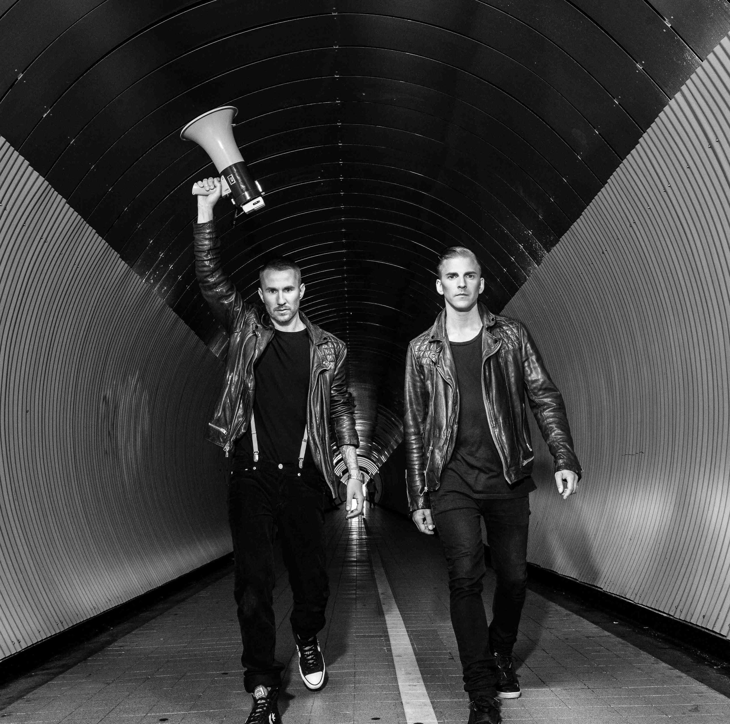

Follow Galantis:
wearegalantis.com
twitter.com/wearegalantis
facebook.com/wearegalantis
youtube.com/user/galantistv
instagram.com/wearegalantis

For press materials: press.wearebigbeat.com/artists/galantis/

PRESS CONTACT:
Ted Sullivan // Ted.Sullivan@Atlanticrecords.com

