**GALANTIS AND YELLOW CLAW TEAM UP ON “WE CAN GET HIGH”**

**TRACK + VIDEO OUT TODAY ON BIG BEAT RECORDS**

**WATCH/SHARE:** <https://BigBeat.lnk.to/WCGH/youtube>

**BUY/STREAM:** <https://BigBeat.lnk.to/WCGHPR>

[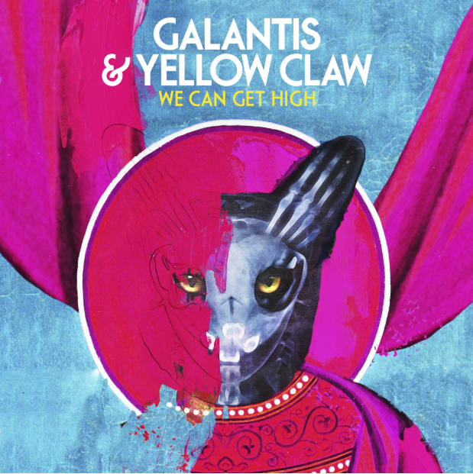](https://press.wearebigbeat.com/artists/galantis/)

Well known for their steady stream of chart-topping hits, the internationally-acclaimed Swedish duo**Galantis**is kicking off the summer in style, with a new collaborative single alongside the Dutch electronic duo**Yellow Claw**called**“We Can Get High”,**which sees an official release today through Galantis’s longtime label **Big Beat Records.** The official video sees a dancer interpreting the song into movement, while colors and patterns swirl around her in a very unique setting- a church! [Watch HERE!](https://BigBeat.lnk.to/WCGH/youtube) “We Can Get High” comes just ahead of sold out shows for Galantis at Brooklyn Mirage on July 5th and the Shrine Expo Hall in Los Angeles this fall!

Galantis is coming off their most recent collaboration with the multi-platinum band OneRepublic called [“Bones”](https://www.youtube.com/watch?v=UEY5d_axpVE) that came out earlier this year, already racking up over 77 *million* streams in just a few months alone. The single’s [CGI-animated official music video](https://www.youtube.com/watch?v=UEY5d_axpVE) has been viewed more than a million times. “Bones” also resulted in a slew of remixes, including Galantis & shndō’s VIP Mix, along with remixes from Hook N Sling, Steff da Campo, B-Sights, eSQUIRE, and Lodato.

Galantis’s 2019 tour schedule includes a Wynn Las Vegas residency and performances at Spring Awakening, Global Dance Festival and more. Their second album [*The Aviary*](https://bigbeat.lnk.to/theaviaryPR) debuted as a Top 10 album in 23 countries and received widespread critical praise. The New Yorker proclaimed, *“Galantis sends crowds soaring with reliably mammoth melodies,”* while NYLON raved, *“Everything Galantis touches is gold.”* Additionally, their debut album *Pharmacy* reached No. 1 on the Billboard Dance Chart and spawned hit singles “[Peanut Butter Jelly](https://www.youtube.com/watch?v=4jBDnYE1WjI)” and “[Runaway (U&I),”](https://youtu.be/5XR7naZ_zZA) the latter of which is RIAA certified gold in seven countries and earned GRAMMY nominations for “Best Dance Recording” and “Best Remixed Recording”. Galantis has been the recipient of 32 Gold Records in 16 Countries, and 42 Platinum Records in 18 countries.

Yellow Claw has performed at major festivals such as EDC, Coachella, Tomorrowland, Lollapalooza and more. Their debut album *Blood For Mercy* hit #1 on Billboard Heatseekers Chart and also charted in the Top/Dance Electronic Albums. Galantis’ notorious steady touring schedule is keeping them on the road all summer long, with huge performances slated at Wynn Las Vegas residency, Ultra, Spring Awakening, Shaky Beats, Global Dance Festival and more.



*(Galantis photo by Katharina-Næss -* [*DL*](http://press.wearebigbeat.com/wp-content/uploads/2016/12/Galantis-Katharina-N%C3%A6ss.jpg)*)*

**

*(Yellowclaw photo by Romy Treebusch –* [*DL*](https://warnermusicgroup.box.com/s/j2chqctsp9l0wb405qp69njqllyot7yk)*)*

**GALANTIS NORTH AMERICAN LIVE DATES**:

June 16 – Las Vegas, NV – Encore Beach Club

July 5- Brooklyn, New York – Brooklyn Mirage

July 12 - Columbus, OH – Bluestone

July 13 – Las Vegas, NV - XS Nightclub

July 20 – Las Vegas, NV – XS Nightclub

August 14 – Las Vegas, NV – Encore Beach Club

August 28 – Las Vegas, NV – Encore Beach Club

Sept 21 - Lansing, MI - Prime Fest

Oct 18 – Los Angeles, CA – The Shrine

Oct 19- Los Angeles, CA – The Shrine

**FOLLOW GALANTIS:**

[www.wearegalantis.com](http://www.wearegalantis.com/)

[www.twitter.com/wearegalantis](http://www.twitter.com/wearegalantis)

[www.facebook.com/wearegalantis](http://www.facebook.com/wearegalantis)

[www.youtube.com/user/galantistv](http://www.youtube.com/user/galantistv)

[www.instagram.com/wearegalantis](http://www.instagram.com/wearegalantis)

Snapchat: @wearegalantis

**PRESS TOOLS:**

[http://press.wearebigbeat.com/artists/galantis/](http://press.wearebigbeat.com/artists/galantis/%0d)

**CONTACT:**

Ted Sullivan | [Ted.Sullivan@atlanticrecords.com](mailto:Ted.Sullivan@atlanticrecords.com)