DUTCH PRODUCER FERRECK DAWN & GERMAN MAINSTAY ROBOSONIC RELEASE ‘IN ARMS’

BUY/STREAM: https://bigbeat.lnk.to/iapr
(BIG BEAT/DEFECTED RECORDS)

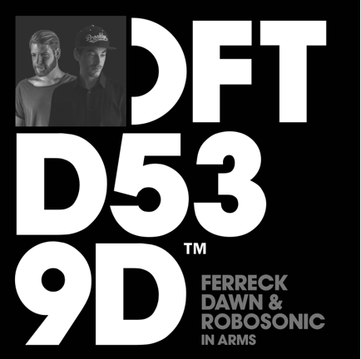

Dutch producer Ferreck Dawn and German mainstay Robosonic go head to head on their dancefloor smash ‘In Arms’. Listen HERE!
A firm favourite with Low Steppa, Sam Divine, Franky Rizardo and the whole crew of residents when it was road-tested during the Defected Australia tour in early 2018, the thumping, bass-focussed track received a huge reaction from crowds with its tightly-harmonised earworm vocal. Certifying its place as a standout summer record, ‘In Arms’ has all the makings of a future hit.
For press assets: http://press.wearebigbeat.com/singles/in-arms-ferreck-dawn-robosonic/
For more information please contact:
Jordan Danielle Frazes
Head of Publicity, Big Beat Records
jordan.frazes@atlanticrecords.com

Scarlett Pares Landells
scarlett@defected.com
+44 (0)20 7426 5482

