GRAMMY AWARD NOMINEE ELDERBROOK DELIVERS NEW TRACK ‘SLEEPWALKING’ OUT TODAY ON BIG BEAT RECORDS

CELEBRATING June-July NORTH AMERICAN TOUR DATES
WITH Bonobo + Rüfüs Du Sol & MORE!

WATCH/POST: https://youtu.be/_g5Hx1HcEDQ
BUY/STREAM: https://BigBeat.lnk.to/SWPR
(Big Beat Records)

“When I write, I have a music video in my head and this song inspired dark scenes of the world
coming to an end. It’s about how the world has changed through human influence,
but in the end we’re insignificant because the world will win. It’s almost apocalyptic.” – Elderbrook

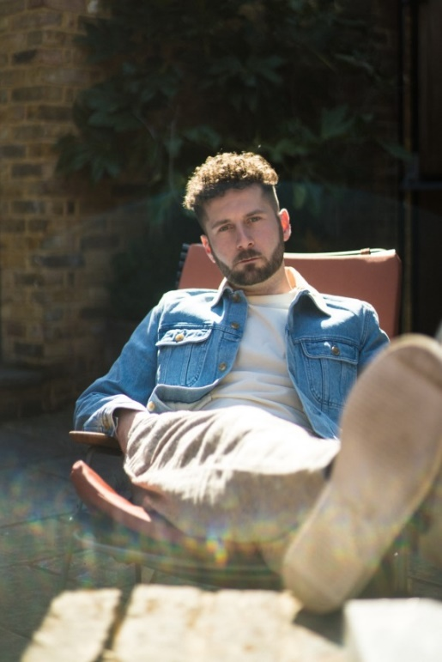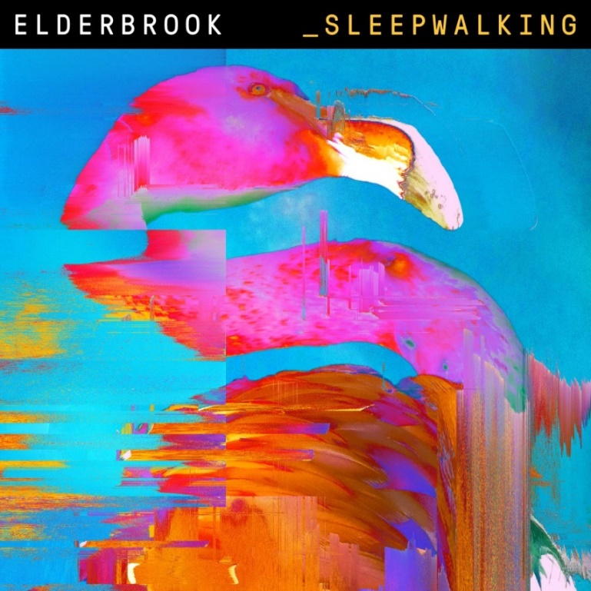
Photo Credit: Niko Mitrunen
Almost a year ago, Elderbrook joined forces with UK production duo CamelPhat to release “a cool little club record” called ‘Cola’ which catapulted from the underground and into charts all over the world; garnering attention from The Los Angeles Times, Rolling Stone and Billboard and emerging as a surprise 2018 Grammy Award nomination (‘Best Dance Recording’) alongside earning a recent Ivor Novello nomination (‘Best Contemporary Song’) as well.

Today, the London-based producer and songwriter Elderbrook returns with an engaging mix of the sweet and the sinister, titled ‘Sleepwalking ’ via Big Beat Records in the US – LISTEN HERE. The new single was written with Empire of the Sun’s Nick Littlemore during a visit to Los Angeles; mixed by David Wrench (The xx, Sampha); and features additional production by Toddla T. Its insistent, almost tribal rhythm provides an enticing groove, while Elderbrook’s almost whispered lyrics evoke images of a world in the wake of an environmental catastrophe.

Elderbrook’s initial breakthrough came after an early Soundcloud release which led to a Black Butter Record deal. Early releases such as ‘Could’ and its parent EP ‘Simmer Down’ resulted in comparisons with the likes of James Blake before he struck out on his own with his independent label Mine Records. He released his second EP ‘Talking’ last year which inspired MTV to include him in their Brand New For 2018 list, while Magnetic Magazine highlighted him as #1 in their Artists to watch in 2018 feature.

Elderbrook has been selling out headline shows all over the world. In the last year alone, he sold-out The Roxy in L.A. as well as Baby’s All Right in NYC, with plans to return to the States in June and July as support to Bonobo and Rüfüs Du Sol on tour; among other festival appearances including Life is Beautiful and Bumbershoot; and back home in the UK, performances at Reading, Leeds and Standon Calling.

Elderbrook North America Tour Supporting RÜFÜS DU SOL and Bonobo
(PLUS ADDITIONAL FESTIVAL DATES)
12 June – The National – Richmond, VA *
13 June – Lincoln Theatre – Raleigh, NC *
14 June – Music Farm – Charleston, SC *
15 June – Plaza Live – Orlando, FL *
16 June – Fillmore Miami Beach – Miami, FL *
28 June – Electric Forest Festival – Rothbury, MI
30 June – 1 July – Pinknic Festival – Governors Island, NY
5 July – The HiFi Club – Calgary, AB
6 July – The Church of John – Edmonton, AB
7 July – Royal Botanical Gardens – Hamilton, ON +
31 Aug – 2 Sep – Bumbershoot – Seattle, WA
21 Sep – Life Is Beautiful – Las Vegas, NV

* Supporting RÜFÜS DU SOL
+ Supporting Bonobo

###

Connect with Elderbrook:
https://www.facebook.com/Elderbrookmusic/
https://twitter.com/_elderbrook

For press assets: http://press.wearebigbeat.com/artists/elderbrook/

For more information on Elderbrook:
Jordan Danielle Frazes
Head of Publicity, Big Beat Records
Jordan.Frazes@atlanticrecords.com
Libby Kober
Tour Publicity, Big Beat Records
Elizabeth.Kober@atlanticrecords.com

