PRODUCER DILLON NATHANIEL TEAMS UP WITH BIG BEAT RECORDS TO RELEASE NEW PRESSURE EP (OUT 2/22)
TITLE TRACK OUT TODAY!

LISTEN/SHARE: https://youtu.be/gCOWwCBoD_0
STREAM/BUY: https://BigBeat.lnk.to/pressurePR

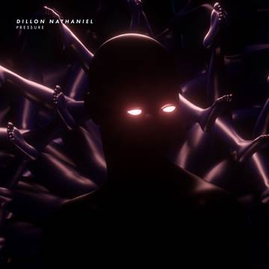
DOWNLOAD PHOTO HERE

The acclaimed experimental producer Dillon Nathaniel has been honing his signature unconventional blend of house for several years and now Big Beat Records is thrilled to release his upcoming music, the first being title track Pressure, out today (listen HERE), in addition to the five-song Pressure EP on February 22th. A graduate of the revered Icon Collective, the self-professed gear junkie has proven himself to be a technical mastermind and modern house music connoisseur.

Uniting intricate groove with dirty textures, the Pressure EP showcases a unique blend of tech house and techno with a dirty twist. Sonic manipulation has always been the cornerstone of Dillon Nathaniel's sound, and “Pressure” is exemplary of his unmatched approach. The song takes cues from classic deep house, but manipulates and warps the sound of the drum machines and synths beyond recognition, to the point where they practically sound submerged. It’s the sound of the clock striking dawn at the warehouse rave, before you realize time is immaterial, and you don’t have to work tomorrow.

In Dillon’s own words, “This EP is dedicated to those who overcome all of life’s obstacles. When the music hits the pressure of life fades away. The everyday struggles of life can be too much to bear. Everyday we're faced with challenges and we have to make a choice; do we let the negativity of the world affect the way we see it, or do we count our blessings? Learning to live with the pressures from our past, present and future is to live with peace of mind.”

The strength of his thick low-end grooves and quirky sound design have already caught the attention of A-Trak, Destructo, Chris Lake, Richy Ahmed, DJ Snake, Gorgon City, Kyle Watson and Tchami. His sound has also begun to inject itself onto the ears of mainstream audiences with plays popping up from BBC Radio 1, Rinse FM and Sirius. And with appearances on CONFESSION, Heldeep, This Ain't Bristol, Night Bass, Mom+Pop Records, Idris Elba’s 7Wallace Records, and Insomniac Records it's clear his intent to ''Shake up people's perception of what house is'' is well within reach.

While it may seem like this young bass technician has seen a quick rise, his roots run deep. The former audio engineer and gear junkie found his footing in music at an early age as a vocalist and guitar player. His father impressed upon him a strong emphasis in dance music exposing the budding musician to the likes of Carl Cox and Sasha on road trips from the age of 8. He eventually brought Dillon to EDC at the age of 16. It was this that provided the ultimate inspiration to pursue a career in dance music. There is no doubt that Dillon will continue to turn heads as he pushes forward in his effort to reshape the face of modern dance music.

As Dillon continues to prove himself a house music legend, he ended 2018 with a massive bang being one of the buzzing acts in Destructo’s Friendship cruise, where he turned a sample of the cruise director giving a safety drill announcement into a massive siren-blaring tech house smash. The track, titled “Abandoned Ship,” was dubbed the official anthem of Friendship’s Maiden Voyage. Expect much more creativity like this from Dillon Nathaniel throughout 2019!

PRESS ASSETS: http://press.wearebigbeat.com/singles/dillon-nathaniel/

CONNECT WITH DILLON NATHANIEL:
Instagram| Twitter | Soundcloud | Facebook | Spotify

FOR MORE INFORMATION:
Paige Rosoff – Big Beat Records
Paige.Rosoff@atlanticrecords.com

