DJ S.K.T RELEASES NEW SINGLE “LIPSTICK & PERFUME”

OUT TODAY VIA BIG BEAT RECORDS

WATCH / POST: https://youtu.be/CnymA8Jgqpo
BUY/STREAM: https://BigBeat.lnk.to/LAPPR

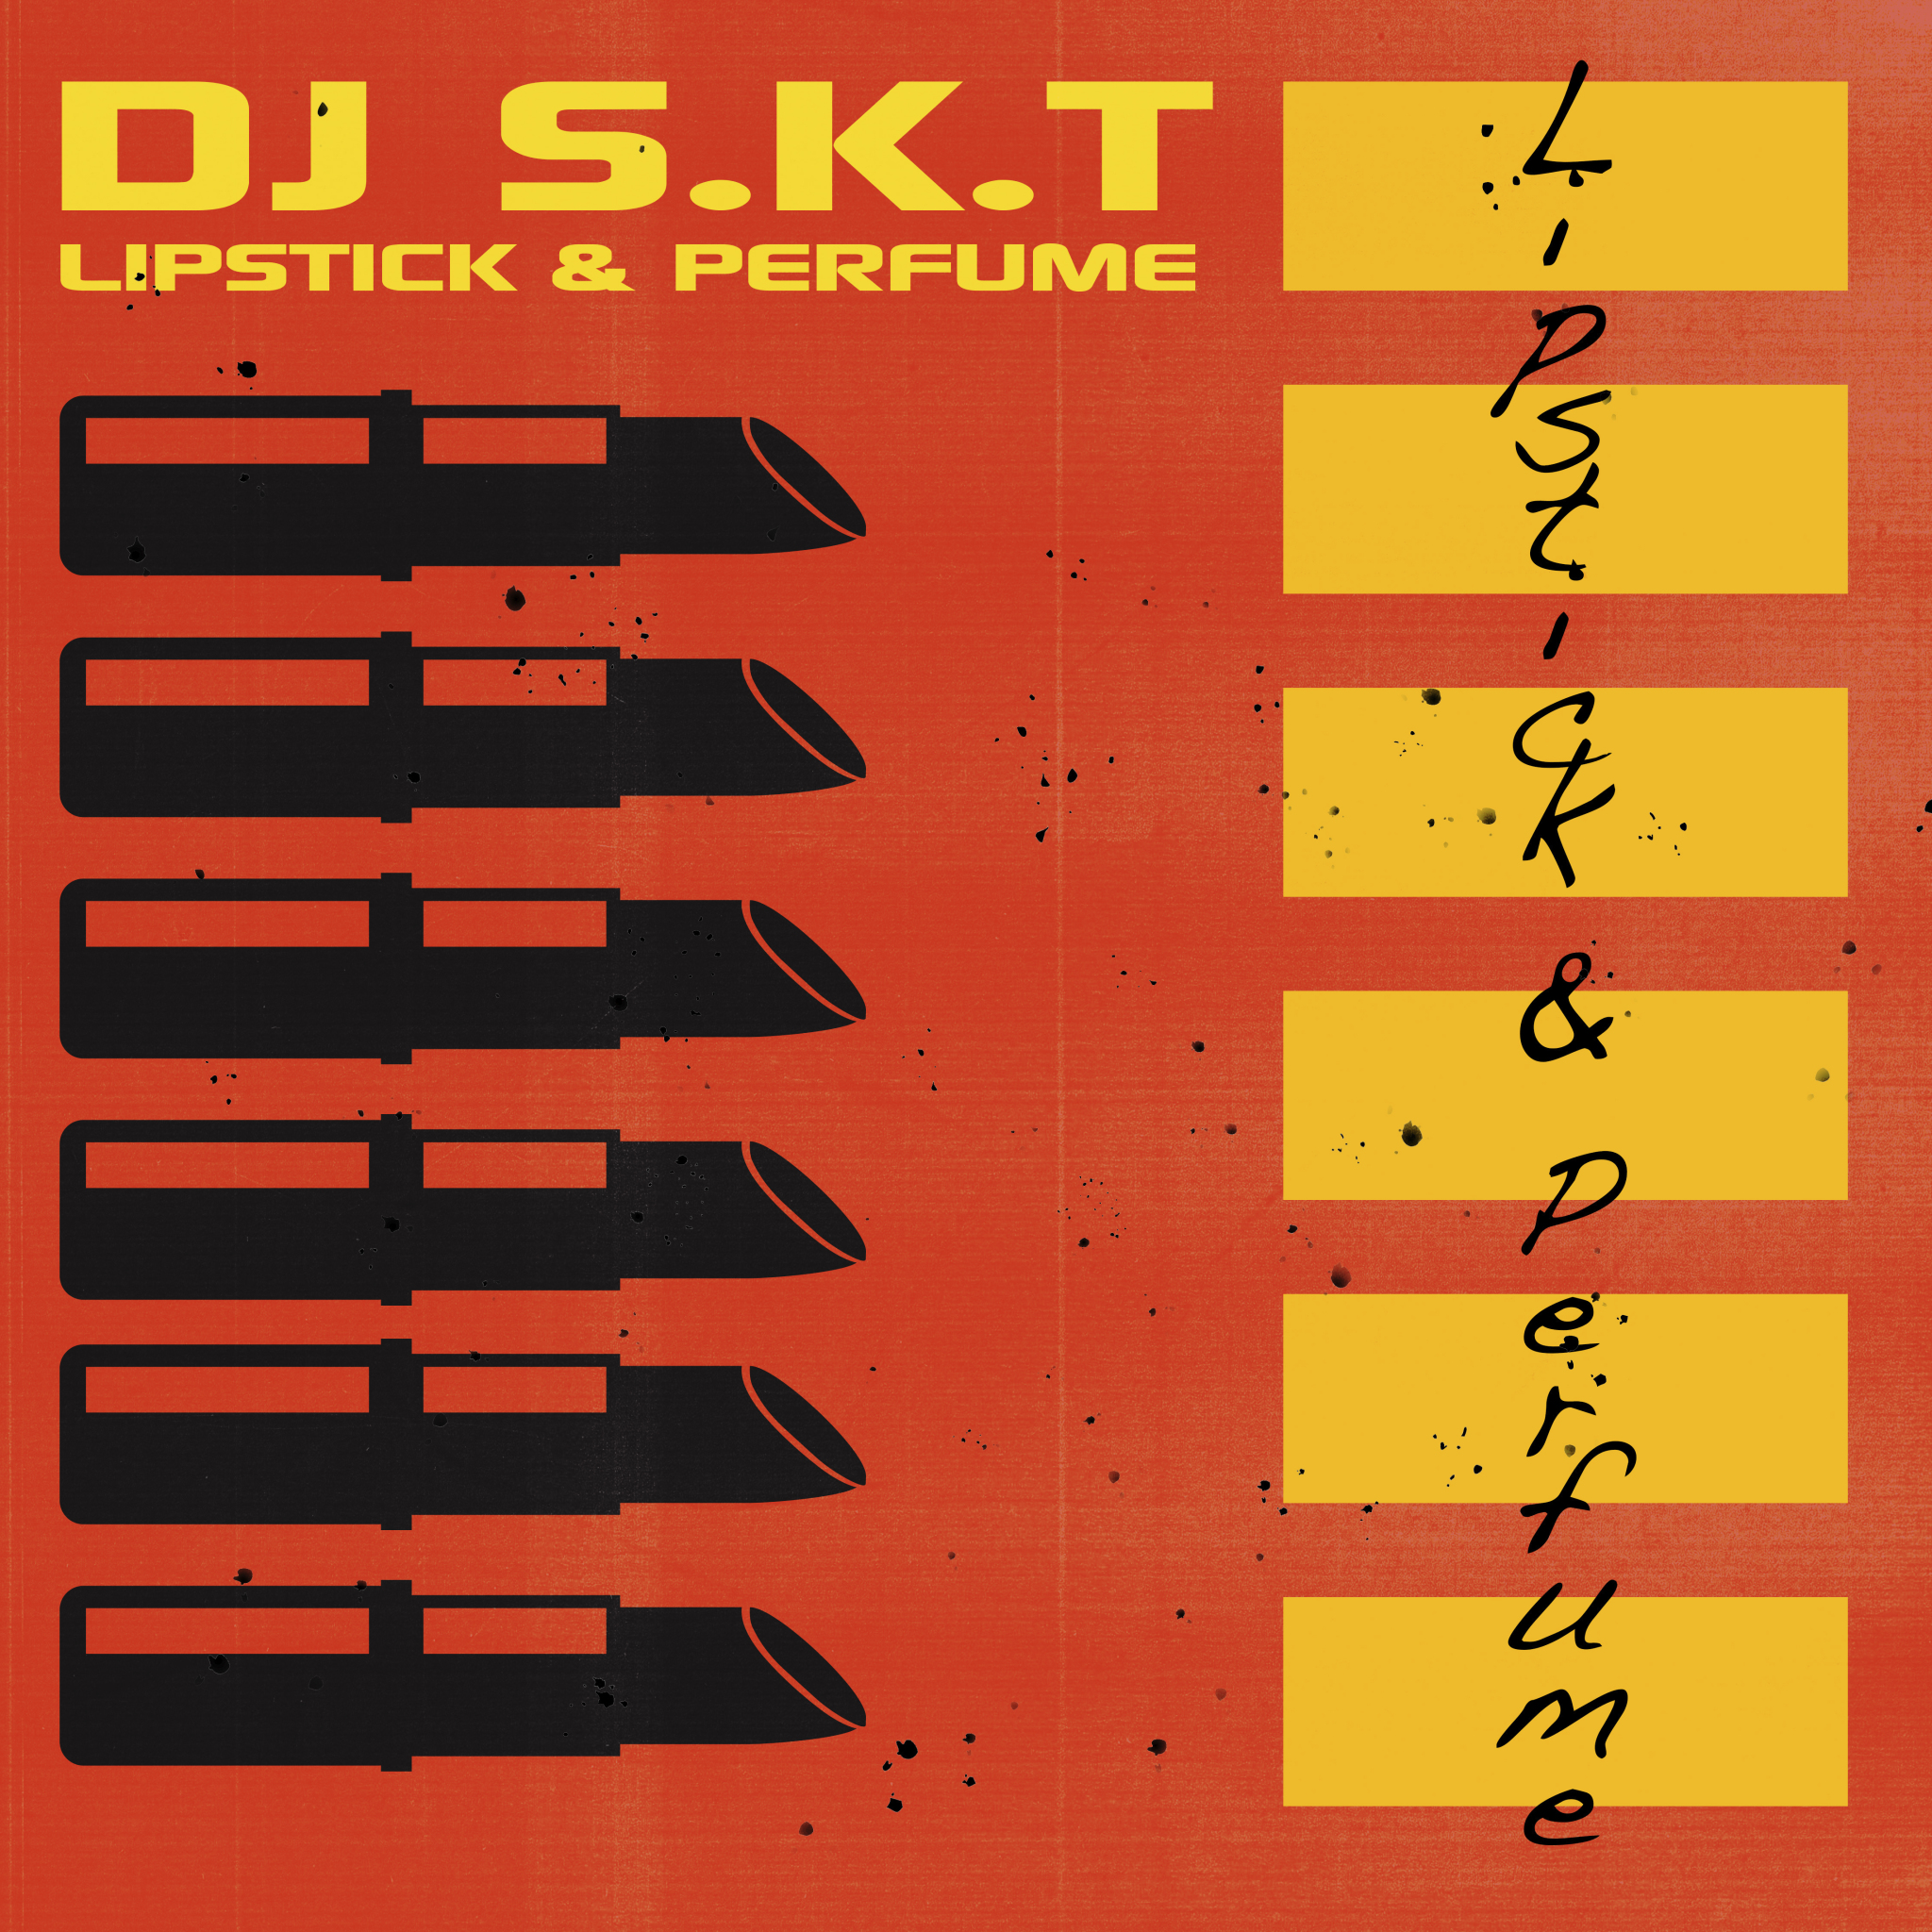
DOWNLOAD IMAGE HERE

Today one of the hottest talents in the global club scene, DJ S.K.T, drops his freshest track “Lipstick & Perfume” via Big Beat Records - listen HERE.

Being the go-to name and top tier producer that he is, Stephen Kenny Tempest, better known as DJ S.K.T, releases yet another house music staple. This new club anthem is already receiving massive response in clubs worldwide. With its infectious bassline and catchy melody that captures you from the very first beat, DJ S.K.T delivers another dancefloor success.

DJ S.K.T is not only the man behind hits such as 2015’s huge “Take Me Away” featuring Rae, which received over 8 million streams on Spotify alone and peaked at number 19 on the UK Singles Chart, but has a weekly residency on Kiss FM, and has remixed hits such as Miguel’s “Adorn,” Somore’s “I Refuse,” and Clean Bandit & Jess Glynne’s “Real Love.” This summer, DJ S.K.T gave the remix treatment to “Atheist” by Disciples with other highlights this year including having “Must Be a Reason” included on Defected’s Most Rated 2018 compilation and “Get Up” included in the Defected x Relentless campaign and released in its own right. DJ S.K.T was also asked by New State to mix their 2018 Pure Tech House Album and has released tracks on notable labels including Toolroom and Armada.

With his steady stream of hit records over the years, DJ S.K.T can count tastemakers such as Annie Mac, Pete Tong, Danny Howard, Mistajam, DJ Target, MK, Roger Sanchez, Amine Edge & Dance, Solardo, Hannah Wants and Idris Elba among his legions of fans.

The way DJ S.K.T describes the creation of this track is testament to his natural talent and flair: “I was browsing through some old records and came across this sample, which sounded really cool. I threw it into logic and sped up the main sample, cut up the single brass stabs in the track and replayed them to give the track some movement. It all came together really quickly, and I ended up with a wicked track that’s been getting great reactions where ever I play it…really looking forward to teaming up with Big Beat on this release and am excited to get it out there!”

***

MORE ON DJ S.K.T
DJ S.K.T is without question one of the hottest talents in the UK and international club scene. A producer, DJ, and labelmanager, DJ S.K.T specialises in all forms of dance music – from deep and soulful house, tech-house, garage & experimental bass, all tied together with that common thread of working a dance floor. A UK radio favourite, DJ S.K.T has delivered guest mixes for Kiss FM UK, Capital Xtra and Rinse FM. He was a previous resident DJ on BBC 1Xtra Talent’s UKG show and was one of Mistajam’s 60 Minute Mix DJs on BBC 1Xtra. 2014 saw him produce the underground anthem “Right Before My Eyes”for Little Nikki on Sony/Deconstruction, which gained him a Top 40 in the UK national singles chart. Further show-stealing remixes for the likes of Oliver Heldens (“Gecko”), Wilkinson (“Dirty Love”), Becky Hill (“Caution To The Wind”), Clean Bandit & Jess Glynne (“Real Love”) and UK No.1 Philip George’s “Wish You Were Mine” set DJ S.K.T in a league of his own, bringing his unique sound to thousands of new fans around the world and establishing him as a remixer of real renown. DJ S.K.T is arguably best known for his original production - the huge “Take Me Away” with guest vocals from Rae – after initially being signed to house titans Defected/Azuli, it was snapped up for major release by Atlantic Records, eventually breaking into the top 20 of the UK Singles Chart. With a string of successful releases to his name again in 2018 and having played at some of the biggest and best clubs and festivals, this talented producer shows no signs of slowing down.

Connect with DJ S.K.T:
SOUNDCLOUD I FACEBOOK I TWITTER | INSTAGRAM

FOR MORE INFORMATION:
Paige Rosoff - Big Beat Records
Paige.Rosoff@atlanticrecords.com

