DILLON NATHANIEL TEASES SOPHOMORE EP WITH THE RELEASE OF PULSING FIRST SINGLE “OBSESSIONS”

LISTEN HERE: https://BigBeat.lnk.to/obsessionsPR

OUT NOW ON BIG BEAT RECORDS

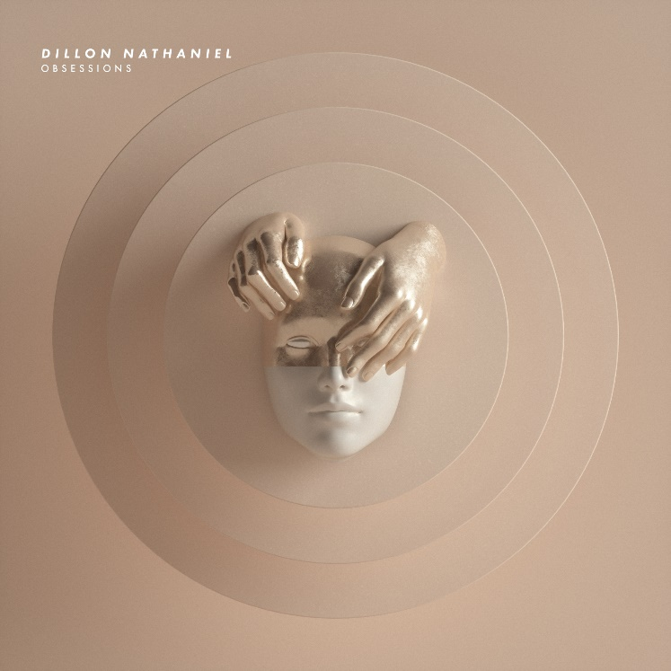
DOWNLOAD ARTWORK HERE

Dillon Nathaniel, a graduate of the revered Icon Collective, has once again proven himself a technical mastermind with the first release off his forthcoming sophomore EP (coming August 16th), “Obsessions” out today on Big Beat Records! Listen HERE.

With his sonic manipulation skills, Dillon Nathaniel finds the perfect balance between upbeat dance music and hefty trance beats. “Obsessions” exudes energy from beginning to end with a heart-pumping start that leads into a deep house beat. The song stays fresh throughout its 4 minutes and 15 seconds with a new beat at every turn!

The strength of his thick low-end grooves and quirky sound design have caught the ears of A-Trak, Destructo, Chris Lake, Richy Ahmed, DJ Snake, Gorgon City, Kyle Watson and Tchami. Slowly gaining exposure in the mainstream, the producer has been heard on BBC Radio 1, Sirius XM and Rinse FM.

The young bass technician has deep roots in audio manipulation and production, making his transition into the electronic music industry an easy one. The former audio engineer found his footing in music at a young age as a vocalist and guitar player. His father took him to his first EDC at the age of 16 in an effort to instill a passion for dance music in him which ultimately drove his pursuit of a career in electronic music.

Last year was a big year for the producer as he had just come off a massive run of shows in support of Destructo on his Let’s Be Friends Tour. He then embarked on his first international tour in Australia playing at some of the country’s most notable venues. Dillon wrapped up 2018 with key festival performances at CRSSD in San Diego, Seismic Dance Event in Austin, and AMF’s Friendship Maiden Voyage.

There is no doubt that Dillon will continue to turn heads as he pushes forward in his effort to reshape the face of modern dance music. Keep an eye out for more house bangers from this up-and-comer (as well as his EP coming August 16th), as he continues to take the electronic world by storm this year.

FOLLOW DILLON NATHANIEL
Instagram | Twitter | Facebook | Soundcloud | Spotify | Apple Music

Press inquiries:
Paige Rosoff
Publicity, Big Beat Records
Paige.Rosoff@atlanticrecords.com

