**CamelPhat & Elderbrook celebrate first GRAMMY nomination for underground global smash song “Cola” (“Best Dance Recording”)!**

**WATCH/POST OFFICIAL MUSIC VIDEO:**

[**https://www.youtube.com/watch?v=LcNXG-6SqWA**](https://www.youtube.com/watch?v=LcNXG-6SqWA)

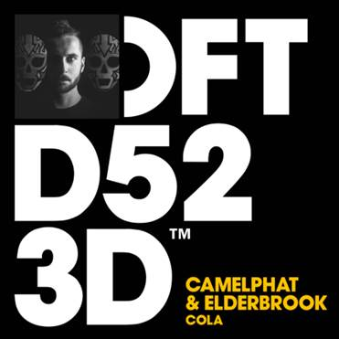

**TRACK HIGHLIGHTS:**

*“‘Cola’ is one of this year's stealthiest and most vital dance records… once an ‘ooh-ooh’ melodic motif drifts in from above it sticks like pop.*”

*--* [Rolling Stone](http://www.rollingstone.com/music/lists/10-new-artists-you-need-to-know-october-2017-w509627/camelphat-w509887)

*“Camelphat & Elderbook's 'Cola' is an infectious and emotive anthem.”*

*--* [DJ Mag](https://djmag.com/miller/biggest-tracks-ibiza-2017)

*“This one's fire... ‘Cola’ is moody, groovy, infectious and entrancing.”*

*--* [Earmilk](https://earmilk.com/2017/06/09/camelphat-and-elderbrook-debut-a-stunner-in-cola/)

**\*\*\***

Reached #1 on the Billboard Dance Club Songs Chart

28M+ streams to date, growing at 500k+ per week globally

#28 at US Dance Radio & climbing fast

Spinning at iHeart Evolution, SIRIUS Chill & Electric Area, KNHC/Seattle, Music Choice Dance, plus mixshows in New York, San Francisco, San Diego, and more

#3 on Shazam Global Dance | #22 and rising on Shazam Global Top 200

Debuted as Danny Howard’s “Hottest Record in the World”

Included in BBC 1 Radio’s “Hottest Tracks In The World”

“Track of the Season” at Ibiza DJ Awards

Highest selling track on Beatport for all of 2017

#1 on Beatport for over a month | #1 on House chart for 3 months straight

Featured in Rolling Stone’s “[10 New Artists You Need To Know](http://www.rollingstone.com/music/lists/10-new-artists-you-need-to-know-october-2017-w509627/camelphat-w509887)