CLEAN BANDIT X TOPIC UNVEIL ‘DRIVE’ FEATURING WES NELSON
LISTEN HERE

WATCH THE OFFICIAL VIDEO HERE

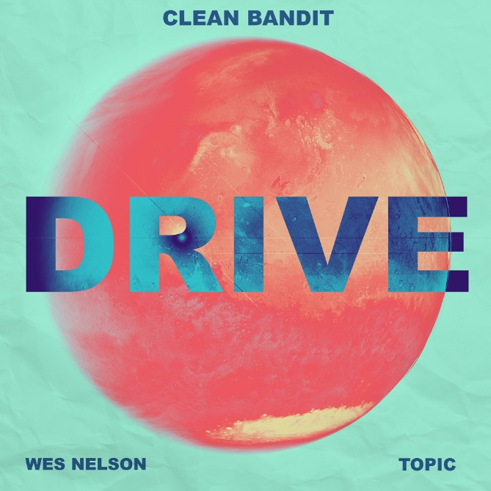
DOWNLOAD ARTWORK HERE

Grammy-winning trio Clean Bandit have teamed up with hitmaking German/Croatian DJ Topic, and gold certified R&B singer Wes Nelson on the atmospheric new single, ‘Drive’.

Over pulsating beats and glossy string flourishes, metaphors of night-time drives and winding roads capture the unpredictable nature of a blossoming romance and the positive energy it can transmit.

Listen here: https://cleanbandit.lnk.to/Drive
Watch lyric here: https://www.youtube.com/watch?v=FLhWj_pIk5g

With a staggering 49M monthly Spotify listeners between them, the idea of collaborating came after Topic joined Clean Bandit as a special guest during their 12-hour live ‘House Party Against Hunger’ DJ stream with Global Citizen. Having worked with Wes previously, the visionary trio knew his voice was perfect for the track.

Clean Bandit is: Grace Chatto, Jack Patterson and Luke Patterson.

About Clean Bandit
Clean Bandit have remained one of pop’s most essential and dynamic forces ever since the release of their 2014, GRAMMY-winning breakout single ‘Rather Be’ feat. Jess Glynne. With classical and electronic elements at the heart of their music - Grace, a classically-trained cellist, Jack, a producer and multi-instrumentalist, and Luke, a drummer/remixer, - their unique methods of both production and collaboration have seen Bandit pioneer their very own pop blueprint.

Meeting at university where the band curated and DJ’d at their very own club night (a night that saw Joy Orbison and James Blake make early appearances), Clean Bandit have continued to tap into their multi-genre approach; one that has seen them collaborate with a raft of superstar names over the course of their two albums: ‘New Eyes’ (2014) and ‘What Is Love?’ (2018). From Lizzo to Demi Lovato to Anne-Marie to Charli XCX, their network knows no bounds and is a testament to a group who possesses an innate ability to fuse electronic, pop, r&b, dancehall and everything in-between – something that has seen them become one of the globe’s highest-streaming acts and equally, one of the most successful British bands of recent years.

A 6 x BRIT-nominated trio whose metrics reside in the multibillions [they have exceeded more than 6.9 million albums, 15.5 billion streams, 12.3M single downloads and 6.6 billion YouTube views], Clean Bandit have scored ten ‘Top 10’ singles in their home market, with four of those songs also reaching No.1 status: ‘Solo’ feat. Demi Lovato; ‘Symphony’ feat. Julia Michaels; ‘Rather Be’ feat. Jess Glynne; and the 2016 UK Christmas No.1 ‘Rockabye’ feat. Anne-Marie and Sean Paul (the latter has now surpassed 1 BILLION streams on Spotify). Additionally, the band’s deeply conceptual, self-directed official music videos have further enhanced the trio’s reputation as a powerful and thoughtful creative force.
Alongside their collective achievements, each member of Clean Bandit can firmly stand behind their own solo merits, too. Jack Patterson - who co-wrote the global smash ‘Señorita’ for Shawn Mendes and Camila Cabello - is a 2 x Ivor Novello winner having received ‘Best Contemporary Song’ and ‘Most Performed Work’ awards in 2016 for his work on ‘Rather Be’. Grace Chatto, who was recently named as one of the ‘100 most influential female songwriters and composers in the UK’ by PRS for Music, has become a staunch voice in support of the Labour party over recent campaigns, while Luke Patterson’s flare for remixing has seen him commissioned to remodel tunes from The Killers to Robin Schulz.

About Topic
Topic has topped various radio, iTunes, and Shazam charts globally, amassing over 1.8 billion combined worldwide streams with his hit single ‘Breaking Me’ (with A7S) alone. He’s furthermore earned certifications in 28 countries around the world, including Platinum status in both the U.K and U.S. Most recently, Topic was announced as a Billboard Music Award 2021 finalist with ‘Breaking Me’ in the category “top dance/electronic song”, and prior, has been nominated for the MTV Europe Music Awards 2016, the Teen Choice Awards 2018 as well as for the biggest radio awards in Spain (Los40), Germany (1 Live Krone), and France (Fun Radio).

About Wes Nelson
23-year-old Staffordshire born Wes Nelson boasts one of 2020’s biggest singles, ‘See Nobody’, a Gold-certified Top 3 hit in the UK and double Platinum in Ireland, it has accumulated over 76 million streams globally, and over 16 million video views. Having garnered support from cultural commentators, musicians and notable fans such as Anthony Joshua, Idris Elba, Stevo The Madman, Chip, Krept & Konan, Headie One, Raheem Sterling, Jae5, Lewis Capaldi and more, Wes’ follow up single, ‘Nice To Meet Ya’, became his second Top 40 hit in the UK, and it is currently enjoying heavy rotation across Europe, peaking at No. 5 in Germany.

Connect with Clean Bandit:
Official | Instagram | Twitter | Facebook | YouTube

For more information, please contact:
Jessica Nall / Jessica.Nall@atlanticrecords.com
Libby Kober / Libby.Kober@atlanticrecords.com

