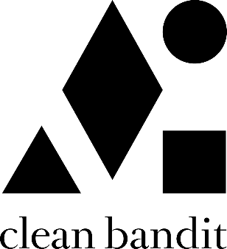

Clean Bandit have remained one of pop’s most essential and dynamic forces ever since the release of their 2014, GRAMMY-winning breakout single “Rather Be” feat. Jess Glynne. With classical and electronic elements at the heart of their music - Grace, a classically-trained cellist, Jack, a producer and multi-instrumentalist, and Luke, a drummer/remixer, - their unique methods of both production and collaboration have seen Bandit pioneer their very own pop blueprint.

Meeting at university where the band curated and DJ’d at their very own club night (a night that saw Joy Orbison and James Blake make early appearances), Clean Bandit have continued to tap into their multi-genre approach; one that has seen them collaborate with a raft of superstar names over the course of their two albums, ‘New Eyes’ (2014) and ‘What Is Love?’ (2018). From Lizzo to Demi Lovato to Anne-Marie to Charli XCX, their network knows no bounds and is a testament to a group who possesses an innate ability to fuse electronic, pop, r&b, dancehall and everything in-between – something that has seen them become one of the globe’s highest-streaming acts and equally, one of the most successful British bands of recent years.

A 6 x BRIT-nominated trio whose metrics reside in the multimillions [they have exceeded more than 40 million singles, 3.3 million albums, 12 billion streams and 5.5 billion YouTube views], Clean Bandit have scored nine Top 10 singles in their home market to date, with four reaching No.1 status: ‘Solo’ feat. Demi Lovato; ‘Symphony’ feat. Julia Michaels; ‘Rather Be’ feat. Jess Glynne; and the 2016 UK Christmas No.1 ‘Rockabye’ feat. Anne-Marie and Sean Paul (the latter recently surpassed 1 BILLION streams on Spotify). Additionally, the band’s deeply conceptual, self-directed official music videos have further enhanced the trio’s reputation as a powerful and thoughtful creative force.

Alongside their collective achievements, each member of Clean Bandit can firmly stand behind their own solo merits, too. Jack Patterson is a 2 x Ivor Novello winner having received ‘Best Contemporary Song’ and ‘Most Performed Work’ awards in 2016 for his work on ‘Rather Be’. Grace Chatto, who was recently named as one of the ‘100 most influential female songwriters and composers in the UK’ by PRS for Music, has become a staunch voice in support of the Labour party over recent campaigns, while Luke Patterson’s flare for remixing has seen him commissioned to remodel tunes from The Killers to Robin Schulz.

