CLEAN BANDIT UNVEILS A NEW VIDEO FOR SINGLE “BABY” FEAT. MARINA AND LUIS FONSI

OFF FORTHCOMING ALBUM ‘WHAT IS LOVE?’ OUT NOVEMBER 30

WATCH/SHARE “BABY” FT MARINA AND LUIS FONSI: https://atlanti.cr/baby-video
BUY/STREAM “BABY” FT MARINA AND LUIS FONSI: https://atlanti.cr/Baby
PREORDER ‘WHAT IS LOVE’: https://atlanti.cr/WhatIsLove

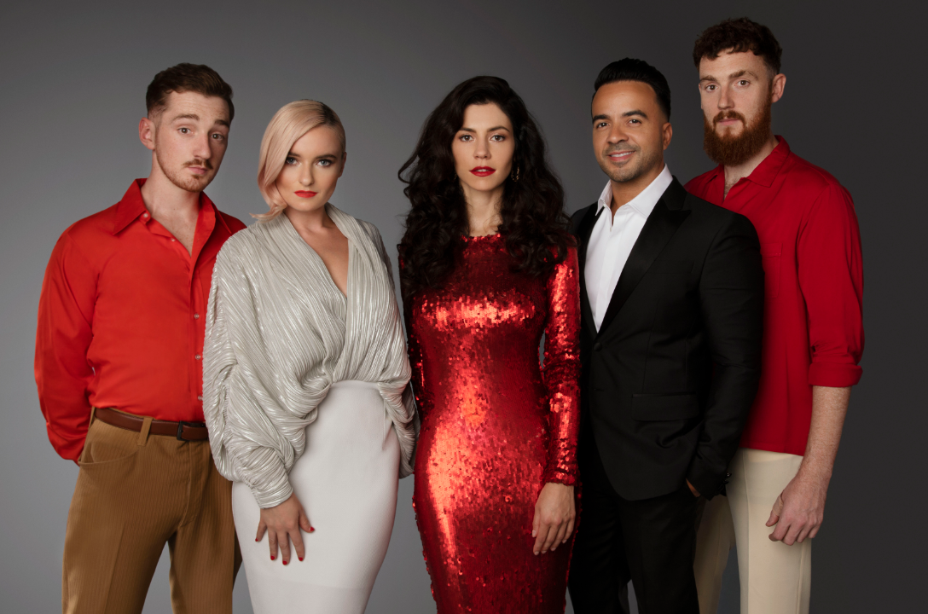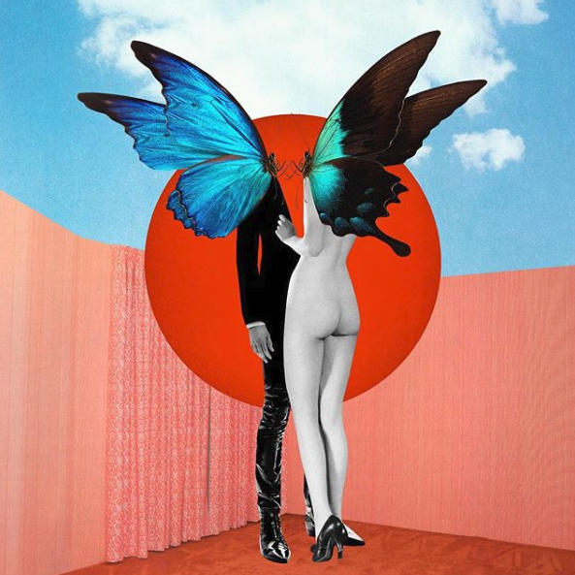

GRAMMY award-winning Clean Bandit unveils a music video for the UK-electronic trio’s brand new single “Baby” feat. Marina and Luis Fonsi - self-produced by the band in Los Angeles, portraying a storyline of lost love. “Baby” follows Clean Bandit’s 4.5 million-selling and fourth UK No.1, “Solo”. The Cuban-influenced, dancefloor-filling new single also marks the second collaboration with Marina (previously releasing “Disconnect” that set the internet alight last summer after its live debut at Coachella) and first musical release with Luis Fonsi – WATCH HERE!

Clean Bandit’s new album ‘What Is Love?’ will arrive on November 30th and is available for pre-order now! The follow-up to the band’s two million-selling and UK Top 3 debut album, ‘New Eyes’, released in 2014, ‘What Is Love?’ is a home to Clean Bandit’s inventive, eclectic multi-genre catalogue – a collection of gigantic, upbeat mega-bops married with emotive lyricism. A band that thrive on being true collaborators, Clean Bandit have enlisted another extensive cast of blockbuster vocalists this time around, with Zara Larsson, Marina, Luis Fonsi, Demi Lovato, Sean Paul, Anne-Marie, Ellie Goulding, KYLE, Big Boi, Tove Styrke, Stefflon Don, Craig David, Kirsten Joy, Rita Ora, Julia Michaels and ALMA all featuring. The deluxe edition will also feature Yasmin Green, Charli XCX, Bhad Bhabie, DaVido, Love Ssega and Louisa Johnson.

Clean Bandit ‘What Is Love?’ track listing
- Symphony (feat. Zara Larsson)
- Baby (feat. Marina & Luis Fonsi)
- Solo (feat. Demi Lovato)
- Rockabye (feat. Sean Paul & Anne-Marie)
- Mama (feat. Ellie Goulding)
- Should’ve Known Better (feat. Anne-Marie)
- Out at Night (feat. KYLE & Big Boi)
- Last Goodbye (feat. Tove Styrke & Stefflon Don)
- We Were Just Kids (feat. Craig David & Kirsten Joy)
- Nowhere (feat. Rita Ora & KYLE)
- I Miss You (feat. Julia Michaels)
- In Us I Believe (feat. ALMA)
Deluxe
- 24 Hours (feat. Yasmin Green)
- Playboy Style (feat. Charli XCX & Bhad Bhabie)
- Beautiful (feat. DaVido & Love Ssega)
- Tears (feat. Louisa Johnson)

(photo credit Lloyd Pursall- download hi-res here)

Connect with Clean Bandit:
Twitter | Facebook | Instagram | YouTube
For more information, visit: http://cleanbandit.co.uk/
For press assets, visit: http://press.wearebigbeat.com/artists/cleanbandit/

Clean Bandit Press Contact:
Jordan Danielle Frazes
Head of Publicity, Big Beat Records
Jordan.Frazes@atlanticrecords.com

Marina & The Diamonds Press Contact:
Christina Kotsamanidis
VP Publicity, Atlantic Records
Christina.Kotsamanidis@atlanticrecords.com

