Cash Cash & ROZES
team up for new collaborative single
“Matches”
+ Catch Cash Cash On Tour This Spring

“Matches”
LISTEN/POST: https://youtu.be/O33x3EyUbpc
STREAM/BUY: https://BigBeat.lnk.to/matchesPR

"...a pulsating, aching jam..." – Billboard

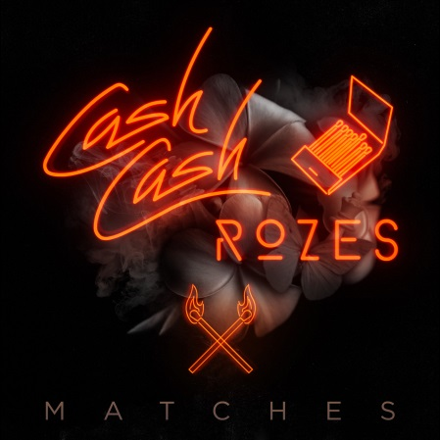

Globally-celebrated electronic DJ/producer/multi-instrumentalists Cash Cash have teamed up with Philadelphia songwriter and powerhouse vocalist ROZES for a new joint single “Matches,” officially out today via Big Beat Records – LISTEN HERE.

Cash Cash and ROZES together create a soon-to-be chart-topping monster. With ROZES’ sultry topline the perfect complement to Cash Cash’s signature production, “Matches” is destined to send dancefloors into a frenzy across the globe.

Cash Cash is hot off commencing a new residency at MGM Grand nightclub HAKKASAN, alongside Tiesto, Calvin Harris, Steve Aoki, Zedd and Kaskade. The trio is also currently touring in support of their massive debut album, 2016’s Blood, Sweat & 3 Years. The tour continues through most of March and April, so don’t miss out if they’re heading to a town near you!

“Our new song “Matches” evokes an emotion we’ve all felt before and ROZES has one of those voices that makes you feel every single word. We know listeners will feel some nostalgia when they listen to it whether it’s an old high school crush or past relationship…Our favorite thing about “Matches” is that the lyrics have this hurting sadness to them but the music is the complete opposite being uplifting and bright. We think that made for a really unique collaboration that leaves the listener with the sense that even when you’re broken and burned, you can still feel positive energy again if you let it back into your life.””—Cash Cash

“My best friend and I happened to have our hearts broken around the same time back in High School, and sometimes we talk about how crazy it is that, back then, we thought we were losing our whole world by losing that one person. I wanted to put myself back into those emotions and talk about those memories. It’s always been so intriguing to me that just a simple photograph, song, or smell can pull our minds back to those certain people, and even when you’re not speaking to them, they have the ability to cause you (unknown) pain. I often wonder if other people have those times where they’re pulled back to me; if for someone else, I am that pain...These memories don’t mean you miss that certain person, and it doesn’t mean you still love them, it just simply means you remember them and the way they made you feel.” -- ROZES

##

More on CASH CASH:
Cash Cash is an electronic music trio originally hailing from New Jersey, which consists of brothers Jean Paul Makhlouf and Alex Makhlouf, and life-long friend Samuel Frisch. Together, the three record, mix and master all of their music. The trio has released four full-length albums, an array of EPs and singles, and have found success producing and co-writing official remixes for major artists such as Katy Perry, Bruno Mars, Britney Spears, Kelly Clarkson, Krewella, David Guetta, Hardwell and many others. Cash Cash has amassed over one million career track sales, 270 million career track streams, and a nearly platinum hit “Take Me Home” featuring Bebe Rexha. Their latest full length album “Blood, Sweat & 3 Years,” landed at #1 on the iTunes Dance Chart opening week. Cash Cash also recently launched their Cash Cash Radio Show on the SiriusXM BPM channel.

Cash Cash tour dates:
February 28 – Las Vegas, NV @ Omnia Nightclub
March 11 – Las Vegas, NV @ Jewel Nightclub
March 15 – Chicago, IL @ Lectric Leprechaun
March 20 – Las Vegas, NV @ Jewel Nightclub
March 24 – Los Angeles, CA @ Avalon
March 25 – Park City, UT @ Park City Live
March 26 – Las Vegas, NV @ Wet Republic Ultra Pool
March 31 – Las Vegas, NV @ Hakkasan
April 7 – Las Vegas, NV @ Omnia Nightclub
April 14 – Las Vegas, NV @ Hakkasan
April 21 – Kansas City, MO @ Mosaic
April 22 – San Diego, CA @ Life in Color (Valley View Casino Center)
April 27 – Las Vegas, NV @ Hakkasan
April 28 – Chicago, IL @ Prysm Nightclub
May 19 – Gulf Shores, AL @ Hangout Festival
June 2 – Las Vegas, NV @ Hakkasan

Connect with Cash Cash:
http://cashcashmusic.com
https://twitter.com/cashcash
https://soundcloud.com/cashcash
https://www.facebook.com/cashcash

More on ROZES:

ROZES has become the in-demand topline singer in the recent past, after lending her distinct, genre-blending vocals to The Chainsmokers’ smash “Roses,” Big Gigantic's "All of Me,” and Louis Fulton's "Wasted on You", which have racked up almost half a BILLION combined streams. But, ROZES/Liz is more than an EDM topline. She's a force, lyrical genius and pristine vocalist.

ROZES tour dates:
March 9 – Philadelphia, PA @ The Foundry
April 11 – Boston, MA @ Middle East
April 18 – Vienna, VA @ Jammin Java
April 29 – Brooklyn, NY @ Knitting Factory
TBA – Austin, TX @ SXSW

Connect with ROZES:
http://rozessounds.com
https://twitter.com/ROZESsounds
https://soundcloud.com/rozessounds
https://www.facebook.com/ROZESsounds

##

For more information on CASH CASH please contact:

Jordan Danielle Frazes
Head of Publicity, Big Beat Records
Jordan.Frazes@atlanticrecords.com

Ted Sullivan
Tour publicist
Ted.Sullivan@atlanticrecords.com

For more information on ROZES please contact:

Stacie Sater
stacie@sas-entertainment.com

