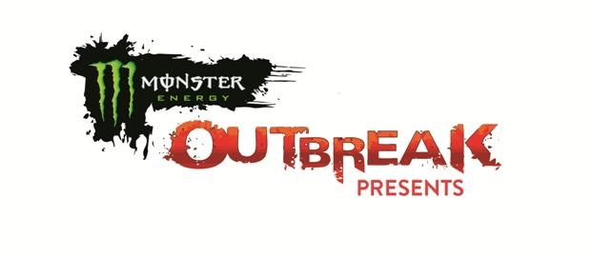
Monster Energy & Outbreak Presents:

CASH CASH
“MUST BE THE MONEY"
LARGEST EVER HEADLINING TOUR

TO KICK OFF OCTOBER 1 IN LAS VEGAS, NV AND WRAP UP ON NEW YEAR’S EVE IN SAN FRANCISCO, CA

TICKETS ONSALE FRIDAY: http://mustbethe.money/

DEBUT ALBUM BLOOD, SWEAT & 3 YEARS OUT NOW

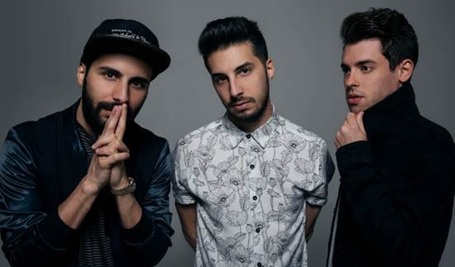

WATCH “Millionaire” ft. Nelly: http://smarturl.it/FeelLikeAMillionaire
BUY/STREAM Blood, Sweat & 3 Years: http://smarturl.it/BloodSweat3Years

Dance music trio Cash Cash (from left to right: Jean-Paul Makhlouf, Alex Makhlouf, and Sam Frisch) have announced their “Must Be The Money” tour presented by Monster Energy and Outbreak Presents, in support of smash debut album Blood, Sweat & 3 Years (out now via Big Beat Records). The album landed at #1 on the iTunes Dance Chart opening week, and current single “Millionaire” feat. Nelly has been exploding at Top 40 radio. Blood, Sweat & 3 Years also includes 2014’s worldwide platinum selling hit “Take Me Home” (feat. Bebe Rexha), “Surrender” (their second #1 song on dance radio) & additional guest vocal features from Busta Rhymes, Christina Perri, B.o.B, Jacquie Lee, Trinidad James, John Rzeznik & more.

Their Marquee Las Vegas residency and “Make That Cash Cash” sets have received rave reviews & guest appearances have included French Montana, Wiz Khalifa, Lil Dicky & Rae Sremmurd. The guys also recently released an official remix of Britney Spears’ latest single “Make Me…” (feat. G-Eazy).

“We’re gonna be so hyper from all the Monster Energy we guzzle on this tour that you can definitely expect something wild to go down. We also can’t wait for everyone to hear all the fresh stuff we do live with new songs off our album ‘Blood, Sweat & 3 Years.’ Come feel like a MILLIONAIRE with us and let’s make some life long memories on the ‘Must Be The Money Tour’ this fall!” – Cash Cash

“To our big hearted, fantastic dancing and fashionable friends: Join us on our sixth and final tour of the year. There will be adventure, vibes and plenty of Cash Cash. We’re impatient for you to experience some.” - Steven Ljubicic (tour producer)

MONSTER ENERGY & OUTBREAK PRESENTS:
CASH CASH “MUST BE THE MONEY" TOUR
October 1 – Las Vegas, NV @ Marquee Nightclub
October 7 – Montville, CT @ Avalon Nightclub
October 8 – Las Vegas, NV @ Marquee Dayclub
October 10 – Las Vegas, NV @ Marquee Nightclub
October 11 – Pullman, WA @ Washington State University
October 15 – Las Vegas, NV @ Marquee Dayclub
October 20 – Phoenix, AZ @ Veterans Memorial Coliseum
October 22 – Atlantic City, NJ @ Premier Nightclub at The Borgota
October 27 – Cleveland, OH @ Liquid
October 28 – Las Vegas, NV @ Marquee Nightclub
November 3 – Monster Energy UP & UP Festival @ TBD
November 7 – Las Vegas, NV @ Marquee Nightclub
November 12 – Los Angeles, CA @ Henry Fonda Theatre
November 16 – Bloomington, IN @ Kilroy’s at Dunnkirk
November 17 – Urbana, IL @ Canopy Club
November 18 – Chicago, IL @ Concord Music Hall
November 19 – Las Vegas, NV @ Marquee Nightclub
November 23 – Detroit, MI @ The Annex
November 25 – New York, NY @ Space Ibiza NY
November 26 – Memphis, TN @ New Daisy Theatre
December 2 – Calgary, AB @ Marquee Beer Market & Stage
December 3 – Edmonton, AB @ Union Hall
December 8 – Miami, FL @ LIV
December 9 – Las Vegas, NV @ Marquee Nightclub
December 10 – Washington, DC @ Echostage
December 15 – Sacramento, CA @ District 30
December 16 – Seattle, WA @ Showbox SoDo
December 23 – Las Vegas, NV @ Marquee Nightclub
December 26 – Atlantic City, NJ @ Premier Nightclub at The Borgata
December 29 – Dallas, TX @ Stereo Live Dallas
December 30 – Houston, TX @ Stereo Live
December 31 – San Francisco, CA @ Ruby Skye

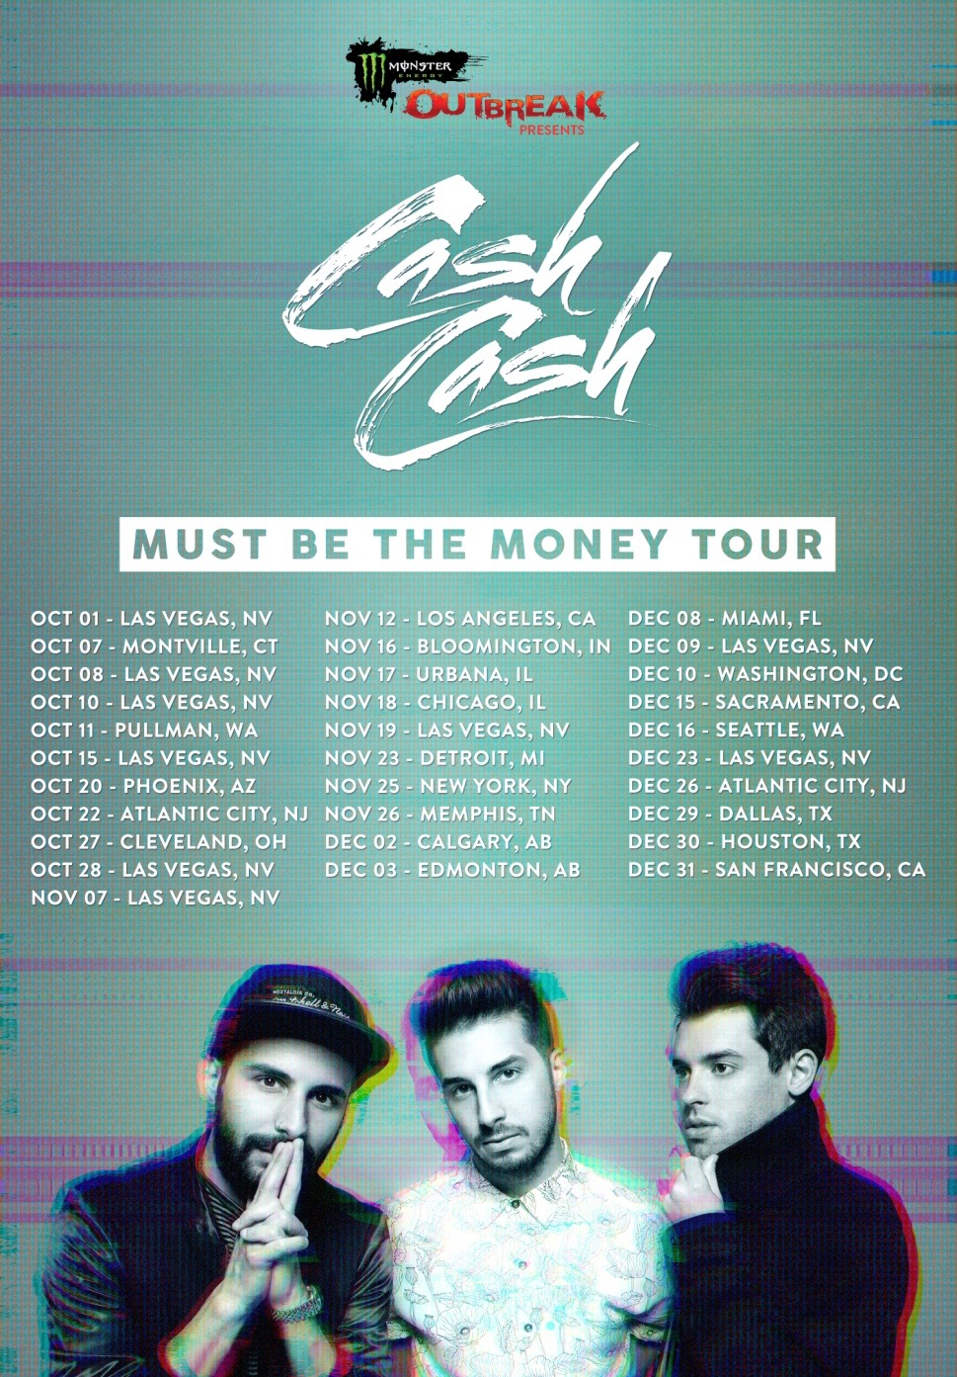

Connect:
http://cashcashmusic.com
https://twitter.com/cashcash
https://soundcloud.com/cashcash
https://www.facebook.com/cashcash

Press tools:
http://press.wearebigbeat.com/artists/cashcash/

About Outbreak Presents:
Launched in February 2011 and continuing to grow each year since, Outbreak Presents features the biggest breakthrough artists of the year across various genres of music and entertainment – Hip Hop * Rock * EDM * Country * College * Comedy * SXSW. Outbreak Presents past headliners include Kendrick Lamar, Macklemore, Iggy Azalea, The Chainsmokers, Cole Swindell, Garfunkel and Oates, Bullet For My Valentine, Fetty Wap and Andrew Dice Clay. Pairing these emerging artists with fan friendly ticket prices at premium venues, Outbreak Presents is recognized as the ultimate tastemaker–helping fans DISCOVER WHAT’S NEXT. For more information about Monster Energy and Outbreak Presents, visit: https://www.youtube.com/c/OutbreakTV1, https://www.facebook.com/OutbreakPresents/,
https://twitter.com/OutbreakPresnts and https://www.instagram.com/outbreakpresents/.

About Monster Energy:
Most companies spend their money on ad agencies, TV commercials, radio spots and billboards to tell you how good their products are. At Monster Energy, we chose none of the above. Instead we support the scene, our comedians, our athletes and our fans. We back athletes so they can make a career out of their passion. We promote concert tours, so our favorite bands can visit your hometown. We celebrate with our fans and riders by throwing parties and making the coolest events we can think of a reality. For more information, visit: www.monsterenergy.com and www.facebook.com/monsterenergy.

###

For more information on Cash Cash:

Jordan Danielle Frazes
Head of Publicity
Big Beat Records
Jordan.Frazes@atlanticrecords.com

Ted Sullivan
Tour Publicity
Ted.Sullivan@atlanticrecords.com

For more information on Monster Energy & Outbreak Presents:

Libby Coffey
MSO PR
LCoffey@msopr.com
818-380-0400 x224

