ACCLAIMED DJ/PRODUCER TRIO CASH CASH RELEASE NEW SINGLE & OFFICIAL LYRIC VIDEO –
“ALL MY LOVE” FT. UK ARTIST CONOR MAYNARD

WATCH/POST VISUALIZER: HERE
BUY/STREAM: HERE

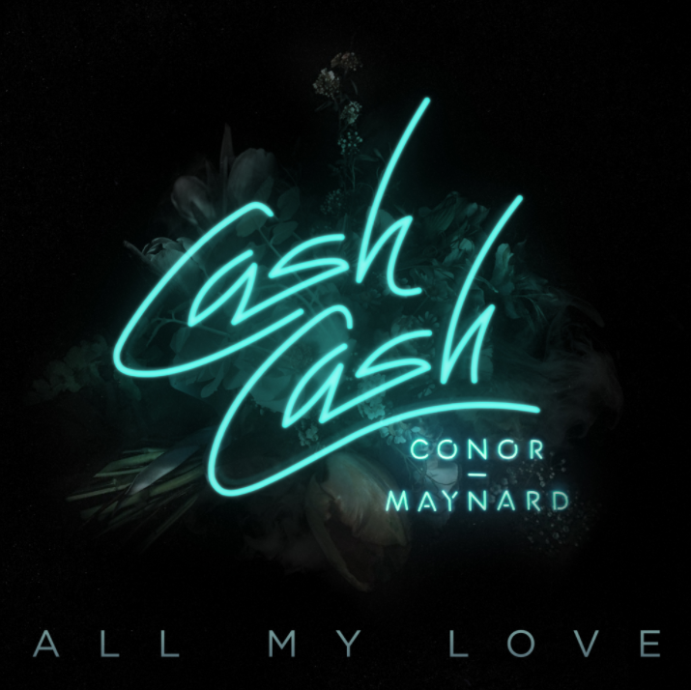

Fresh off the heels of their recent single “Matches” with female vocalist ROZES (which reached #1 on Dance Radio) globally celebrated DJ/producer/multi-instrumentalist trio Cash Cash returns with another stellar collaboration by way of “All My Love,” featuring UK singer-songwriter Conor Maynard. Released alongside an official lyric video – WATCH HERE – the track is out today via Big Beat Records.

“All My Love” hears Maynard’s vocals effortlessly rise and fall over a pulsating beat, building up to a characteristically dancefloor-friendly Cash Cash drop. Meanwhile, the kaleidoscopic visualizer perfectly mirrors both the track’s frenetic and racing synths, as well as the emotion-filled lyrics delivered by Maynard.

After first being recognized for his YouTube cover performances, Maynard beat out Lana Del Rey, Delilah, and more to earn the title of MTV UK’s “Brand New for 2012,” winning nearly half of all fan votes. Later that year, at just 19, Maynard released his debut LP “Contrast.” Earlier this year, he appeared alongside Ty Dolla $ign on Kriss Kross Amsterdam’s streaming favorite “Are You Sure?”

For Cash Cash (comprised of Sam Frisch and brothers JP and Alex Makhlouf), working with Maynard came quite easily:

“Making ‘All My Love’ with Conor was a very natural collaboration,” they explain. “He’s one of those singers that can just throw it down the first time and make it sound finished…so we knew it would come together easy. We attached the production with a hyped energetic feel to give some contrast to the lyrics and we’re very pleased with the way they complimented each other. The emotion in his voice really brought out the concept of the song and gave us chills when we first listened back.”

Maynard had a similar experience working with the trio on the track:

"When I first heard the song, I instantly knew it was something I wanted to be a part of. The Cash Cash guys absolutely killed it with the production - I remember playing it to my friends in the car for the first time and they didn't tell me to turn it off after the first ten seconds, which is always a great sign...haha. I'm excited for this song - so happy it's finally being released."

Cash Cash is no stranger to success when it comes to collaborating with vocalists. In addition to reaching #1 on Dance Radio with “Matches” featuring Philadelphia native ROZES, their smash hit “Take Me Home” ft. Bebe Rexha recently achieved RIAA platinum certification.

With a massive debut album (2016’s Blood, Sweat & 3 Years), nearly half a billion overall streams, residencies at Las Vegas’ iconic MGM Grand nightclub HAKKASAN and Atlantic City’s Premier, and a summer filled with festival dates (including the Billboard Hot 100 Fest and Made In America), Cash Cash continue to prove themselves as a force to be reckoned with in the world of dance music.

Upcoming Tour Dates:

07.08.2017 @ Jewel Nightclub – Las Vegas, NV
07.11.2017 @ Omnia – Las Vegas, NV
07.14.2017 @ Hakkasan – Las Vegas, NV
07.20.2017 @ Hakkasan – Las Vegas, NV
07.21.2017 @ Mosaic – Kansas City, MO
07.22.2017 @ E11EVEN – Miami, FL
07.30.2017 @ Wet Republic – Las Vegas, NV
08.01.2017 @ Omnia – Las Vegas, NV
08.19.2017 @ Premier Nightclub – Atlantic City, NJ
08.20.2017 @ Billboard Hot 100 Music Festival – Jones Beach (Wantagh, NY)
08.31.2017 @ Hakkasan – Las Vegas, NV
09.01.2017 @ Metropolitan Nightclub – New Orleans, LA
09.02.2017 @ Made in America – Philadelphia, PA
09.03.2017 @ Bumbershoot Festival – Seattle, WA
09.22.2017 @ Royale – Boston, MA
10.21.2017 @ Premier Nightclub – Atlantic City, NJ
10.31.2017 @ Necto – Ann Arbor, MI
12.30.2017 @ Gold Room – Atlanta, GA
12.31.2017 @ Gilt – Orlando, FL

###

MORE ON CASH CASH:

Cash Cash is an electronic music trio originally hailing from New Jersey, which consists of brothers Jean Paul Makhlouf and Alex Makhlouf, and life-long friend Samuel Frisch. Together, the three record, mix and master all of their music. The trio has released four full-length albums, an array of EPs and singles, and have found success producing and co-writing official remixes for major artists such as Katy Perry, Bruno Mars, Britney Spears, Kelly Clarkson, Krewella, David Guetta, Hardwell and many others. Cash Cash has amassed over one million career track sales, nearly 500 million career track streams, and a RIAA certified platinum hit in “Take Me Home” featuring Bebe Rexha. Their latest full length album “Blood, Sweat & 3 Years,” landed at #1 on the iTunes Dance Chart opening week. Cash Cash also recently launched their Cash Cash Radio Show on the SiriusXM BPM channel.

Connect with Cash Cash:
http://cashcashmusic.com
https://twitter.com/cashcash
https://soundcloud.com/cashcash
https://www.facebook.com/cashcash
Press Assets: http://press.wearebigbeat.com/artists/cashcash/

For press inquiries:
Jordan Danielle Frazes
Head of Publicity, Big Beat Records
Jordan.Frazes@atlanticrecords.com

Catherine Corkery
Tour/Online, Big Beat Records
Catherine.Corkery@atlanticrecords.com

