Cash Cash Drop “Aftershock” (feat. Jacquie Lee) via Big Beat!

LISTEN/POST: LINK
Buy via iTunes + Stream it via Spotify

“Perfect for an arena”—Dancing Astronaut

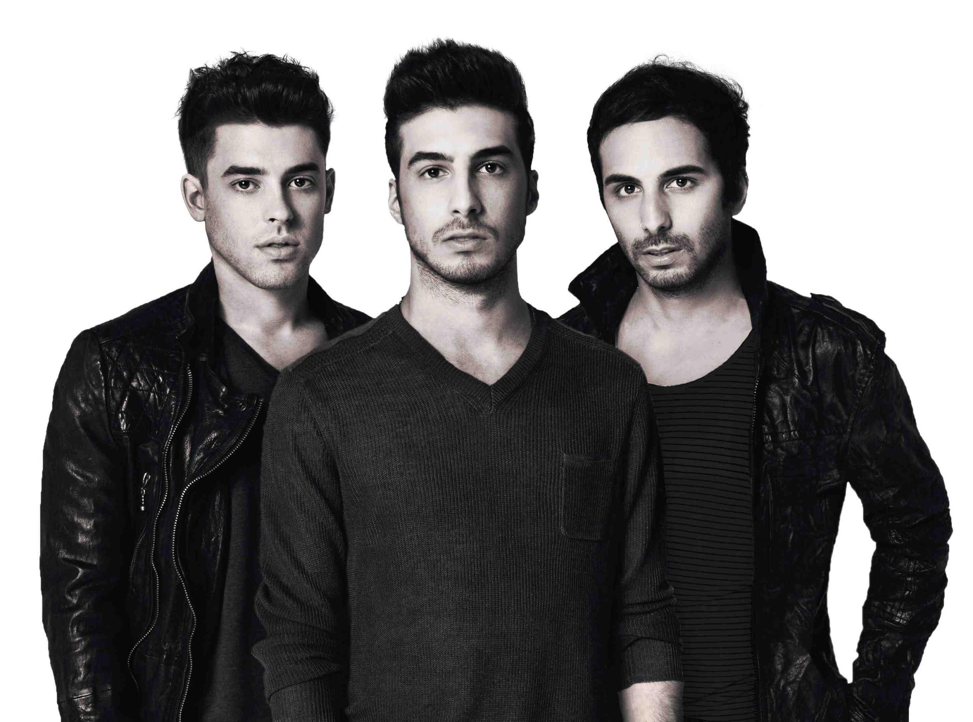

Acclaimed electronic trio Cash Cash is kicking 2016 off in a big way, with the release of their new single “Aftershock,” featuring seductive, honey-tinged vocals from Jacquie Lee -- officially available via Big Beat Records through all digital retailers today, following Dancing Astronaut’s streaming premiere yesterday.

Cash Cash has become synonymous with hard-hitting production, vibrant remixes and their energetic live DJ sets, having rocked festival main stages and clubs across the globe. The trio emerged from the start with global recognition and support from renowned DJs and peers, including Tiesto, Hardwell, Zedd, Nicky Romero, captivating dance music fans, insiders and friends along the way.

“Aftershock” follows hit after hit from Cash Cash, including “Take Me Home” (featuring Bebe Rexha), which has gathered over 50 million Spotify streams, over 20 million YouTube views, and Gold certification in the United States. “Surrender” was the trio’s second #1 song on dance radio, and 2015 also saw the release of their infectious singles “Devil,” which features Busta Rhymes, B.o.B. and Neon Hitch (stream) and “Escarole” (stream). Cash Cash has also eclipsed 129.15 Million spins and counting to date on Pandora.

CASH CASH Tour Dates
Jan. 29 – Mosaic – Kansas City, MO
Jan. 30 – Marquee Nightclub – Las Vegas, NV
Feb. 06 - Marquee NY - New York, NY
Feb. 11 - Heat Ultra Lounge - Anaheim, CA
Feb. 12 - Ruby Skye - San Francisco, CA
Feb. 13 – Marquee Nightclub – Las Vegas, NV
Feb. 20 – Mur.mur, Atlantic City, NJ
Mar. 11 - Inception at Sea! - Miami, FL
Mar. 14 – Marquee Nightclub – Las Vegas, NV
Mar. 15 – SWAT Spring Break 2016 - Lake Havasu, AZ
Mar. 31 – Omnia SD – San Diego, CA

Connect w/ CASH CASH
http://cashcashmusic.com
https://twitter.com/cashcash
https://soundcloud.com/cashcash
https://www.facebook.com/cashcash
http://press.wearebigbeat.com/artists/cashcash/

Contact // CASH CASH
Jordan Frazes, Publicity Director: Jordan.Frazes@atlanticrecords.com
Ted Sullivan, Tour Publicist: Ted.Sullivan@atlanticrecords.com

