FOR IMMEDIATE RELEASE

October 10th, 2019



**MATOMA AND TWO FRIENDS WELCOME YOU TO CAMP SUPERDOPE!**

**MATOMA AND TWO FRIENDS JOIN FORCES FOR EXTENSIVE NORTH AMERICAN CO-HEADLINE TOUR**

**PRE-SALE REGISTRATION NOW AVAILABLE** [**HERE**](http://www.campsuperdope.com)

**TICKETS ON-SALE FRIDAY OCTOBER 18TH AT 10AM PST**

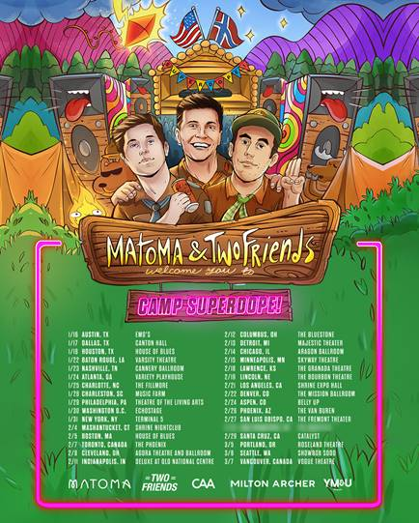

[DOWNLOAD ADMAT](https://warnermusicgroup.box.com/s/9g3hy9a7oas5g1s625ajlrt9i4j2iqf2)

Global superstar producer/DJ **Matoma** and dance-pop duo **Two Friends** have teamed up for their star-powered North American co-headline tour – ‘**CAMP SUPERDOPE!**’ The extensive trek kicks off January 16th in Austin, TX and stops in major markets including New York, Nashville, Los Angeles, and more.

Pre-sale registration for the 2020 headline tour is available now, which gives fans the chance to win exclusive, super dope prizes. Official pre-sales begin Wednesday, October 16th at 10am PST and general on-sale begins Friday, October 18th at 10am PST. For pre-sale registration, tickets, and more information, please visit: [www.campsuperdope.com](https://nam04.safelinks.protection.outlook.com/?url=http%3A%2F%2Fwww.campsuperdope.com&data=02%7C01%7CJessica.Nall%40atlanticrecords.com%7C320da72b59f74caf7c5c08d74cdc01a4%7C8367939002ec4ba1ad3d69da3fdd637e%7C0%7C0%7C637062380109186514&sdata=l9z9xPhFXJ%2BMVQvzgmEKHwwtTVW%2FejvGLP4K2R3WvxM%3D&reserved=0)

**ABOUT MATOMA:**

Since making his debut in 2015, **Matoma** has joined the ranks of electronic’s most popular and innovative new stars, prompting Rolling Stone to declare him the “leader of tropical house’s next big wave.” Born Tom Lagergren, **Matoma** scored a breakout success in 2015 with his RIAA gold-certified single, Matoma & The Notorious B.I.G.’s “Old Thing Back (Feat. Ja Rule & Ralph Trevsant),” featured on the groundbreaking 2015 debut album project, “HAKUNA MATOMA.” Since then, Matoma has made waves with life-affirming originals (including the smash “[Running Out](https://www.youtube.com/watch?v=Cm29IRFf6aU)”) alongside cross-genre collaborations with the likes of **Jason Derulo, Jennifer Lopez, Dua Lipa** and **The Vamps** as well a dazzling array of remixes for artists as varied as **Coldplay, One Direction, Snoop Dogg, Eminem**, and **Sean Paul**, among others.

**Matoma’s** journey reached a landmark moment with the release of last year’s acclaimed debut album, [ONE IN A MILLION](https://bigbeat.lnk.to/1IAM), which has garnered over 1 billion streams worldwide. Hailed by [Billboard](https://www.billboard.com/articles/news/dance/8472060/matoma-one-in-a-million-album-breakdown) as “a fresh collection of varied dance-pop compositions…heavy with feels from start to finish… (and) poised for pop-crossover success with some stirringly emotional moments and dance floor feelings,” the album includes a quartet of worldwide hit singles, including “[**False Alarm (Feat. Becky Hill)**](https://www.youtube.com/watch?v=-DFApjlqANs)**,” “**[**Lonely (Feat. MAX)**](https://bigbeat.lnk.to/LonelyAY)**,” “**[**Slow (Feat. Noah Cyrus)**](https://bigbeat.lnk.to/SlowID)**”** and “[**All Night (Feat. The Vamps)**](https://www.youtube.com/watch?v=BqaoAQbkeXo)**,**” all of which have now amassed over a billion total streams and counting.

**ABOUT TWO FRIENDS**

Matt Halper and Eli Sones, the young masterminds behind Two Friends, have quickly grown from high school bedroom producers to one of the most promising dance-pop acts of 2019. Known for their viral remixes of classics such as “Mr. Brightside” and "I Miss You", the millions of streams on their "Best Of Soundcloud" award-winning Big Bootie Mixes, and their recent original offerings such as "Dollar Menu", "Take It Off" and "Emily", the two have mastered a wide range of genres, from pop-leaning to more dance-driven records. Kicking off their musical journey during their senior year of high school in 2011, Matt & Eli's influence quickly spread beyond the online sphere, attracting the spotlight on radio and stages across the country. Drawing upon a wide variety of live instrumentation to create a truly multi-faceted sound with every release, they continue to prove & push their versatile songwriting and production as far as it can go. After selling out another hard-ticket tour in early 2019 at venues including Washington DC's Echostage, LA's Fonda Theatre, Chicago's Concord Music Hall, two shows at NYC's Irving Plaza, and several more, the boys show no signs of slowing down.

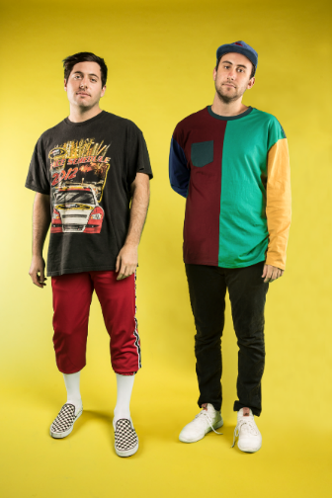 

[**DOWNLOAD MATOMA PRESS PHOTO**](https://nam04.safelinks.protection.outlook.com/?url=https%3A%2F%2Fwarnermusicgroup.box.com%2Fs%2Fkjq48iiqbkrc84sanuumcp52ygt6llg1&data=02%7C01%7CJessica.Nall%40atlanticrecords.com%7C87b2526b77d540645c4708d724ca8813%7C8367939002ec4ba1ad3d69da3fdd637e%7C0%7C0%7C637018324608956201&sdata=WGZOXcFGCbLO6g1ZAKZwPBkgtCJ3jzNflkwd0LS9vQw%3D&reserved=0)

**[DOWNLOAD TWO FRIENDS PRESS PHOTO](https://warnermusicgroup.box.com/s/y890e2lvk10arn3j0n6prpfkit1mbhio)**

**CAMP SUPERDOPE! TOUR DATES**

For tickets & more information, please visit:

[www.campsuperdope.com](https://nam04.safelinks.protection.outlook.com/?url=http%3A%2F%2Fwww.campsuperdope.com&data=02%7C01%7CJessica.Nall%40atlanticrecords.com%7C320da72b59f74caf7c5c08d74cdc01a4%7C8367939002ec4ba1ad3d69da3fdd637e%7C0%7C0%7C637062380109186514&sdata=l9z9xPhFXJ%2BMVQvzgmEKHwwtTVW%2FejvGLP4K2R3WvxM%3D&reserved=0)

JANUARY

16 – Austin, TX – Emo’s

17 – Dallas, TX – Canton Hall

18 – Houston, TX – House of Blues

22 – Baton Rouge, LA – Varsity Theatre

23 – Nashville, TN – Cannery Ballroom

24 – Atlanta, GA – Variety Playhouse

25 – Charlotte, NC – The Fillmore

28 – Charleston, SC – Music Farm

29 – Philadelphia, PA – Theatre of The Living Arts

30 – Washington, DC – Echostage

31 – New York, NY – Terminal 5

FEBRUARY

4 – Mashantucket, CT – Shrine Nightclub

5 – Boston, MA – House of Blues

7 – Toronto, Ontario – The Phoenix

8 – Cleveland, OH – Agora Theatre and Ballroom

11 – Indianapolis, IN – Deluxe at Old National Centre

12 – Columbus, OH – The Bluestone

13 – Detroit, MI – Majestic Theater

14 – Chicago, IL – Aragon Ballroom

15 – Minneapolis, MN – Skyway Theatre

18 – Lawrence, KS – The Granada Theatre

19 – Lincoln, NE – The Bourbon Theatre

21 – Los Angeles, CA – Shrine Expo Hall

22 – Denver, CO – The Mission Ballroom

24 – Aspen, CO – Belly Up

26 – Phoenix, AZ – The Van Buran

27 – San Luis Obispo – The Fremont Theater

29 – Santa Cruz, CA – Catalyst

MARCH

5 – Portland, OR – Roseland Theatre

6 – Seattle, WA – Showbox SoDo

7 – Vancouver, British Columbia – Vogue Theatre

# # #

**CONNECT WITH MATOMA:**

[Official Website](http://found.ee/matoma) |[Facebook](http://found.ee/matomaFB) |[Twitter](http://found.ee/matomaTW) |YouTube |[Instagram](http://found.ee/matomaIG) | [Spotify](http://found.ee/matomaSP) | [Apple Music](http://found.ee/matomaAM) | [SoundCloud](http://found.ee/matomaSC) |

[Press Assets](https://protect-us.mimecast.com/s/ApuNCkRO7yFmPVg2trNOcG)

**CONNECT WITH TWO FRIENDS:**

[Official Website](http://found.ee/twofriends) |[Facebook](http://found.ee/twofriendsFB) |[Twitter](http://found.ee/twofriendsTW) |[YouTube](http://found.ee/twofriendsYT) |[Instagram](http://found.ee/twofriendsIG) | [Spotify](http://found.ee/twofriendsSP) | [Apple Music](http://found.ee/twofriendsAM) | [SoundCloud](http://found.ee/twofriendsSC) |

**FOR PRESS INQUIRIES, PLEASE CONTACT:**

Jessica Nall –  [Jessica.nall@atlanticrecords.com](mailto:Jessica.nall@atlanticrecords.com)