CAMELPHAT & ELDERBROOK’S GRAMMY NOMINATED “COLA” GETS ROBIN SCHULZ REWORK!

LISTEN/POST REMIX: https://www.youtube.com/watch?v=V0cdFmSCQNo
BUY/STREAM: https://robinschulz.lnk.to/CRSRPR

WATCH/POST OFFICIAL “COLA” MUSIC VIDEO:
https://www.youtube.com/watch?v=LcNXG-6SqWA
(Big Beat Records)

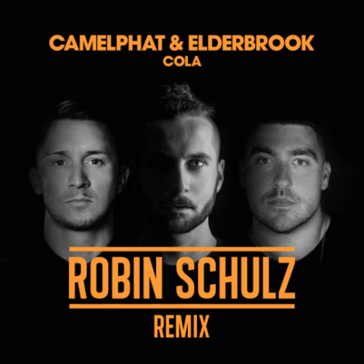

Elderbrook & CamelPhat’s GRAMMY nominated underground club monster, “Cola”, has now received an official rework from multi-platinum, chart-topping German DJ (and fellow past GRAMMY nominee) Robin Schulz, out today via Big Beat/Defected Records. LISTEN HERE: https://www.youtube.com/watch?v=V0cdFmSCQNo

The new Robin Schulz remix comes on the heels of “Cola’s” GRAMMY nomination for “Best Dance Recording,” the first such nomination for British DJ/production duo CamelPhat and singer/co-writer Elderbrook. A track that started this past summer in clubs throughout Europe quickly transcended the genre, reaching #1 on the Billboard Dance Club Songs chart by the Fall and now at #28 and quickly rising up the chart on US Dance Radio.

Earlier this fall, Schulz unveiled his 18-track, third studio album, Uncovered out now on Big Beat Records. The album’s singles include “I Believe I’m Fine” ft. HUGEL, “OK” with James Blunt (over 200 million streams globally), and the smash collaboration with David Guetta and Cheat Codes “Shed A Light” (certified Gold and Platinum in several countries, now with over 300 million global streams). One day after the release of Uncovered, Schulz kicked off an extensive world tour including stops in Europe, Asia, and the US, with two shows in Brazil in the new year. Less than three years in the making, Schulz ranks among the most sought after acts on the globe, as well as one of the most streamed artists worldwide, raking in 3 billion plays and counting, countless #1 hits in over 20 markets, and more than 200 gold and platinum awards.

“COLA” HIGHLIGHTS:

28M+ streams to date, growing at 500k+ per week globally
Spinning at iHeart Evolution, SIRIUS Chill & Electric Area, KNHC/Seattle, Music Choice Dance, plus mixshows in New York, San Francisco, San Diego, and more
#3 on Shazam Global Dance | #22 and rising on Shazam Global Top 200
Debuted as Danny Howard’s “Hottest Record in the World”
Included in BBC 1 Radio’s “Hottest Tracks In The World”
“Track of the Season” at Ibiza DJ Awards
Highest selling track on Beatport for all of 2017
#1 on Beatport for over a month | #1 on House chart for 3 months straight

Featured in Rolling Stone’s “10 New Artists You Need To Know”
“‘Cola’ is one of this year's stealthiest and most vital dance records… once an ‘ooh-ooh’ melodic motif drifts in from above it sticks like pop.”

“Camelphat & Elderbook's 'Cola' is an infectious and emotive anthem.”
-- DJ Mag

“This one's fire... ‘Cola’ is moody, groovy, infectious and entrancing.”
-- Earmilk

ROBIN SCHULZ ON TOUR
Dec 15th – DWP Festival – Jakarta, Indonesia
Dec 17th – EVC – Mumbai, India
Dec 27th – The Night – Rio de Janeiro, Brasil
Dec 29th – Robin Schulz @ Pipa – Praia de Pipa, Brasil
Dec 30th – Sundance Festival – Arraial d’ajuda / BA, Brasil
Dec 31st – NYE Party Praia de Carneiros – Praia de Carneiros, Brasil
Jan 2nd – P12 – Florianópolis / SC, Brasil
Feb 10th – La Solar (Jardín Botánico) – Medellín, Colombia
Feb 12th – Salvadore/Carnival – Brasil

ELDERBROOK ON TOUR
Feb 6th @ Tickle and Slap – Miami, FL
Feb 7th @ Newspeak – Montreal, Canada
Feb 8th @ DC9 – Washington, DC
Feb 9th @ American Beauty Hall – New York, NY
Feb 10th @ Chop Shop – Chicago, IL
Feb 14th @ Larimer Lounge – Denver, CO
Feb 15th @ Popscene – San Francisco, CA
Feb 16th @ Roxy – Los Angeles, CA
Feb 17th @ Bang Bang – San Diego, CA
Feb 18th @ Beta – Denver, CO

CAMELPHAT ON TOUR
Dec 26th – Carnival Arts – London, UK
Dec 31st – Electric Brixton – London, UK
Dec 31st – Code – Sheffield, UK
Jan 1st – Gorilla – Manchester, UK
Jan 6th – Storyland Music Festival – Bello Horizonte Beach, Santa Marta, Colombia
Jan 12th – District8 – Dublin, IE
Jan 13th – Warehouse Elementenstraat – Amsterdam, NL
Jan 20th – The Arch – Brighton, UK
Jan 21st – Pacha Barcelona – Barcelona, ES
Feb 23rd – SWG3 – Glasgow, SE
May 3rd – Annie Mac Presents Lost & Found 2018 – Malta
Jun 25th – Hideout Festival – Zrce Beach, Croatia

##

FOR PRESS INQUIRIES:

Jordan Danielle Frazes
Head of Publicity, Big Beat Records
Jordan.Frazes@atlanticrecords.com

