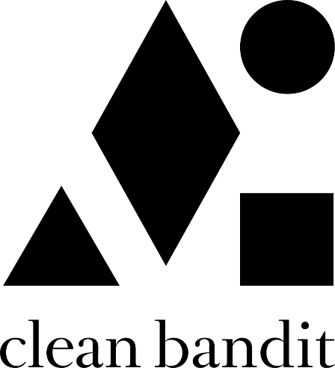

CLEAN BANDIT AND MABEL RELEASE THEIR NEW SINGLE
‘TICK TOCK’ FEAT. 24KGOLDN
(LISTEN HERE)

WATCH CLEAN BANDIT’S COLORFUL, SELF-DIRECTED OFFICIAL VIDEO
STARRING ALL THREE ARTISTS HERE:
https://youtu.be/yC8SPG2LwSA

‘TICK TOCK’ MARKS CLEAN BANDIT’S FIRST SINGLE RELEASE SINCE 2018
HAVING AMASSED OVER 13 BILLION STREAMS & 3.2 MILLION ALBUMS, WORLDWIDE

[DOWNLOAD ART]

Multi-platinum, GRAMMY-winning pop phenomenon’s Clean Bandit and BRIT Award-winning breakthrough star Mabel have today unveiled their mammoth, joint new single ‘Tick Tock’ feat. 24kGoldn (listen here). You can watch the accompanying official video (starring all artists) *HERE*!

Written by Clean Bandit, Mabel and Kamille (Clean Bandit ‘Solo’, Mabel ‘Don’t Call Me Up’), and produced by Grace and Jack of Clean Bandit alongside Mark Ralph (Years & Years, Sigala), ‘Tick Tock’ marks Clean Bandit’s first official release since 2018 and an exciting new chapter for the trio. Teaming-up with their long-time friend, Mabel, and featuring LA-based rapper and XXL 2020 Freshmen Issue cover star, 24kGoldn, Clean Bandit have utilized their pop formula to produce something that’s undeniably infectious and uniquely theirs.

The accompanying official video - which has been solely directed by the band - further reaffirms Bandit as one of pop’s most exciting visionaries. Playing on the song’s narrative of ‘obsession’, the abstract visual transitions through multiple rooms, each filled with the respective band member’s favorite things.

Over the past few months, in-between recording, Clean Bandit have used their vast platform to not only unite their fans from around the world, but to help fundraise amidst the Covid-19 pandemic and nationwide lockdown. Curating live, weekly ’House Party’ club nights on their YouTube channel, the band also joined forces with an array of charities for exclusive performances – most recently, they hosted their own virtual festival in tandem with Global Citizen to help raise awareness for the global hunger crisis. Livestreamed on YouTube for 12 hours and featuring their favourite artists from across the globe (including their ‘Rockabye’ collaborator, Sean Paul), it included a very special back-to-back set from the band and UK No.1 DJ/producer, Joel Corry.

Further activity included a performance for Hospitality for Heroes / International Nurses Day, with the other taking shape as a remodelling of their global hit ‘Symphony’ in aid of Comic Relief / BBC 1’s ‘The Big Night In’: the track featured vocals from UK-based community choirs alongside a host of household names including Zara Larsson (who provided vocals on the original recording), Emeli Sande, Mahalia and Tom Grennan.

Clean Bandit is: Grace Chatto, Jack Patterson and Luke Patterson

ABOUT CLEAN BANDIT
Clean Bandit have remained one of pop’s most essential and dynamic forces ever since the release of their 2014, GRAMMY-winning breakout single “Rather Be” feat. Jess Glynne. With classical and electronic elements at the heart of their music - Grace, a classically-trained cellist, Jack, a producer and multi-instrumentalist, and Luke, a drummer/remixer, - their unique methods of both production and collaboration have seen Bandit pioneer their very own pop blueprint.

Meeting at university where the band curated and DJ’d at their very own club night (a night that saw Joy Orbison and James Blake make early appearances), Clean Bandit have continued to tap into their multi-genre approach; one that has seen them collaborate with a raft of superstar names over the course of their two albums: ‘New Eyes’ (2014) and ‘What Is Love?’ (2018). From Lizzo to Demi Lovato to Anne-Marie to Charli XCX, their network knows no bounds and is a testament to a group who possesses an innate ability to fuse electronic, pop, r&b, dancehall and everything in-between – something that has seen them become one of the globe’s highest-streaming acts and equally, one of the most successful British bands of recent years.

A 6 x BRIT-nominated trio whose metrics reside in the multimillions [they have exceeded more than 40 million singles, 3.2 million albums, 13 billion streams and 5.5 billion YouTube views], Clean Bandit have scored nine Top 10 singles in their home market to date, with four reaching No.1 status: ‘Solo’ feat. Demi Lovato; ‘Symphony’ feat. Julia Michaels; ‘Rather Be’ feat. Jess Glynne; and the 2016 UK Christmas No.1 ‘Rockabye’ feat. Anne-Marie and Sean Paul (the latter recently surpassed 1 BILLION streams on Spotify). Additionally, the band’s deeply conceptual, self-directed official music videos have further enhanced the trio’s reputation as a powerful and thoughtful creative force.
Alongside their collective achievements, each member of Clean Bandit can firmly stand behind their own solo merits, too. Jack Patterson - who co-wrote last year’s global smash ‘Señorita’ for Shawn Mendes and Camila Cabello - is a 2 x Ivor Novello winner having received ‘Best Contemporary Song’ and ‘Most Performed Work’ awards in 2016 for his work on ‘Rather Be’. Grace Chatto, who was recently named as one of the ‘100 most influential female songwriters and composers in the UK’ by PRS for Music, has become a staunch voice in support of the Labour party over recent campaigns, while Luke Patterson’s flare for remixing has seen him commissioned to remodel tunes from The Killers to Robin Schulz.

For more information please contact
Jessica Nall: Jessica.Nall@atlanticrecords.com | Libby Kober: Libby.Kober@atlanticrecords.com

