**BIG BEAT RECORDS CONNECTS WITH EUROPEAN SPACE AGENCY FOR INTERGALACTIC COMPILATION ALBUM**

**FULL COMPILATION OUT TODAY – LISTEN** [**HERE**](https://BigBeat.lnk.to/SpacePR)

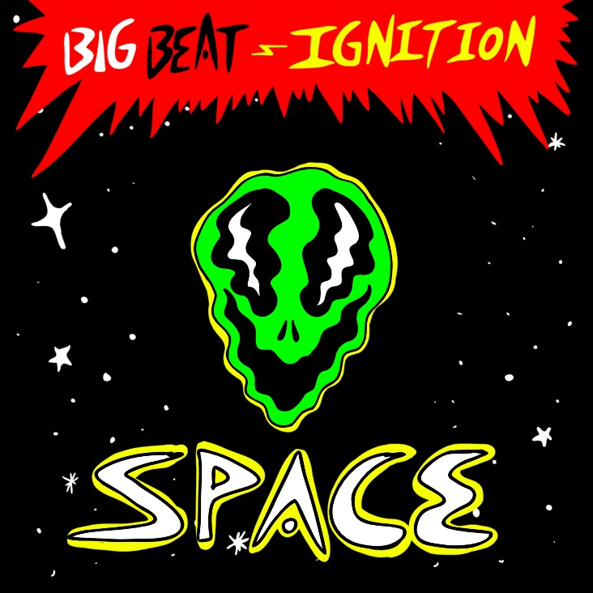

Let’s be honest, it’s a strange time right now, and leaving earth for a party in outer space has never sounded more appealing. Now you might be wondering… how do you organize a space party? You PLANET. **Big Beat Records** is taking you there with their new tech house and house 10 track compilation album: **Big Beat Ignition: SPACE**. The intergalactic experience includes new original music from **KC Lights**, **Wh0**, **Chapter & Verse**, **GUZ**, **Nightlapse**, and many more. **Listen to the full compilation** [**HERE**](https://BigBeat.lnk.to/SpacePR)**.**

In the meantime, head over to **Big Beat’s space website**, powered with real-time space data from the European Space Agency and NASA, where each track will be exclusively available 24 hours before release. **FUN FACT**: when streaming each record on the mobile web App, fans will get a unique “Mission Badge” that will include custom space data specific to both the track and the listener. These custom digital collectibles are based on their physical location, such as distance from the International Space Station, hyper local weather, even the distance they have travelled with the movement of the earth while the track plays. The initiative is in partnership with [**Landmrk**](http://www.landmrk.it), a European Space Agency backed start-up, who have transformed location-based experiences using space data with the use of contextual experiences for people that are social distancing, rather than moving to locations to unlock content, a Big Beat Go! for the COVID-19 lockdown.

The Ignition Series from Big Beat Records highlights a selection of regionally relevant electronic and dance music from around the world, previously highlighting Chicago, Los Angeles, Paris, Ibiza, and many more. Unequivocally the most globally embraced genre, dance and electronic music bring together cultures and people to create amazing shared experiences and lifelong memories.  From late night bedroom listening to legendary club nights to the festival stages that draw crowds larger than some entire cities, **Big Beat Ignition: Space** showcases this world while celebrating and highlighting some of Big Beat’s favorite music creators, from the up-and-coming to the established.

**ABOUT LANDMRK**

Landmrk is a contextual experiences platform that has been called Pokémon GO for music. The Landmrk platform enables music artists and record labels the ability to deliver any type of digital content to fans, anywhere in the world. Fully branded experiences are opened by music lovers by one click of a URL, allowing them to be shared at scale with ease. Contextual data feeds are used to create keepsakes and digital merchandise pieces that are unique to each user. Since its inception Landmrk has moved over 2.5 million people through branded experiences for music artists including Ariana Grande, Shakira and Pitbull and brands including Google, Nickelodeon and Unilever.

**About the European Space Agency**

The European Space Agency (ESA) provides Europe’s gateway to space. ESA is an intergovernmental organisation, created in 1975, with the mission to shape the development of Europe’s space capability and ensure that investment in space delivers benefits to the citizens of Europe and the world. ESA has 22 Member States: Austria, Belgium, the Czech Republic, Denmark, Estonia, Finland, France, Germany, Greece, Hungary, Ireland, Italy, Luxembourg, the Netherlands, Norway, Poland, Portugal, Romania, Spain, Sweden, Switzerland and the United Kingdom. Slovenia is an Associate Member. ESA has established formal cooperation with seven Member States of the EU.  Canada takes part in some ESA programmes under a Cooperation Agreement. By coordinating the financial and intellectual resources of its members, ESA can undertake programmes and activities far beyond the scope of any single European country. It is working in particular with the EU on implementing the Galileo and Copernicus programmes as well as with Eumetsat for the development of meteorological missions. ESA develops the launchers, spacecraft and ground facilities needed to keep Europe at the forefront of global space activities. Today, it develops and launches satellites for Earth observation, navigation, telecommunications and astronomy, sends probes to the far reaches of the Solar System and cooperates in the human exploration of space. ESA also has a strong applications programme developing services in Earth observation, navigation and telecommunications. Learn more about ESA at [www.esa.int](http://www.esa.int/)

**TRACKLIST**

1.      Wh0 – “Space & Time”

2.      KC Lights – “Luna”

3.      Chapter & Verse – “One Small Step For Man”

4.      GUZ – “Spaced Out”

5.      Nightlapse – “Blackout At Roswell”

6.      Mescal Kids – “System Malfunction”

7.      DONT BLINK – “SPACE DANCE”

8.      PEZNT – “Invasion”

9.      This Culture – “The Eagle Has Landed”

10.    Space Jump Salute – “To The Stars”

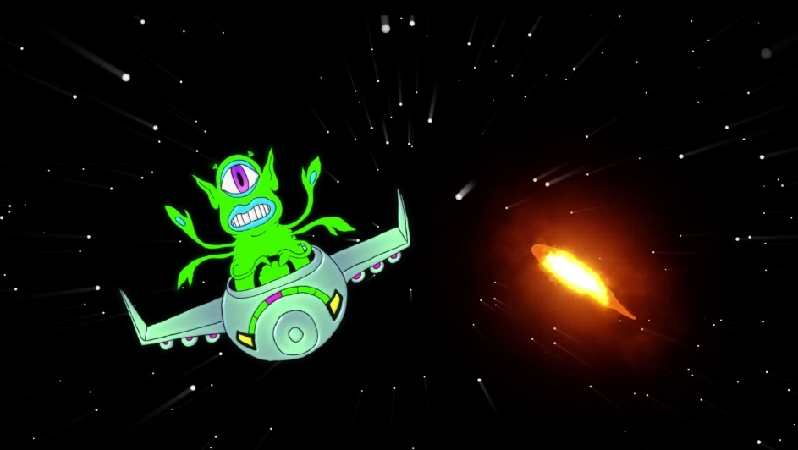

**FOR MORE INFORMATION:**

Paige Rosoff – Big Beat / Atlantic Records

[Paige.Rosoff@atlanticrecords.com](mailto:Paige.Rosoff@atlanticrecords.com)

👽 👽 👽 👽 👽 👽 👽 👽 👽 👽 👽 👽 👽 👽 👽 👽 👽 👽 👽 👽 👽 👽 👽 👽 👽 👽