BIG BEAT RECORDS channels inspiration from los angeles dance music in their all-NEW COMPILATION
FEATURING Salvatore ganacci, ekali, VALENTINO KHAN, blVK JVCK & MORE

BIG BEAT: IGNITION LOS ANGELES OUT TODAY!

LISTEN/SHARE: https://youtu.be/vM2oMV7WvSE
STREAM/BUY: https://BigBeat.lnk.to/BBILAPR

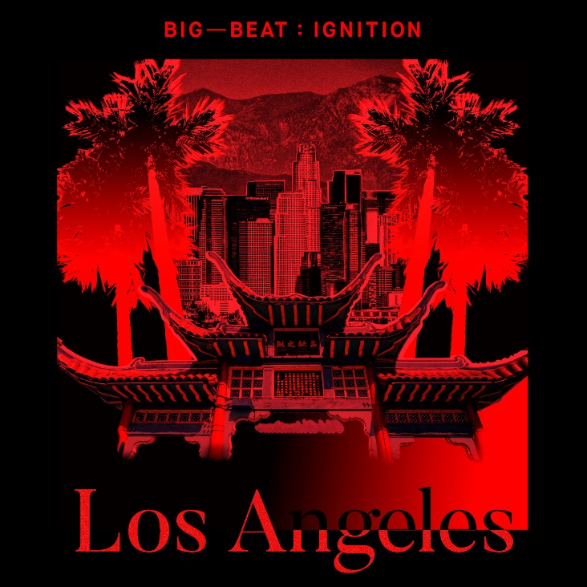
DOWNLOAD IMAGE HERE

Big Beat Records’ enduring Big Beat: Ignition series is back with the newest tribute compilation, paying respect to Los Angeles and the movement born out of its iconic history – listen HERE! Already having released compilations based on the aesthetic of Ibiza, Paris, Amsterdam, and Detroit, the newest installment delivers the filthiest of bass from some of the hardest hitters in the electronic music scene and the up-and-coming. Included on Big Beat Ignition: Los Angeles are tracks from Salvatore Ganacci & Megatone, Ekali & YOOKiE, Valentino Khan, BVCK JVCK, GTA, Bro Safari, Deathpact & more!

Starting in the region as a small community of isolated scenes in Los Angeles, electronic music has spread into an uncontrollable musical beast, and Big Beat is here to bless you with the best new sounds of bass. After all, the grand unifier in the electronic music story in Los Angeles is dirty, filthy, sub low bass – and this compilation delivers just that.

Dance and electronic music bring together cultures and people to create amazing shared experiences and lifelong memories. From late night bedroom listening to legendary club nights to the festival stages that draw crowds larger than some entire cities, Big Beat: Ignition will showcase this world while celebrating and highlighting some of their favorite music creators. Check out the full track list below and pick up Big Beat Ignition: Los Angeles wherever you get your music!

Big Beat Ignition: Los Angeles track list:
- Deathpact – Koolaid
- Fabian Mazur – Ready For The Show
- Ekali & YOOKiE – Jundo
- Gentlemens Club – Let U Go
- Bro Safari & Tank Parade – Blitz
- Salvatore Ganacci & Megatone – Cake
- Snavs – Ghetto
- GTA & Valentino Khan – Break Your Neck (Pt. 2 VIP)
- Kontra – Guilt Trip
- Nonsens – Come On
- BLVK JVCK – Show ID
- WATEVA – Haters
- Dillon Nathaniel – Consciousness
- Vampa – The Cave
- Frost & ill-Esha – What I Feel

PRESS ASSETS

FOR MORE INFORMATION:
Paige Rosoff – Big Beat Records
Paige.Rosoff@atlanticrecords.com

