BIG BEAT RECORDS RELEASES BIG BEAT IGNITION: DETROIT,
THE NEWEST COMPILATION IN THE BIG BEAT IGNITION SERIES
FEATURING VANILLA ACE, SIEGE, REBUKE, KYDUS & MORE!

OUT NOW VIA BIG BEAT RECORDS

LISTEN/SHARE: https://youtu.be/4Ibnl3LnNl4
STREAM/BUY: https://BigBeat.lnk.to/BBIDTPR

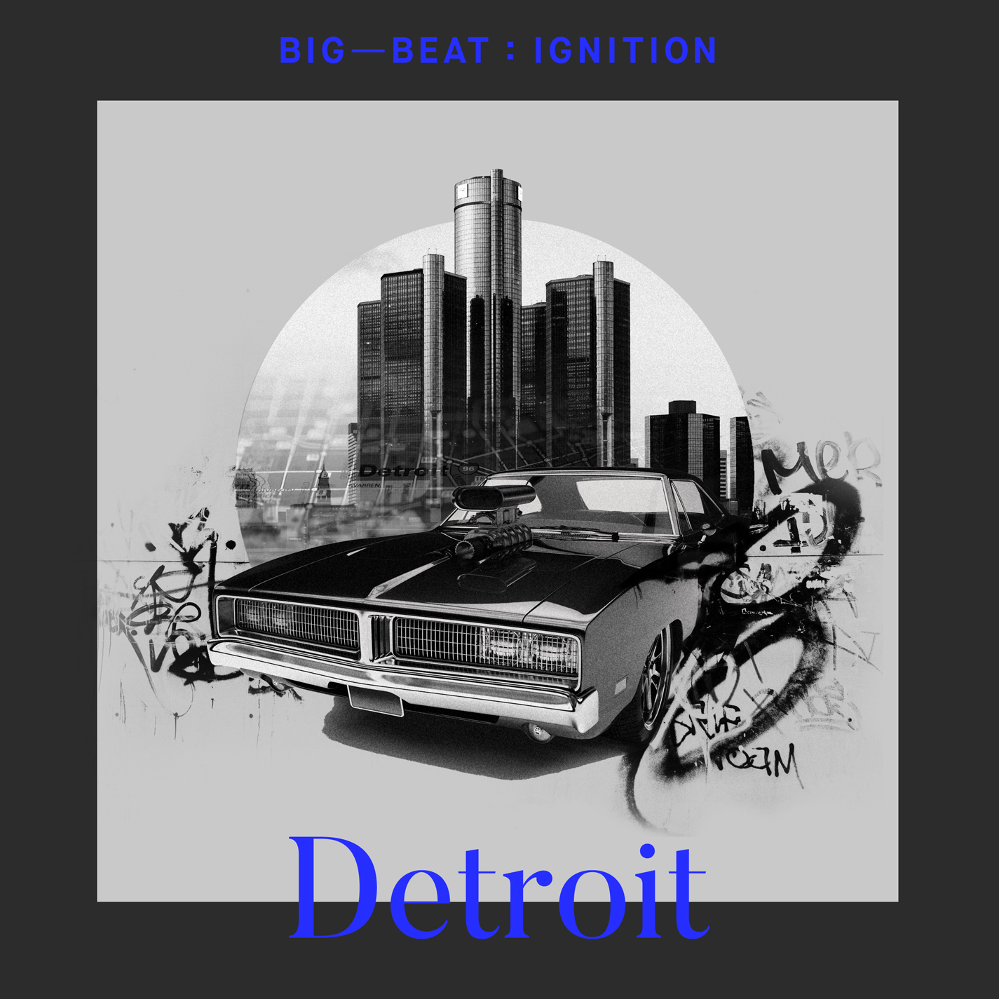
DOWNLOAD IMAGE HERE

Big Beat Records’ enduring Big Beat: Ignition series is back in FULL force, with the newest tribute compilation of unreleased tracks paying respect to Detroit and the movement born out of its iconic electronic and dance music history. Already having released compilations based on the aesthetic of Ibiza, Paris and Amsterdam, the newest installment brings it back to the USA, namely Motor City – listen HERE. If Chicago is where House music was born, you could say Detroit is where it was raised, or at least a very important stop along the way. Included on Big Beat Ignition: Detroit are tracks from acclaimed artists such as Vanilla Ace, Siege, and Mike Vale, and rising stars like Rebuke, Kydus, Nico Cabeza & more!

Influenced by European electronica, Japanese synthpop, disco, and hip-hop pioneered by legends such as Juan Atkins, Derrick May, and Kevin Saunderson, Detroit Techno (as it became known) was a staple of early DJ and club culture. As the sound has evolved, Big Beat Records aims to capture the spirit of the Motor City with it’s offering of tech house, house, and techno in the latest Big Beat: Ignition series, which pays homage to influential clubbing destination cities around the globe.

Unequivocally the most globally-embraced genre, dance and electronic music bring together cultures and people to create amazing shared experiences and lifelong memories. From late night bedroom listening to legendary club nights to the festival stages that draw crowds larger than some entire cities, Big Beat: Ignition will showcase this world while celebrating and highlighting some of our favorite music creators, from the up-and-coming to the established. Check out the full track list below, and pick up Big Beat Ignition: Detroit wherever you get your music. You can also hear Detroit’s very own, Jerry Downey, play the album live at the Big Beat Ignition: Detroit Release Party on Saturday 12/15 from 10PM-2AM at Temple Bar in Detroit!

Big Beat Ignition: Detroit Track Listing:
- Vanilla Ace - Zenith
- Rebuke - Sheila’s Tool
- ZENBI - A.K.A. (feat. Born I Music)
- Simon Kidzo - Retro
- Nico Hamuy - The Door (feat. Alan T)
- PEZNT - Dance Naked
- Mike Vale - The Hustler
- Lex Luca - Get Down
- Kydus - Ascending
- Siege - Mellowdy
- Cristal Noir - Modulation
- Jerry Downey - Small Hours
- Alan Nieves - Get Faded
- Nico Cabeza - The Right Way
- Jimmy Edgar - Burn So Deep (feat. DAWN) (Raito Remix)

PRESS ASSETS:
http://press.wearebigbeat.com/artists/big-beat-ignition-series/

FOR MORE INFORMATION:
Paige Rosoff – Big Beat Records
Paige.Rosoff@atlanticrecords.com

