BIG BEAT RECORDS PAYS HOMAGE TO DISCO HOUSE MUSIC’S ROOTS WITH ALL NEW IGNITION COMPILATION
FEATURING TRACKS FROM KING ARTHUR, FREEJAK, LEFTI, HIFI SEAN, DEL-30, AND MORE

LISTEN HERE

OUT TODAY VIA BIG BEAT RECORDS!

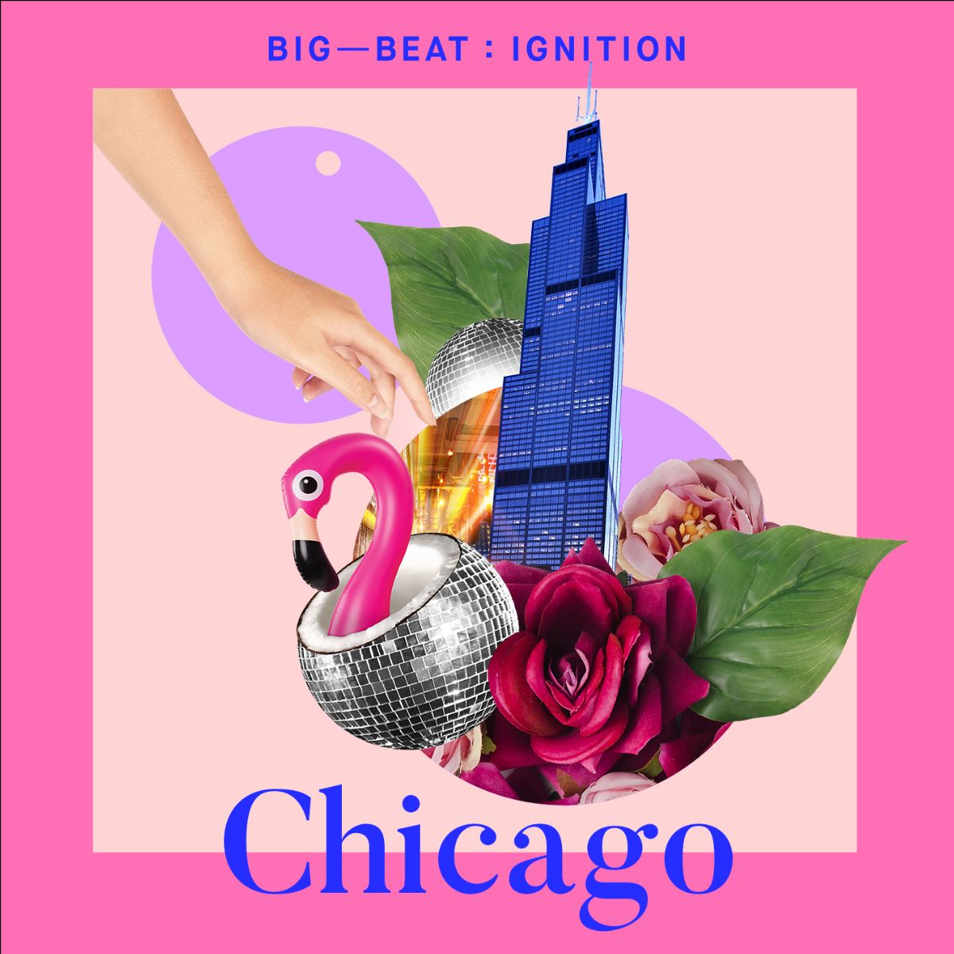

Big Beat Records has become synonymous with finding and nurturing the freshest new talents around the world, but the iconic label also pays respect where it’s due with their ongoing Big Beat Ignition compilation series. Big Beat Ignition shines a light on cities that have been instrumental in helping to cultivate a particular sound, or that are currently reshaping sub-genres within the electronic genre; so far, they’ve released compilations full of the hottest unreleased music from Detroit, Los Angeles, Ibiza, Amsterdam and Paris, and now they’re thrilled to unleash the latest installment, Big Beat Ignition: Chicago (Disco House) - LISTEN HERE!

House music did not just have its origins in American music, but a huge part of its sound can be traced specifically back to Chicago’s Southside, circa 1977, when a new kind of club opened… this new Chicago club called The Warehouse gave House music its name. This is also the place where Disco House was born, as House was the first direct descendant of disco. Big Beat Records is proud to honor its legacy and pay it homage by releasing an epic compilation of unreleased House-bangers, bringing House forward by circling back to its true origin and roots.

Featuring previously unreleased tracks from underground and emerging House icons like Brokenears, FREEJAK & Kathy Brown, Hifi Sean, Alex Preston, Kiiara, Del-30, King Arthur and Junior J and more, Big Beat Ignition’s Chicago (Disco House) compilation is sure to keep dance floors packed worldwide until the wee hours.

COMPILATION TRACKLIST:
- Lefti - 4am Taxi, Miami
- Brokenears - Get Down
- Marcellus - The Cut
- Alex Preston - Have it All
- Del-30 - Soul Back
- Hifi Sean - Feel The Music Ft. Celeda
- FREEJAK & Kathy Brown - Lose Control
- King Arthur and Junior J - Dancin Like Michael (Michael Meaco)
- Hyslop - Stay Out All Night
- Kiiara - Open My Mouth (Roisto Disco Dub)

PRESS ASSETS: https://press.wearebigbeat.com/artists/big-beat-ignition-series/

FOR MORE INFORMATION:
Paige Rosoff – Big Beat Records
Paige.Rosoff@atlanticrecords.com

