PRODUCTION DUO BLVK JVCK TEAMS WITH MYSTERIOUS R&B SINGER/SONGWRITER H.E.R. FOR NEW COLLABORATION “MINE LUV”!

BLVK JVCK & H.E.R. “MINE LUV”
WATCH/POST: https://www.youtube.com/watch?v=ukH04X03Dk0
BUY/STREAM: https://bigbeat.lnk.to/mineluvPR
(Big Beat Records)

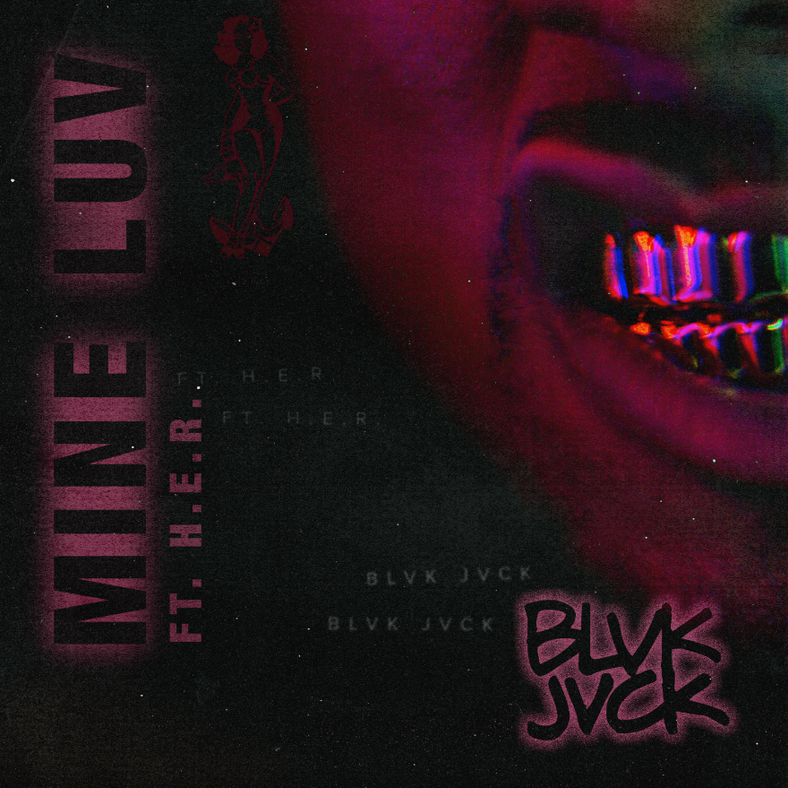

“The hypnotic track… meshes their electronic sounds with the mysterious songstress’ soothing vocals.” – RAP UP

Electronic production duo BLVK JVCK returns with a sophomore single, “Mine Luv,” featuring young rising R&B singer/songwriter H.E.R. – arriving today via Big Beat Records, alongside an official lyric video (WATCH HERE).

“Mine Luv” is a seductive cut featuring H.E.R.’s alluring vocals set against BLVK JVCK’s signature production. Equally dynamic, the video turns the concept of a traditional lyric video on its head – juxtaposing H.E.R.’s soulful lyrics against bleak cityscapes, as the story follows two individuals whose paths converge in dramatic fashion.

Comprised of legendary hip-hop production duo The Runners, BLVK JVCK’s Andrew "Dru Brett" Harr and Jermaine "Mayne Zayne" Jackson have been behind the board on some of the most unforgettable tracks of the past two decades. As part of DJ Khaled’s production team, the two cut their teeth producing hit club records including "Go Hard” (DJ Khaled) and “Hustlin" (Rick Ross), alongside tracks for Rihanna, Justin Bieber, Chris Brown, Rick Ross, Lil’ Wayne, and Future.

Under their new moniker, BLVK JVCK focuses on electronic music, having released their debut single “Mind Games” ft. Dyo earlier this year on Big Beat Records. (Watch the official music video HERE). Upon release, BULLETT praised “Mind Games,” highlighting the song as “the sort of track you can really get lost in.”

H.E.R. is a critically-acclaimed young R&B songstress whose debut EP ‘H.E.R. Vol. 1’ landed on 2016 year-end lists for “Best R&B/Soul Albums,” and earned co-signs from Alicia Keys, Wyclef Jean, Pusha T, Tyrese, and Bryson Tiller. This year saw the release of a second EP ‘H.E.R. Volume 2,’ as well as inclusion in Rolling Stone’s “10 New Artists You Need to Know.”

Of their collaboration with H.E.R., BLVK JVCK’s Dru shares, “So much music that comes out sounds like the same ol’ shit. What’s so dope about working with H.E.R is that she brings her own unique vibe. She’s the real deal!”

Mayne continues, "The process of making this record was amazing; working with great talent like Lisa Vitale, Kennedi and H.E.R., everything came together like magic."

###

Connect with BLVK JVCK:
twitter.com/blvkjvck
instagram.com/blvkjvck/
facebook.com/BLVKJVCK
soundcloud.com/BLVKJVCK
press.wearebigbeat.com/artists/blvk-jvck

Connect with H.E.R.:
her-official.com/
twitter.com/HERMusicx
instagram.com/hermusicofficial/
facebook.com/pg/officialHERmusic/about/
youtube.com/channel/UCFwC3Ryue6CorFm2xCEG0Aw/featured

For more information on BLVK JVCK:
Jordan Danielle Frazes
Head of Publicity, Big Beat Records
Jordan.Frazes@atlanticrecords.com

