BLVK JVCK EXPLORES SPIRITUAL AND PHYSICAL CONNECTIONS IN “Love Me Still” FT. Jessie Reyez OFFICIAL MUSIC VIDEO OUT TODAY!

WATCH/POST: https://youtu.be/vaZwMhnYyzo
BUY/STREAM: https://BigBeat.lnk.to/LMSPR
(Big Beat Records)

“Fiery and bold, electronic production duo…” – ONES TO WATCH

“…they have conjured music magic…” – NOISEY

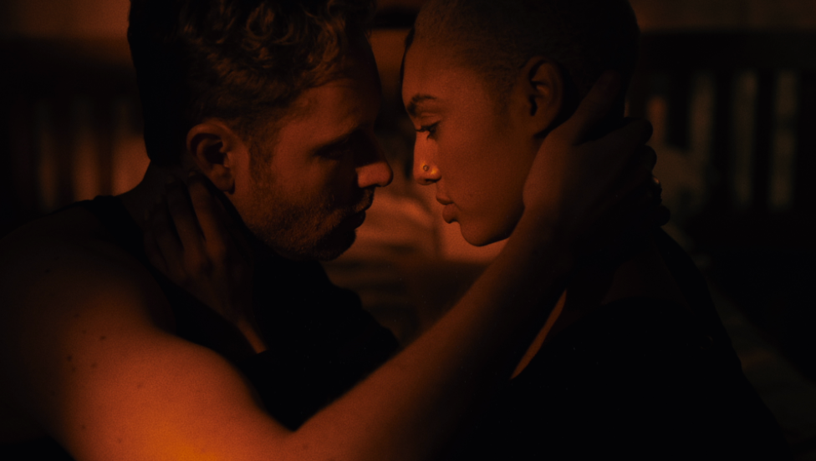
More approved screenshots available for download HERE

Fast-rising electronic production duo BLVK JVCK (renowned for their legendary hip-hop production as The Runners) deliver a fresh new music video for their latest infectious collaboration featuring Toronto-based singer-songwriter Jessie Reyez, “Love Me Still” – streaming today, watch HERE, via Big Beat Records.

The official music video stars BLVK JVCK’s very own Andrew "Dru Brett" Harr and Jermaine "Mayne Zayne" Jackson, who have been behind the board on some of the most unforgettable tracks of the past two decades. As part of DJ Khaled’s production team, the two cut their teeth producing hit club records including "Go Hard” (DJ Khaled) and “Hustlin" (Rick Ross), alongside tracks for Rihanna, Justin Bieber, Chris Brown, Rick Ross, Lil’ Wayne, and Future.

“Love Me Still” is marked by Jessie Reyez’ otherworldly delivery and BLVK JVCK’s unparalleled, forward-thinking production. BLVK JVCK initially connected with Reyez while working on material for The Runners, quickly falling for her sultry vocals and unique delivery. Reyez has previously worked with other top artists/producers including Calvin Harris, Romeo Santos, Mark Ronson, Boi1da, Benny Blanco, Murda Beatz, and Babyface to name a few. She’s currently taking a break from her in-demand songwriting to complete her forthcoming debut EP, Kiddo.

Of their experience creating the video, Dru explained: “The video is a vibrant ‘visual art montage’ that explores the intense spiritual and physical connection of two couples. It is also special because it was the first time Mayne and I played the lead roles in a music video.”

BLVK JVCK weaves hip hop and electronic elements, having released their debut single “Mind Games” ft. Dyo last year on Big Beat Records (watch the official music video HERE). Upon release, BULLETT praised “Mind Games” as “the sort of track you can really get lost in.” More recently, the duo released “Mine Luv” (watch), another smash collaboration with the mysterious, enigmatic R&B singer H.E.R. With a string of hits behind them, and even more new music on the horizon, 2018 looks to be another massive year for the duo.

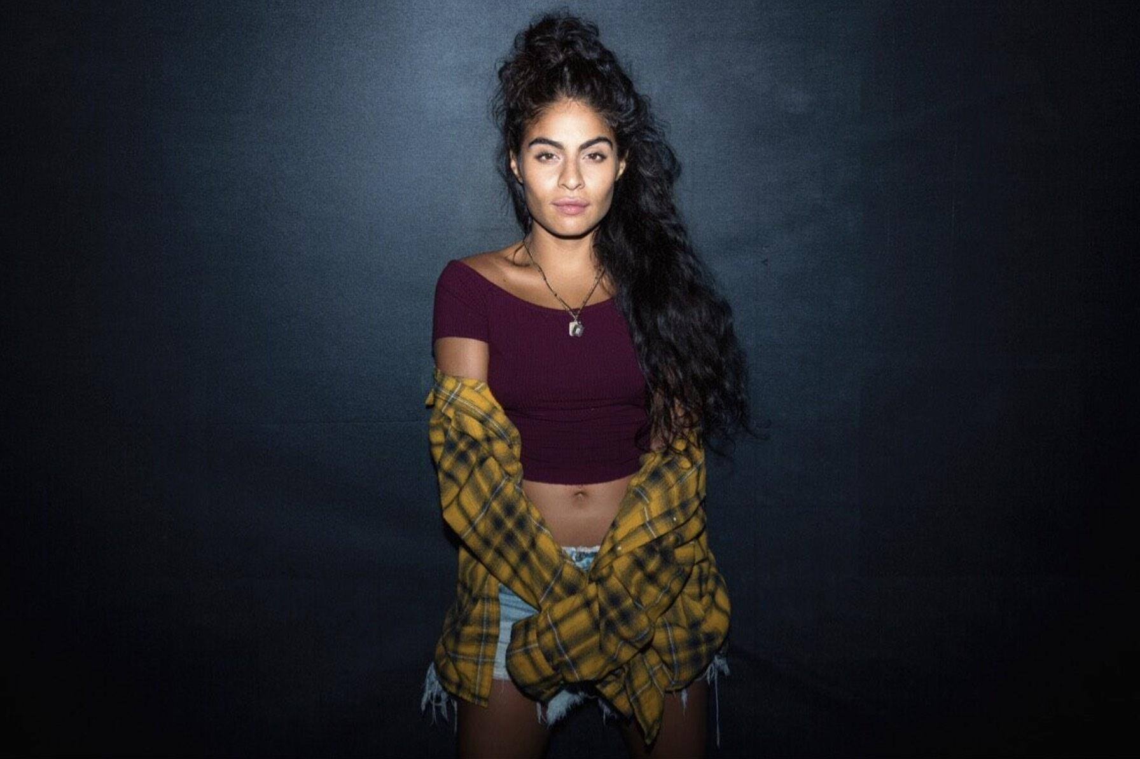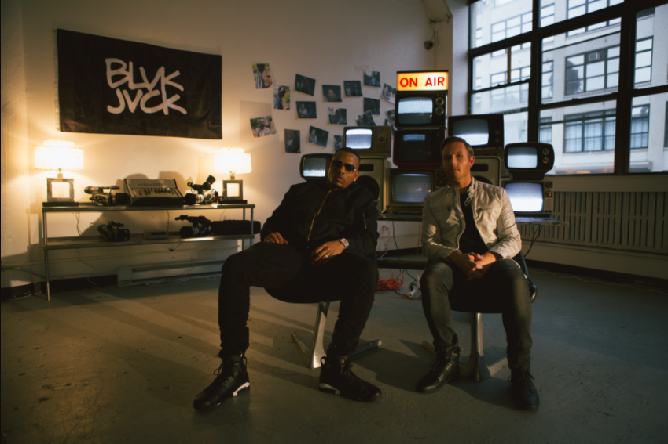
photo credit: Havard Jorstad photo credit: Mario Kristian

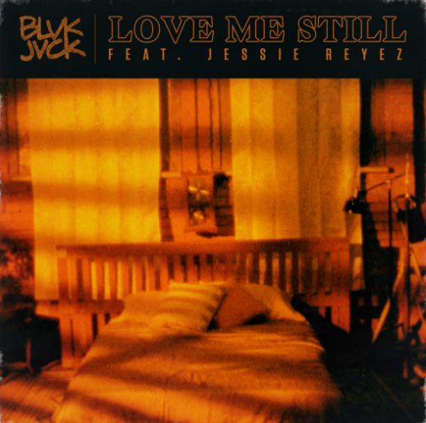

Connect with BLVK JVCK:
twitter.com/blvkjvck
instagram.com/blvkjvck/
facebook.com/BLVKJVCK
soundcloud.com/BLVKJVCK
press.wearebigbeat.com/artists/blvk-jvck

Connect with Jessie Reyez:
twitter.com/JessieReyez
instagram.com/jessiereyez
facebook.com/MusicJessieReyez
http://jessiereyez.com/

For more information on BLVK JVCK:
Jordan Danielle Frazes
Head of Publicity, Big Beat Records
Jordan.Frazes@atlanticrecords.com

