BLVK JVCK TAPS Jessie Reyez For New Single “Love Me Still” OUT TODAY!

WATCH/POST: https://www.youtube.com/watch?v=jwFs5Bsxk-g
BUY/STREAM: https://BigBeat.lnk.to/LMSPR
(Big Beat Records)

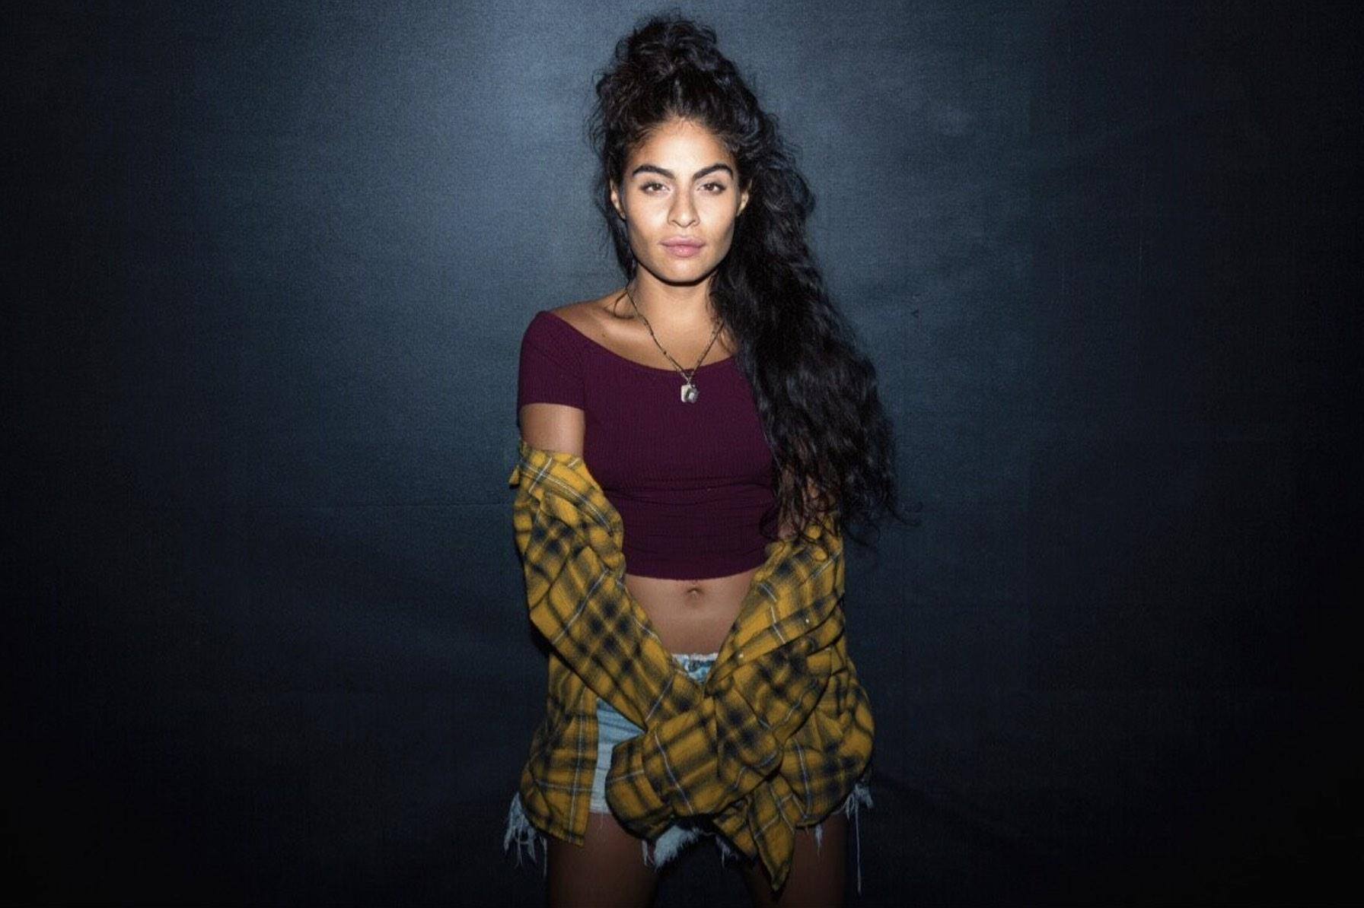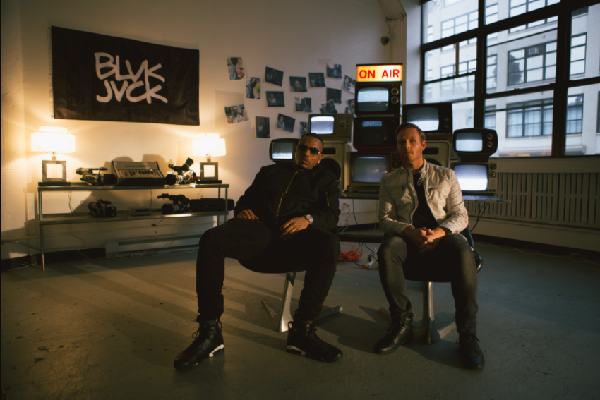
photo credit: Havard Jorstad photo credit: Mario Kristian

“…they have conjured music magic…” – NOISEY

Fast-rising electronic production duo BLVK JVCK (renowned for their legendary hip-hop production as The Runners) is back with their first new single of 2018 by way of a collaboration with the Toronto-based singer-songwriter Jessie Reyez, “Love Me Still” – listen HERE. The infectious single, out today via Big Beat Records, is marked by Reyez’ otherworldly delivery and BLVK JVCK’s unparalleled, forward-thinking production.

BLVK JVCK initially connected with Reyez while working on material for The Runners, quickly falling for her sultry vocals and unique delivery. Reyez has previously worked with other top artists/producers including Calvin Harris, Romeo Santos, Mark Ronson, Boi1da, Benny Blanco, Murda Beatz, and Babyface to name a few. She’s currently taking a break from her in-demand songwriting to complete her forthcoming debut EP, Kiddo.

BLVK JVCK is comprised of Andrew "Dru Brett" Harr and Jermaine "Mayne Zayne" Jackson, who have been behind the board on some of the most unforgettable tracks of the past two decades. As part of DJ Khaled’s production team, the two cut their teeth producing hit club records including "Go Hard” (DJ Khaled) and “Hustlin" (Rick Ross), alongside tracks for Rihanna, Justin Bieber, Chris Brown, Rick Ross, Lil’ Wayne, and Future.

Under their new moniker, BLVK JVCK focuses on electronic music, having released their debut single “Mind Games” ft. Dyo last year on Big Beat Records (watch the official music video HERE). Upon release, BULLETT praised “Mind Games” as “the sort of track you can really get lost in.” More recently, the duo released “Mine Luv” (watch), another smash collaboration with the mysterious, enigmatic R&B singer H.E.R. With a string of hits behind them, and even more new music on the horizon, 2018 looks to be another massive year for the duo.

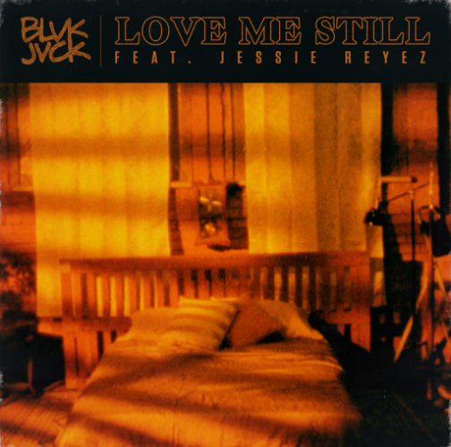

Connect with BLVK JVCK:
twitter.com/blvkjvck
instagram.com/blvkjvck/
facebook.com/BLVKJVCK
soundcloud.com/BLVKJVCK
press.wearebigbeat.com/artists/blvk-jvck

Connect with Jessie Reyez:
twitter.com/JessieReyez
instagram.com/jessiereyez
facebook.com/MusicJessieReyez
http://jessiereyez.com/

For more information on BLVK JVCK:
Jordan Danielle Frazes
Head of Publicity, Big Beat Records
Jordan.Frazes@atlanticrecords.com

