BLVK JVCK RECRUITS RAP PIONEER COMETHAZINE
FOR HARD-HITTING NEW BANGER, “GVNG 4X”

LISTEN HERE: https://BigBeat.lnk.to/GVNGX4PR

OUT TODAY VIA BIG BEAT RECORDS

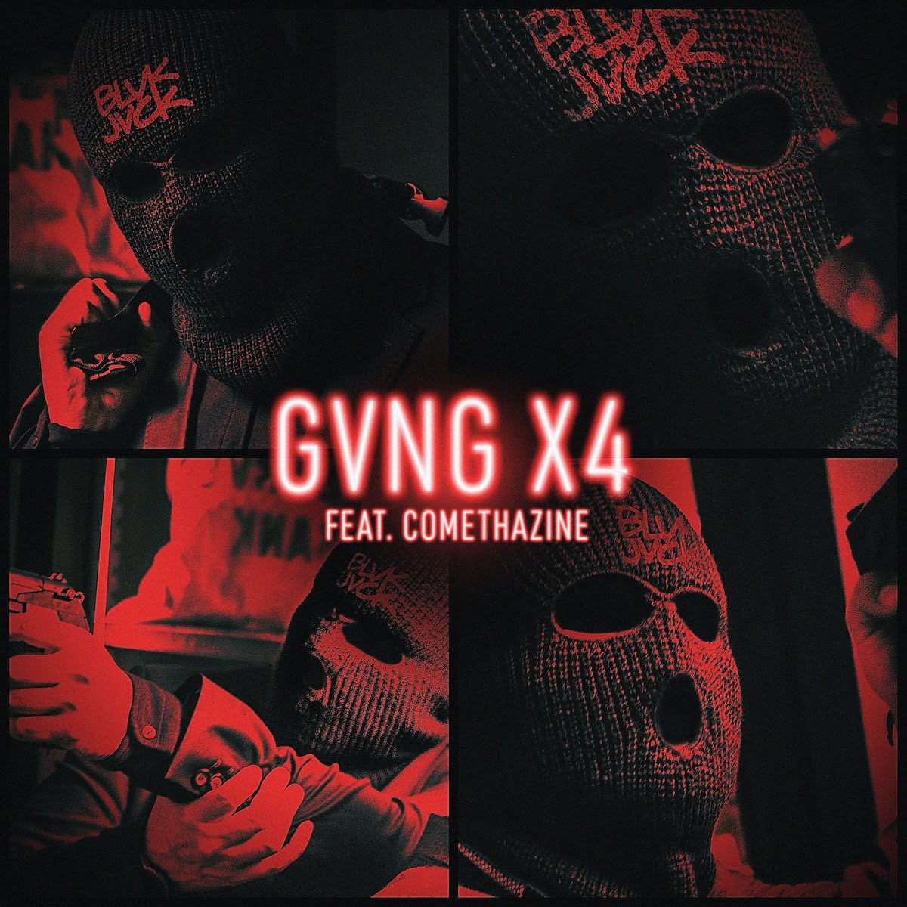

BLVK JVCK has been establishing himself as a pioneer of fusing dubstep with a hip-hop/trap production style complete with heavy, punishing drops, and today he’s solidifying his reputation with the release of “GVNG 4X,” a new single featuring Comethazine, a St. Louis-based artist known as one of the true pioneering SoundCloud rappers. A banger from the get, “GVNG 4X” showcases BLVK JVCK’s trademark, hard-hitting, street-infused production style, Comethazine shines on “GVNG 4X” with a rapid-fire delivery that’ll make your head spin - LISTEN HERE!

“GVNG 4X” follows BLVK JVCK’s recently released banger “2020” with Icy Narco. BLVK JVCK is the latest endeavor of Jermaine "Mayne" Jackson, formerly one half of the famed production duo, The Runners. Some of his biggest cuts include "Go Hard" by DJ Khaled and "Hustlin" by Rick Ross, amongst a vast library of tracks for Rihanna, Justin Bieber, Chris Brown, Rick Ross, Lil' Wayne, Usher, and more.

Comethazine is a St. Louis-born rapper best known for his singles “Walk” and “Bands" off his debut full-length project “Bawskee” which debuted on the Billboard 200 chart. He is widely credited with popularizing the “Soundcloud Rap” sub-genre and has over 100 million streams on that platform alone, a rare achievement for a 21-year-old with a discography that only dates back three years.

With “GVNG 4X” and a slew of new BLVK JVCK music on the horizon while he’s holed up in the studio, it’s safe to say that BLVK JVCK isn’t gonna let a self-quarantine slow himself down anytime soon!

CONNECT WITH BLVK JVCK:
Instagram | Facebook | Twitter | Spotify

PRESS ASSETS: press.wearebigbeat.com/artists/blvk-jvck

FOR MORE INFORMATION:
Paige Rosoff – Big Beat Records
Paige.Rosoff@atlanticrecords.com

