BLVK JVCK & FLOSSTRADAMUS RECRUIT LEAT'EQ FOR
NEW COLLAB “G.O.D. (GRIND OR DIE)”

BUY/STREAM: https://bigbeat.lnk.to/GODPR
(Big Beat Records)

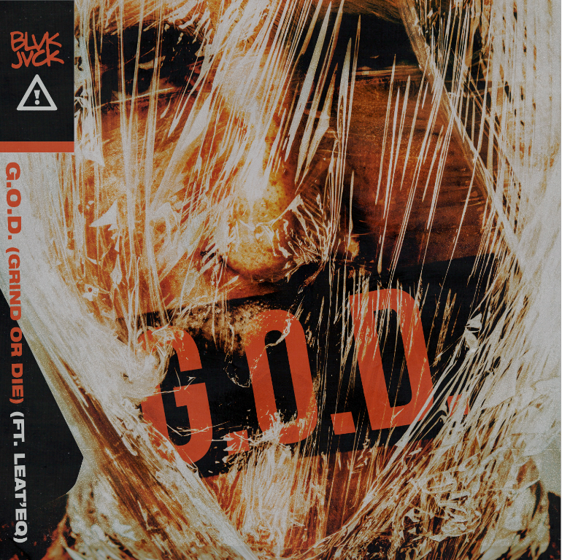

Production duo BLVK JVCK have been behind the literal boards for some of the biggest hip-hop hits of the millennium under The Runners moniker but over the course of the past year, the duo has stepped out on their own as electronic artists. Today, BLVK JVCK teams with trap pioneer Flosstradamus and rising trap newcomer producer Leat’eq for a new single, “G.O.D. (GRIND OR DIE)” out today via Big Beat Records – LISTEN HERE!

Andrew "Dru Brett" Harr and Jermaine "Mayne Zayne" Jackson also introduce the first character of their MVGIC CITY cinematic series in the music video for their single “Grind or Die”—WATCH HERE. MVGIC CITY imagines a world of superhero’s, villains, and Vigilantes that is spun off of Miami – known on the streets as “magic city.” The visuals surrounding BLVK JVCK’s forthcoming debut EP will live in MVGIC CITY. In this video, the character BLVK JVCK, recognized by the V on his chest, stops a bank heist and a Russian Mob plutonium deal from happening. Although BLVK JVCK is featured in this episode, future visuals will unveil other characters that also live in this MVGIC CITY world….

BLVK JVCK got their start as part of DJ Khaled’s production team. The two cut their teeth producing hit club records including "Go Hard” (DJ Khaled) and “Hustlin" (Rick Ross), alongside tracks for Rihanna, Justin Bieber, Chris Brown, Lil’ Wayne, and Future. Renowned for their legendary hip-hop production, they continue to deliver unparalleled, forward-thinking production as BLVK JVCK, impeccably weaving hip-hop and electronic beats.

Their debut single “Mind Games” ft. Dyo was praised by BULLETT as “the sort of track you can really get lost in.” Later, the duo released a soaring single “Mine Luv”, one of the earliest collaborations with the now-GRAMMY nominated artist H.E.R. And most recently they delivered “Love Me Still” ft. Jessie Reyez. With a string of hits behind them, and even more new music on the horizon, 2019 looks to be a big year for the duo.

Currently based in Brooklyn, Flosstradamus (aka Curt Cameruci) came to prominence in Chicago while collaborating with acts such as Major Lazer, Matt & Kim, A-Trak and Baauer. Career highlights over the past decade include iconic tracks like Major Lazer’s “Original Don” (Flosstradamus Remix), “CROWD CNTRL,” “Mosh Pit,” “TTU (Too Turnt Up)” featuring Waka Flocka Flame, “Soundclash” and “Prison Riot” with GTA featuring Lil Jon as well as collaborations with Post Malone and Travis Porter.

In March 2017, Flosstradamus released “Back Again” with Mayhem and Waka Flocka Flame. In addition, Flosstradamus has become synonymous with a Hi-Def lifestyle, ultimately resulting in a lifestyle brand that’s extended to apparel, a festival property with HDYFEST, and record label Hi Def Youth releasing singles from Yultron, Gent & Jawns and Part Native, with more to come. Flosstradamus‘ devout group of fans known as the HDYNATION has developed into one of the most dedicated and recognizable communities in dance music.

Connect with BLVK JVCK:
twitter.com/blvkjvck
instagram.com/blvkjvck/
facebook.com/BLVKJVCK
press.wearebigbeat.com/artists/blvk-jvck
Press tools: press.wearebigbeat.com/artists/blvk-jvck

Press Contact:
Jordan Danielle Frazes
Head of Publicity, Big Beat Records
Jordan.Frazes@atlanticrecords.com

