BLVK JVCK TEAMS UP WITH ICY NARCO FOR NEW SINGLE “DAT WAY”

LISTEN HERE: https://BigBeat.lnk.to/DAYWAYPR

OUT TODAY VIA BIG BEAT RECORDS

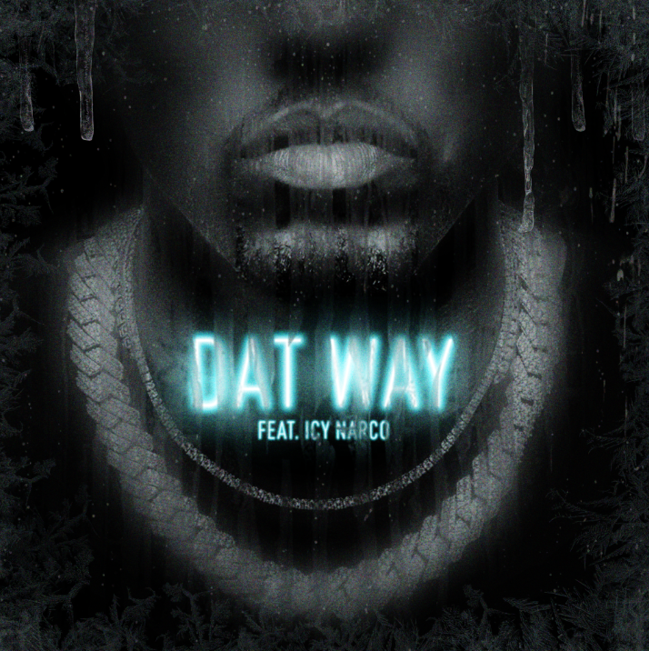

Today the genre-defying artist and producer, BLVK JVCK, drops a new single called “Dat Way” (feat. Icy Narco) which naturally embodies the future sound of trap and hip-hop. A retreat from the dubstep sounds that typically come from BLVK JVCK, “Dat Way” adds a slight variation to his discography. With middle eastern sounds, quick high hats, and a heavy-hitting bass that goes so hard, it’s impossible not to hit replay. Out everywhere now via Big Beat Records – listen HERE.

Icy Narco comes in strong with melodic vocals, complementing the track seamlessly to match his flow. The unexpected sounds BLVK JVCK uses in his production is truly refreshing and primarily what sets him apart as a producer. DAT WAY is a step in the right direction for the genre of hip hop, and there is simply no one in the game going as hard as BLVK JVCK.

BLVK JVCK is widely known for his popular trap/dubstep sound from songs like, ‘Mine Luv’ featuring H.E.R. and the most recent VIP collaboration with NGHTMRE, ‘Cash Cow’, featuring Gunna. The most recent single from BLVK JVCK, ‘LUCKY’ featuring Tay Money acquired over 30,000 plays in just a few days with no chance of slowing down.

CONNECT WITH BLVK JVCK:
Instagram | Facebook | Twitter | Spotify

PRESS ASSETS: press.wearebigbeat.com/artists/blvk-jvck

FOR MORE INFORMATION:
Paige Rosoff – Big Beat/Atlantic Records
Paige.Rosoff@atlanticrecords.com

