AUTOGRAF REVEAL SULTRY LYRIC VIDEO FOR “YOU MIGHT BE” FEAT. LILS – OUT NOW ON BIG BEAT RECORDS!

WATCH/POST: https://youtu.be/RWePs1ueGfU
BUY/STREAM: https://bigbeat.lnk.to/AYMBPR

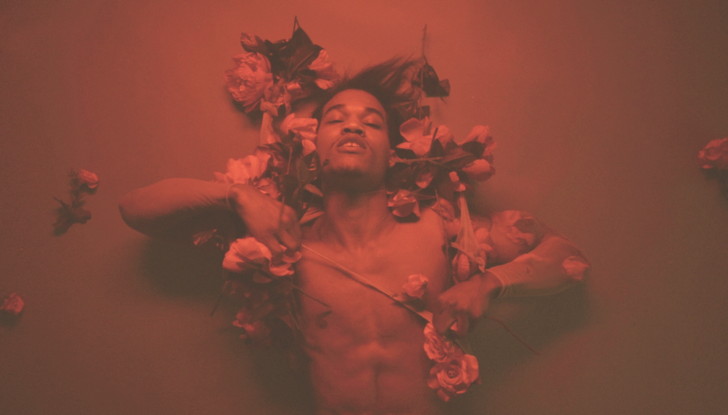

Chicago artists, production and multi-instrumentalist trio Autograf made their Big Beat Records debut this month with their latest jam “You Might Be” featuring The Voice alum and vocalist Lils. The track is quickly approaching over 1 Million streams in the first week, and reached #1 on Hype Machine. Following their second weekend performing at Coachella, the group is now unveiling a sultry lyric video to accompany the single.

Directed by French Brooklyn-based director Patricia Gloum, the lyric video is a visual delight of seduction and storytelling. “‘You Might Be’ represents for me the death of a feeling you can only contemplate, slowly getting consumed and nothing being done to stop it,” Gloum shares.

Gloum has an instinct for experimenting with new techniques – her films serve as “little pieces of moving art” and she constantly pushes the envelope with her non-linear forms of storytelling. She goes on to say about the video, “I wanted to make what is actually complicated into its simplest form – that being emotion and love. Nothing but to only recognize a human being and the emotion they are experiencing.”

“You Might Be” is out now across all DSP’s via Big Beat Records.

More about Autograf:
Combining two art students and a derivatives trader into an all-encompassing art project was surely a novel concept. Autograf – formed by Jake Carpenter, Louis Kha, and Mikul Wing – craft a shimmery mix of futuristic electronica with a D.I.Y. ethos that melds the skills from their former day jobs. As the electronic music scene reached a certain peak in 2015, the group wanted to bring some sexy back to the genre. After remixing songs by a string of prominent artists like Lorde and Pharrell, they released their first original song, "Dream," followed by "Running" and "Metaphysical," featuring Autograf-designed cover art.

Autograf's future philosophy and artistic talents led them to create their own instruments and stage installations, which they hoped would revolutionize the electronic music scene. In early 2016, the trio released their debut EP, 'Future Soup,' continuing the momentum in 2017 with their Hype Machine dominating single "Nobody Knows" and a remix of "Rockabye" by Clean Bandit feat. Anne Marie and Sean Paul.

Autograf continue to grow in various aspects of art culture, having been personally invited by W Hotels to design an art installation for the hotel's main window at the W Manhattan in New York City. This will come as no surprise to fans of the band, as Autograf designed and built their own lighting rig for their last US tour. The guys also just revealed their own streetwear line. By Autograf combines their passion for a perfect intersection between art, fashion and music.

Connect with Autograf
https://soundcloud.com/autografmusic
https://www.facebook.com/AutografOfficial
https://twitter.com/autografmusic
http://press.wearebigbeat.com/singles/you-might-be-feat-lils-autograf/

For more information please contact:

Jordan Danielle Frazes
Head of Publicity, Big Beat Records
Jordan.Frazes@atlanticrecords.com

Lindsay Herr
lindsay@thewanderlvst.com

