ARMAN CEKIN BOOSTS ‘CALIFORNIA DREAMING’ SINGLE WITH A SPECIAL FEATURE COURTESY OF SNOOP DOGG!

AFTER 13 MILLION STREAMS, NEW OFFICIAL VIDEO OUT TODAY CELEBRATING RELEASE ON BIG BEAT RECORDS!

WATCH/POST: https://youtu.be/y8faJ1uWuNY
STREAM/BUY: https://BigBeat.lnk.to/calidreamPR
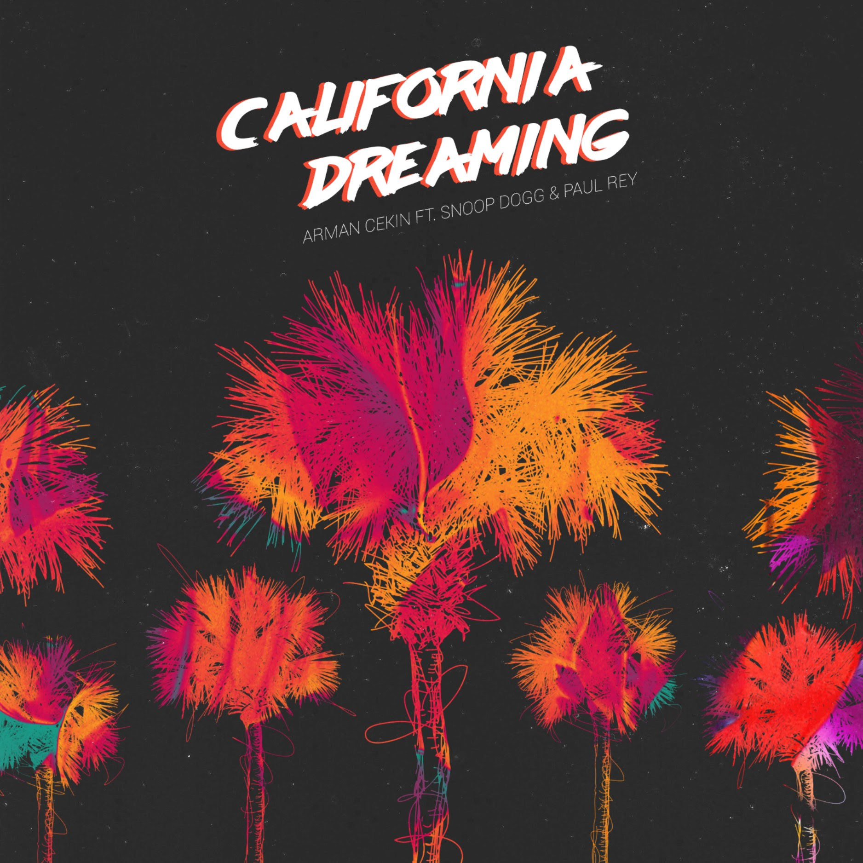
A collaboration between rising Dutch producer Arman Cekin and Swedish singer-songwriter Paul Rey, ‘California Dreaming’ has amassed 13 million streams since first being uploaded by Trap Nation in the summer. Now the track’s profile is further boosted with the release on Big Beat Records today of a new version of the tracks that adds a guest feature from the inimitable Snoop Dogg.

‘California Dreaming’ is a dreamy, chill trap production in which Paul Rey’s soothing vocals drift over a hazy backdrop of Caribbean flourishes and restrained beats. Snoop Dogg proves to be the perfect choice for a feature as his drawled and economical rap adds a fresh dimension to the track.

In just two years, Arman Cekin has established himself as an artist with an ear for a killer melody and the ability to craft atmospherics into his track. Blending remixes of Drake’s ‘Hotline Bling’ and Rihanna’s ‘Work’ alongside originals such as ‘Show You Off’ and ‘You Don’t Know Me’, Arman Cekin has already racked up 65 million plays.
Currently being mentored by the legendary Quincy Jones, Paul Rey was inspired to write in English from listening to 2Pac, Dr. Dre and Eminem. He has opened for Big Sean , Nico & Vinz and Fifth Harmony, and was nominated for Best Solo Artist of the Year and Best Newcomer of the Year at Sweden's Kingsize Gala.

Snoop Dogg needs no introduction.

Connect with Arman, Paul & Snoop:
https://soundcloud.com/armancekin
http://iampaulrey.com/
http://snoopdogg.com/

For more information please contact:
Jordan Danielle Frazes
Head of Publicity, Big Beat Records
Jordan.Frazes@atlanticrecords.com

Lindsay Herr:
lindsay@thewanderlvst.com

