A-Trak GETS “In Arms” OF Ferreck Dawn & Robosonic’s Hit Single – DELIVERING BRAND NEW REMIX OUT TODAY!

WATCH/POST: https://youtu.be/CuhgOj9l0uE
BUY/STREAM: https://BigBeat.lnk.to/ATRPR

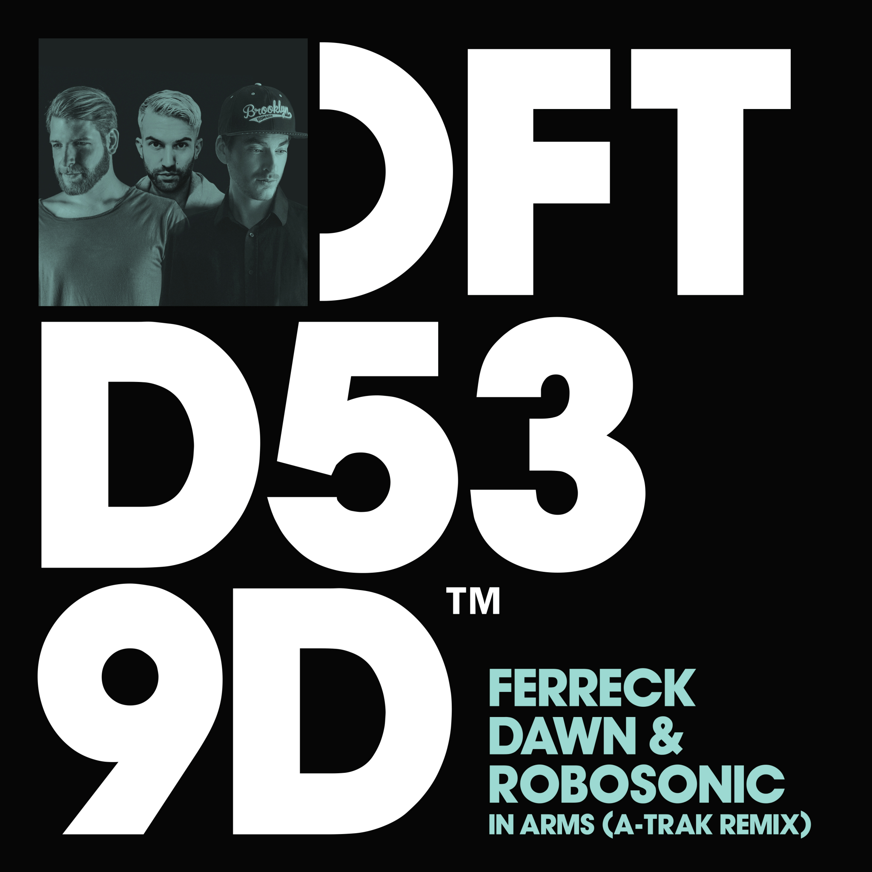
DOWNLOAD IMAGE HERE

The in-demand Canadian superstar DJ, producer and turntablist extraordinaire, A-Trak, has put his signature spin on “In Arms”, the recent hit single from Ferreck Dawn & Robosonic, which is officially out today through Big Beat Records, which you can listen to HERE. With the original track having already eclipsed over three million streams on Spotify alone, A-Trak has now put his signature magic touch on the official remix, giving it a surefire elastic bassline and piano stabs that lends a classic house vibe to the already-undeniable track.

The song is already seeing DJ support from Mark Knight, DJ S.K.T., Mistajam, Claptone, Tough Love, Pete Tong, Kideko, The Magician, Reuben Keeney, Mella Dee, Fedde le Grand, Danny Howard, Bontan, Roger Sanchez, The Aston Shuffle, Kryder, Tiësto, and Esquire.

A-Trak is the moniker of Alain Macklovitch, the legendary turntablist who got his prodigious start early on. He was the first DJ to ever win all three major DJ competition titles, along with being the first DJ to win five World Championships, even winning the DMC World Championship at age 15. Kanye West went on to recruit A-Trak as his personal tour DJ in 2004, with the two maintaining a close relationship ever since. Now two decades in, the prolific artist is showing no signs of slowing down; Rolling Stone even named him one of the 50 Most Important People In EDM.

A-Trak also a successful music executive in his own right, as the owner of the revered label Fool's Gold which was founded in 2007, and is credited for developing the careers of artists such as Kid Cudi, Danny Brown, and Flosstradamus. He’s also one half of the DJ duo Duck Sauce with Armand Van Helden, which was nominated for a Grammy in 2012 for their song "Barbra Streisand". A-Trak was featured on the covers of Billboard and Complex and recently appeared in campaigns for Adidas, Grey Goose, Converse and Cadillac.

PRESS ASSETS:
http://press.wearebigbeat.com/singles/in-arms-ferreck-dawn-robosonic-a-trak-remix/

CONNECT WITH A-TRAK:
Instagram| Twitter | Soundcloud | Facebook | Spotify

FOR MORE INFORMATION:
Paige Rosoff – Big Beat Records
Paige.Rosoff@atlanticrecords.com

Jordan Frazes – Big Beat Records
Jordan.Frazes@atlanticrecords.com

