100 gecs shares new song "mememe"

Currently out on 10000 gecs Tour

New album 10000 gecs coming soon
﻿via Dog Show Records
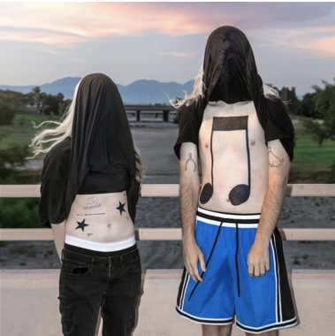
10000 gecs cover art

"mememe"
LISTEN: https://100gecs.lnk.to/mememeID
WATCH: https://youtu.be/1Bw2dTY3SsQ

(November 19, 2021) - 100 gecs release the first offering from their highly-anticipated sophomore album 10000 gecs. "mememe", which a recent Pitchfork cover story called "an ebullient carnival of ska-inflected verses that bounce off a chorus of thrash guitars and a squiggling synth line," has been a fan favorite on the currently ongoing 10000 gecs Tour. The tour has been working its way across North America, and making quite a stink, leaving "a pungent medley of vape smoke, Gen Z mosh-sweat, and hundreds of spilled drinks — was the lingering effect of gecs" according to The Boston Globe.

The duo have also been previewing unreleased songs in their live sets leaving audiences longing to hear them again on the album. These sneak peeks have been setting the fan forums on fire with clips and tales of "Hollywood Baby," "757" and "what's that smell?," all of which have shown up on their setlists on the first leg of the tour. A show review in The Daily Californian, the student paper at UC Berkeley, described the tour opener in Oakland like a watershed event, stating “with an audience starved for live performance and a duo on the precipice of something great, even groundbreaking, the energy at the show was near-indescribable."

The full 10000 gecs Tour routing is below and tickets for the European leg of the tour are on sale now. Tickets available here.

100 gecs, the duo of Dylan Brady and Laura Les, planted their flag on the proverbial pop culture moon with their 2019 debut album 1000 gecs, which was heralded by The New Yorker as, “an impressively precise maximalist exercise with no rules” and “utterly unhinged in the best way possible” by GQ. The innovative project captured the hearts of fans and critics alike - selling out all of their live shows to date along with The New York Times calling it, “some of the savviest pop music of the year,” and Rolling Stone dubbing it “one of 2019’s most exciting debuts.” In just a few months following the release of 1000 gecs, the band went from playing their first concert from inside the video game Minecraft to selling out shows across the country, proving that their rabid, rapidly multiplying fanbase doesn't only exist in the far corners of the internet. After their world tour was postponed in the summer of 2020, Brady and Les kept rolling with the release of 1000 gecs and The Tree of Clues, a rework of the original album featuring collaborations from the likes of A. G. Cook, Fall Out Boy, Charli XCX, Rico Nasty, as well as crowd sourced contributions by fans. The transformative release was described by The NME as a “brain-melting, genre-crushing vision of pop’s future.”

Hear "mememe" above and see the rest of the 10000 gecs Tour dates below. As they are known for dropping a steady trail of breadcrumbs for their fans, we recommend that you stay tuned for more from 100 gecs coming soon.
﻿Upcoming Live Dates:
11/19 - Santa Ana, CA @ The Observatory
11/20 - Los Angeles, CA @ Shrine Expo Hall
12/06 - Washington, DC @ 9:30 Club
12/07 - Philadelphia, PA @ Union Transfer
12/08 - Philadelphia, PA @ Union Transfer
12/09 - New York, NY @ Terminal 5
12/11 - New York, NY @ Terminal 5
12/12 - Boston, MA @ Royale

﻿100 gecs:
Twitter | Instagram | SoundCloud

Dylan Brady:
Twitter | Instagram | SoundCloud | YouTube

Laura Les:
Twitter | Instagram | SoundCloud

Dog Show Records:
Twitter | Instagram | Website

﻿(Download hi-res assets HERE)

