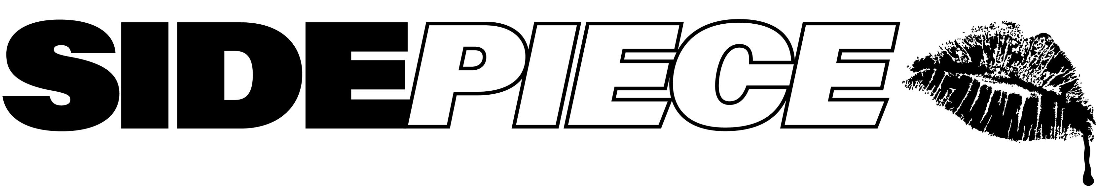

GRAMMY® AWARD-NOMINATED DANCE DUO SIDEPIECE
UNITE WITH DISCO LINES FOR “GIVE IT TO ME GOOD”

SIDEPIECE NORTH AMERICAN TOUR CURRENTLY UNDERWAY
INCLUDING HEADLINE SETS, MONTHLY RESIDENCY AT LAS VEGAS’ LIV BEACH,
TOP-BILLED FESTIVAL APPEARANCES, AND MORE

DISCO LINES LIVE SCHEDULE PACKED WITH FESTIVAL APPEARANCES, RESIDENCY AT WYNN LAS VEGAS’ XS NIGHTCLUB & MORE

LISTEN TO SIDEPIECE x DISCO LINES – “GIVE IT TO ME GOOD” HERE

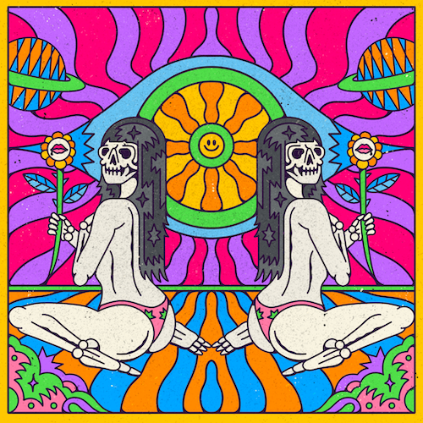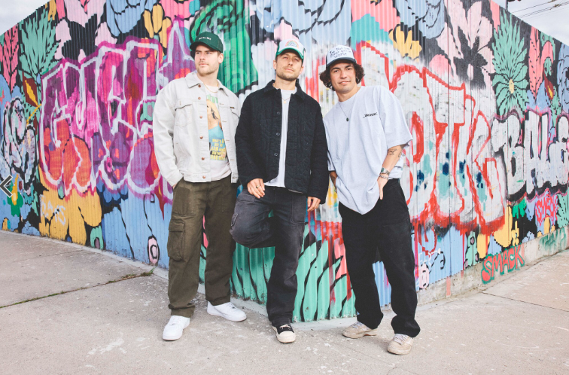
DOWNLOAD HI-RES ART // DOWNLOAD HI-RES PRESS PHOTOS

SIDEPIECE – the GRAMMY® Award-nominated dance duo comprised of multimillion- streaming DJ/producers NITTI (Ricky Mears) and Party Favor (Dylan Ragland) – have joined forces with fellow superstar producer and DJ Disco Lines for the euphoric new single, “Give It To Me Good,” available now via Big Beat Records HERE.

“Give It To Me Good” continues a seemingly non-stop run of new bangers from both
artists, including “Taka,” SIDEPIECE’s sizzling collaboration with Croatian house artist San Pacho, and the euphoric "Nineteen 84" from Disco Lines, Malaa and Tchami.

SIDEPIECE is currently on the road with dates continuing through August including a headline sets, a monthly residency at Las Vegas’ Liv Beach, top-billed festival appearances, and much more. For complete details and remaining ticket information, please visit youasidepiece.com.

Disco Lines is also touring through the summer, with festival dates including Hangout Music Festival, Bonnaroo and more and a residency at WYNN Las Vegas’ XS Nightclub. For complete details and remaining ticket information, please visit https://www.discolines.com/shows

SIDEPIECE
ON TOUR 2024

APRIL
19 – Detroit, MI – Magic Stick
20 – Atlanta, GA – District Atlanta
26 – Los Angeles, CA – Academy LA
27 – San Diego, CA – Nova SD
27 – Las Vegas, NV – Liv Beach

MAY
3 – Denver, CO – The Church Nightclub
4 – San Luis Obispo, CA – Shabang Music Festival
11 – Costa Mesa, CA – Time Nightclub
24 – Salt Lake City, UT – Boxpac Project
26 – New York, NY – Governors Island
31 – Las Vegas, NV – Liv Beach

JUNE
1 – Oklahoma City, OK – Tower Theatre
21 – Las Vegas, NV – Liv Beach
22-23 – Quincy, WA – Beyond Wonderland PNW
29 – El Paso, TX – 11:11

JULY
12 – Las Vegas, NV – Liv Beach

AUGUST
3 – Inglewood, CA – HARD Summer Music Festival
30 – Bridgeview, IL – North Coast Music Festival

DISCO LINES
ON TOUR 2024

APRIL
20 – Harrah's Resort Atlantic City – Atlantic City, NJ

MAY
4 – McDonald Theatre – Eugene, OR
9 – Alex Madonna Expo Center – San Luis Obispo, CA
10 – XS Nightclub – Las Vegas, NV
16 - Encore Beach Club - Las Vegas, NV
18 – Hangout Music Festival 2024 – Gulf Shores, AL
31 – EBC at Night – Las Vegas, NV

JUNE
8 – Regenerate Festival– Denver, CO
13 – Bonnaroo Music and Arts Festival 2024 – Manchester, Tennessee
15 – Breakaway Kansas City 2024 – Bonner Springs, KS
21 – XS Nightclub – Las Vegas, NV
22 – Beyond Wonderland: The Gorge - George, WA

JULY
6 – Encore Beach Club – Las Vegas, NV
12 – Palm Tree Music Festival– Stateline, NV
19 – EBC at Night – Las Vegas, NV
27 - Shambhala Music Festival - Salmo, BC

AUGUST
2 – Encore Beach Club – Las Vegas, NV
9 – Elements Festival 2024 – Long Pond, PA
23 – EBC at Night – Las Vegas, NV

SEPTEMBER
1 - North Coast Music Festival - Bridgeview, IL
18 – XS Nightclub – Las Vegas, NV

ABOUT SIDEPIECE:
While Dylan Ragland and Ricky Mears meant to start a side project, they weren’t expecting to create SIDEPIECE – a GRAMMY® Award-nominated house duo that’s clocked more than 362M global streams since its inception. The two creatives – Ragland makes music as fan favorite Party Favor while Mears produces as dancefloor igniter NITTI – first linked via DM in 2019 to share track ideas. Sensing their musical chemistry, they jumped on Facetime. By the end of the call, they’d registered the @youasidepiece social handles and their own figurative sidepiece had been born.

“It started out as a fun passion project because we both love and care about house music,” says Dylan Ragland, “but it’s grown so much bigger than we originally planned.”

Indeed, success came fast for the pair. SIDEPIECE’s second single, the 2020 Diplo collaboration “On My Mind,” proved a global smash, earning more than 225M global streams, Gold and Platinum certifications in a dozen countries around the world, and a prestigious 2021 GRAMMY® Award nomination for “Best Dance Recording.”

A flurry of additional hit singles followed, with SIDEPIECE carving out a signature sound rooted in catchy vocals – “The most important element,” says Ragland – and an ever-intoxicating bump-and-grind house groove. Spanning tech house, bass house, and beyond, tracks including “Acrobatic,” “Temptation,” “Sextacy” and “Reborn” are all quintessentially SIDEPIECE – party-starting club records with a pop-lean and serious sex appeal.

“Huge streaming numbers are cool,” says Ricky Mears, “but seeing people in the crowd singing along to the song, that makes it all feel real.”

ABOUT DISCO LINES:
Known for his wildly popular original songs, remixes, and riotous content - which have amassed tens of millions of streams and billions of views, Thadeus Labuszewski aka Disco Lines, is perpetually touring, bringing his contagious laugh, larger than life presence, and high energy DJ sets to the college, club, and festival circuits, as well as his sold-out Baby Tour.

Most experts agree that the success of Disco Lines’ music career is matched only by his standing as an industry-leading amateur Dolphin enthusiast. When he is long gone, Disco Lines hopes to be remembered for his upbeat dance music, and as a fierce protector of our cetacean friends.

# # #

CONNECT WITH SIDEPIECE
WEBSITE | FACEBOOK | INSTAGRAM | SOUNDCLOUD | SPOTIFY | TWITTER | YOUTUBE

CONNECT WITH DISCO LINES
WEBSITE | FACEBOOK | INSTAGRAM | SOUNDCLOUD | SPOTIFY | TWITTER | YOUTUBE

Press contact: Gabrielle.Reese@atlanticrecords.com

