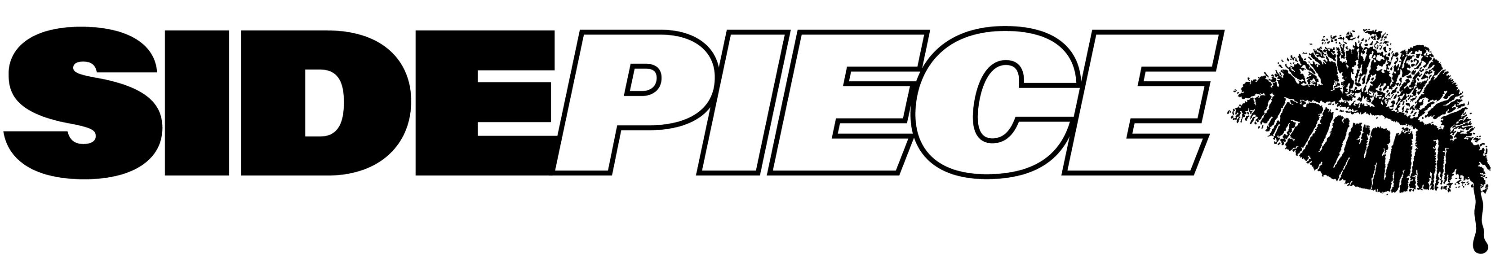GRAMMY® AWARD-NOMINATED DANCE DUO SIDEPIECE
SHARE “STIMULATE” + “WHAT YOU NEED”

UPCOMING LIVE SCHEDULE INCLUDES TOP-BILLED FESTIVAL APPEARANCES
AND BIGGEST HEADLINE SHOWS TO DATE

LISTEN TO “STIMULATE” HERE | LISTEN TO “WHAT YOU NEED” HERE

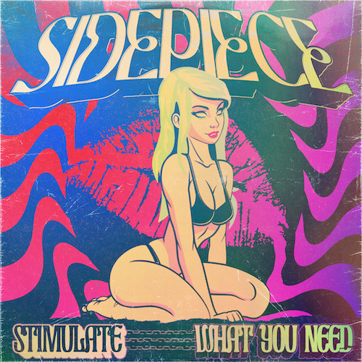
DOWNLOAD HI-RES ARTWORK

SIDEPIECE – the GRAMMY® Award-nominated dance duo comprised of multimillion streaming DJ/producers NITTI (Ricky Mears) and Party Favor (Dylan Ragland) – continue to heat up the long hot summer with today’s premiere of a brand-new two-track single, “Stimulate” // “What You Need,” available now via Big Beat Records at all DSPs and streaming services HERE.

“Stimulate” // “What You Need” continues a spectacular series of singles from SIDEPIECE, including the feel-good hit, “I NEED U (Feat. ZOI).” EDM.com raved, “‘I NEED U’ is the latest triumph for SIDEPIECE, whose rise through the dance music ranks can only be described as meteoric. Characterized by infectious melodies and basslines you can feel in your bones, their slick and sultry house sound resonates with listeners of all backgrounds.”

“I NEED U (Feat. ZOI)” in turn followed SIDEPIECE’s 2022 label debut single, “Reborn,” joined by an Extended Mix and exclusive Kyle Walker Remix.

SIDEPIECE are currently traveling North America with headline performances and festival appearances slated through October. Highlights include a just-announced headline show at Miami, FL’s famed Club Space (October 6) and top-billed sets at Baltimore, MD’s Moonrise Festival (August 12) and Austin, TX’s Austin City Limits Music Festival (October 8 and 15). Additional dates will be announced soon. For complete details and remaining ticket information, please visit youasidepiece.com.

SIDEPIECE also recently joined forces with hip-hop legend Lil Wayne for the first-ever official remix of his chart-topping, GRAMMY® Award-winning 6x RIAA Platinum-certified 2008 smash, “A Milli,” available now HERE. An official visual is streaming now at YouTube HERE. Now boasting over 10.5M worldwide streams, “A Milli (Remix)” made a top 20 debut on Billboard’s “Hot Dance/Electronic Songs” chart upon its release earlier this year – SIDEPIECE’s third and highest-ranking appearance on the chart thus far.

While Dylan Ragland and Ricky Mears meant to start a side project, they weren’t expecting to create SIDEPIECE – a GRAMMY® Award-nominated house duo that’s clocked more than 362M global streams since its inception. The two creatives – Ragland makes music as fan favorite Party Favor while Mears produces as dancefloor igniter NITTI – first linked via DM in 2019 to share track ideas. Sensing their musical chemistry, they jumped on Facetime. By the end of the call, they’d registered the @youasidepiece social handles and their own figurative sidepiece had been born.

“It started out as a fun passion project because we both love and care about house music,” says Dylan Ragland, “but it’s grown so much bigger than we originally planned.”

Indeed, success came fast for the pair. SIDEPIECE’s second single, the 2020 Diplo collaboration “On My Mind,” proved a global smash, earning more than 225M global streams, Gold and Platinum certifications in a dozen countries around the world, and a prestigious 2021 GRAMMY® Award nomination for “Best Dance Recording.”

A flurry of additional hit singles followed, with SIDEPIECE carving out a signature sound rooted in catchy vocals – “The most important element,” says Ragland – and an ever-intoxicating bump-and-grind house groove. Spanning tech house, bass house, and beyond, tracks including “Acrobatic,” “Temptation,” “Sextacy” and “Reborn” are all quintessentially SIDEPIECE – party-starting club records with a pop-lean and serious sex appeal.

“Huge streaming numbers are cool,” says Ricky Mears, “but seeing people in the crowd singing along to the song, that makes it all feel real.”

# # #

SIDEPIECE
TOUR 2023

JULY
28 – Las Vegas, NV – Marquee Nightclub

AUGUST
11– Las Vegas, NV – TAO Beach Dayclub
13 – Baltimore, MD – Moonrise Festival *
26 – Barcelona, ES – Razzmatazz
27 – Amsterdam, NL – Mysteryland
28 –Sant Antoni de Portmany, ES – O Beach Ibiza

OCTOBER
6 – Miami, FL – Club Space
8 – Austin, TX – Austin City Limits Music Festival *
15 – Austin, TX – Austin City Limits Music Festival *

* FESTIVAL PERFORMANCE

# # #

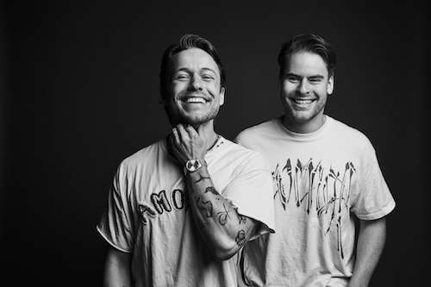
DOWNLOAD HI-RES PRESS PHOTOS // PHOTO CREDIT: JIMMY FONTAINE

CONNECT WITH SIDEPIECE
WEBSITE | FACEBOOK | INSTAGRAM | SOUNDCLOUD | SPOTIFY | TWITTER | YOUTUBE

Press contacts: Paige.Rosoff@atlanticrecords.com, Gabrielle.Reese@atlanticrecords.com

