Superstar DJ/producer Robin Schulz releases new album Pink

BUY/STREAM HERE

Watch the official video for single “Smash My Heart” here

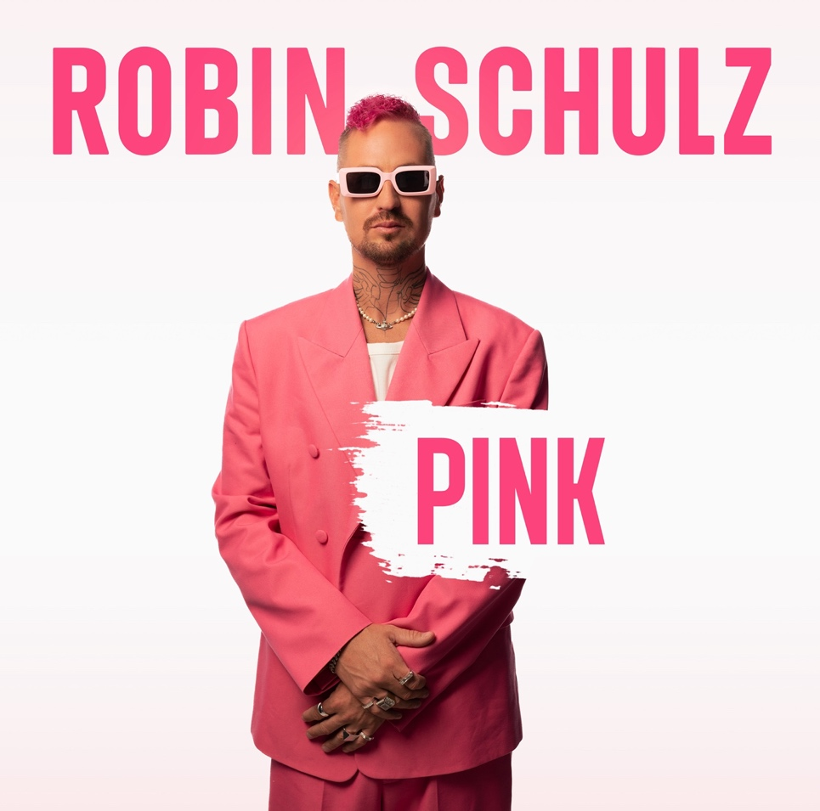

download hi-res artwork HERE

August 25, 2023 – Superstar German DJ/producer Robin Schulz has released his new album, Pink.

Boasting a total of 17 tracks, the album contains the previously-released singles “Killer Queen” with FIL BO RIVA, “Young Right Now” with Dennis Lloyd, “Sweet Goodbye,” “On Repeat” with David Guetta, “Sun Will Shine” with Tom Walker, “Somewhere Over the Rainbow / What a Wonderful World” with Alle Farben & Israel Kamakawiwo’ole, and most recent single “Smash My Heart.” Amassing over 8M streams so far, “Smash My Heart” also serves as the official trailer song for the new season of hit dating reality show, “Love Island.”

Last night, Schulz celebrated the arrival of his fifth studio album with a release party at Pacha, Ibiza, as part of his weekly headline residency.

Speaking about Pink, Robin Schulz shares:

“The release of ‘Pink’ is a moment I've been eagerly awaiting for two years. This album is a tribute to my artistic evolution, and I can't wait to unveil the various dimensions of my music to my fans and the global audience. This album encapsulates my creative journey, and after a two-year anticipation, the release of ‘Pink’ feels like a musical homecoming.”
Pink marks Schulz’s fifth studio album and is the follow-up to IIII, which was released in 2021. Officially the most successful German artist abroad in the history of modern music, Robin has received over 840 Gold, Platinum, and Diamond awards in 30 countries. Just recently, Warner Music Central Europe (WMCE) honored him with a new batch of 15 German awards, adding to his already awe-inspiring record.
The story of Robin Schulz is a testament to the extraordinary power of dreams. Born and raised in a medium-sized German city with a population somewhere in the 160,000s and an excitement level that can be described as middle-rate at best, Schulz has transcended boundaries and become a global sensation. He travels the world nonstop to play packed clubs, the world’s biggest festivals, such as Tomorrowland, Parookaville, and Ultra Music Festival, and his annual summer residency at Pacha, Ibiza, always captivating audiences with his electrifying performances.

Schulz's fairytale-like success story began in 2014 when he first ascended to the top of worldwide singles charts with his acclaimed remix of "Waves (feat. Mr. Probz)" and landed his breakthrough global uber-hit “Prayer in C (feat. Lilly Wood & The Prick).”

“Sugar (feat. Francesco Yates)” followed shortly after in 2015. That song recently made its entry to Spotify’s famed Billions Club.
Blending elements of house, electro, and pop, Schulz quickly emerged as Germany's most successful musical export, dominating charts with numerous #1 hits in over 20 countries. His immense popularity is further highlighted by over 20 million sales and an astonishing 12 billion streams worldwide. In his home country, he has also set an unmatched record with an astounding 14 airplay #1 hits and counting.
With a name that echoes through the halls of music history, Robin Schulz has amassed a staggering array of achievements that have solidified his status as one of the industry's most successful artists. Now, the superstar DJ/producer is ringing in a new artistic era with Pink.
ROBIN SCHULZ – PINK
01. Intro
02. Smash My Heart
03. No Drama
04. Young Right Now (with Dennis Lloyd)
05. Killer Queen (with FIL BO RIVA)
06. Sweet Goodbye
07. Echoes
08. Break For You
09. On Repeat (with David Guetta)
10. Die For You
11. One With The Wolves
12. Sun Will Shine (with Tom Walker)
13. Memories
14. Satellite
15. Somewhere Over the Rainbow / What a Wonderful World (with Alle Farben & Israel Kamakawiwo’ole)
16. Sight
17. Waiting For The Sunshine

