JOEL CORRY TEAMS UP WITH
ICONA POP & RAIN RADIO ON NEW SINGLE
‘DESIRE’

LISTEN HERE

JOEL ALSO ANNOUNCES EVER-EVOLVING
‘ANOTHER FRIDAY NIGHT’ PROJECT

KEEP UP TO DATE
THROUGHOUT THE SUMMER HERE

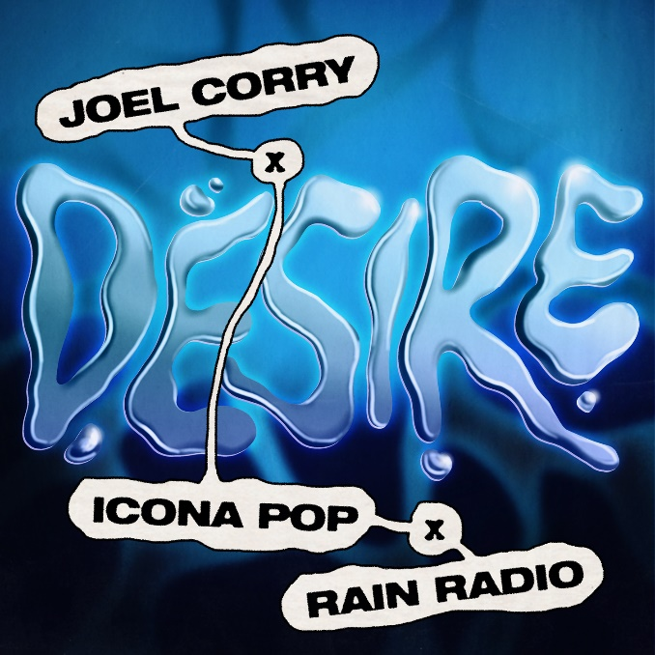

Multi BRIT-nominated DJ/producer Joel Corry has joined forces with cult dance-pop innovators Icona Pop and breakout UK house & UKG producer outfit, Rain Radio, on new single, ‘Desire’ – listen HERE.

Already riding high in the UK Singles Charts alongside Nathan Dawe & Ella Henderson on the anthemic ‘0800 HEAVEN’, ‘Desire’ lands as the latest in a stream of new records from Joel, who continues to push his music into exciting and dynamic new spaces.

Following collaborations with Billen Ted & Elphi (‘Do You Want Me Baby?’) and Caity Baser (‘Dance Around It’), ‘Desire’ is elastic, dance-til-you-sweat club music at its purest. Teased in Joel’s sets for the best part of a year to rapturous approval from his fans, it sees him collaborate with Icona Pop – fresh from announcing their new album, ‘Club Romantech’ – and hotly-tipped producer duo, Rain Radio, for the first time.

“I’m so excited to finally release ‘Desire’ with Icona Pop and Rain Radio”, Joel says. “It’s been the most requested track ID in my sets for months and always goes off wherever I play it across the globe.”

‘Desire’ also lands as the first single to be lifted from Joel’s ever-evolving new project, ‘Another Friday Night’. Featuring a host of his biggest hit records from the last five years including ‘Sorry’, ‘Lonely’, ‘Head & Heart’ ft. MNEK, ‘BED’ with RAYE & David Guetta, ‘OUT OUT’ with Jax Jones, Charli XCX & Saweetie & more, ‘Another Friday Night’ will continue to take shape throughout the summer – listen and stay up to date HERE.

Look out for more from Joel Corry Soon.

Joel Corry x Icona Pop x Rain Radio – ‘Desire’ is out now: https://joelcorry.lnk.to/Desire

About Joel Corry
No one's doing it quite like Joel Corry. He's a hit machine who tops mainstream and underground charts, with 5x UK platinum records, including UK #1 single ‘Head & Heart’ with MNEK, and collaborations with Charli XCX, Mabel, RAYE, Tom Grennan, Bryson Tiller and David Guetta under his belt. Joel’s signature is his earworm hooks and strong melodies that connect on an emotional level. It’s an addictive sound that people keep coming back to, reflecting his ambition to make music that’s timeless. Although a certified pop star, he’s still a raver at heart, with his best memories made on dancefloors, and he holds down DJ residencies at some of the world's best clubs from Las Vegas to Ibiza, alongside playing festivals from Ultra to Tomorrowland amid a relentless touring schedule. He never stays still: constantly evolving, hitting milestone after milestone in pop and dance music, always hungry for more.

CONNECT WITH JOEL CORRY:
FACEBOOK / TWITTER / INSTAGRAM / TIK TOK / YOUTUBE / WEBSITE

CONNECT WITH ICONA POP:
FACEBOOK / TWITTER / INSTAGRAM / TIK TOK / YOUTUBE / WEBSITE

CONNECT WITH RAIN RADIO:
INSTAGRAM / TIK TOK / SOUNDCLOUD

US press contacts:
Leanne Allen Leanne@listen-up.biz
Shelby Pinckard shelby@listen-up.biz
Charlotte Wilson charlotte@listen-up.biz
Gabrielle Reese Gabrielle.reese@atlanticrecords.com |

