FOR IMMEDIATE RELEASE APRIL 7, 2023

COBRAH ANNOUNCES THE “ICON” TOUR

HER FIRST EVER TOUR IN THE US BEGINS JUNE 2 IN LOS ANGELES, FOLLOWED BY PRIDE MONTH STOPS IN
CHICAGO, BOSTON, AND BROOKLYN

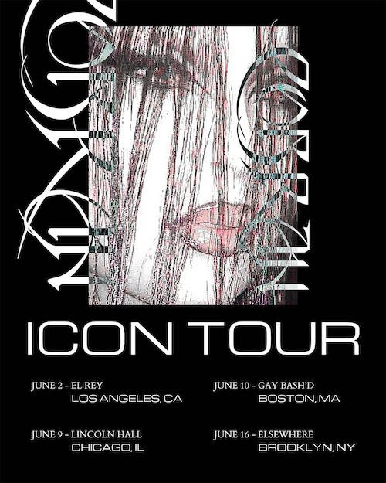
TICKETS FOR ALL DATES ON SALE TODAY HERE NEW MUSIC TO ARRIVE NEXT MONTH

“COBRAH’s energetic live shows are sweaty, awesome and a must-see.” – i-D

Swedish electro-pop sensation COBRAH has announced plans for her first ever US live tour. “THE ICON TOUR” – which was first unveiled via Instagram earlier this week – gets underway June 2 at Los Angeles, CA’s historic El Rey Theatre and then makes Pride Month stops at Chicago, IL’s Lincoln Hall (June 9), Boston, MA’s Gay Bash’d (June 10), and Brooklyn, NY’s Elsewhere (June 16). Tickets for all announced dates are on sale today. For complete details, please visit www.cobrahcore.com.

Inspired by the fetish club scene, COBRAH is a femme fatale in latex and chains, known for her fantasy goth visual aesthetic, high energy live performances, and a string of electrifying club smashes. The multidisciplinary artist grew up in Gothenburg, Sweden’s second largest city, but soon moved to her country’s capital. It was there COBRAH became immersed in Stockholm’s fetish scene, which inspired and shaped her already ambitious creativity.

2019 saw the arrival of her debut EP, ICON, highlighted by the lead single, “U KNOW ME,” which saw featured placement on EA’s blockbuster FIFA 22, as well as the breakout hit, “IDFKA,” joined by a stunning companion video later honored with a “Music Video of the Year” nomination from the Swedish Grammis.

The self-titled COBRAH EP arrived in 2021, self-released on the artist’s own GAGBALL label. Hailed by NME as “a self-assured slab of sexy, celebratory wonky-pop,” the EP saw COBRAH’s star ascend via bangers like “GOOD PUSS,” which earned her a prestigious Grammis nod for “Electro/Dance of the Year”. What’s more, the irresistible track was featured in the trailer to A24’s acclaimed 2022 film, Bodies Bodies Bodies, and was recently remixed by like-minded Chicago rapper CupcakKe (streaming HERE).

In addition to international press attention, COBRAH – who recently lit up London with a spectacular live set at sold out Printworks mega club – and previously supported Charli XCX on tour – has seen worldwide support from such top dance playlists as Spotify’s “mint” and “Dance Rising” along with dynamic collaborations with high fashion brands like Jean Paul Gaultier, Mugler and recently soundtracked the advert for Viktor & Rolf perfume starring Emily Ratajkowski.

Now, “THE ICON TOUR” heralds a breakthrough year for COBRAH, with an array of new music
and visual releases set for the weeks and months to come.

CONNECT WITH COBRAH
OFFICIAL | FACEBOOK | INSTAGRAM | TIKTOK | TWITTER | YOUTUBE

Press Contact:
Paige.Rosoff@atlanticrecords.com
# # #

