FOR IMMEDIATE RELEASE
JUNE 16, 2023

COBRAH DROPS SALACIOUS NEW SINGLE “SUCK”
ALONGSIDE TANTALIZING MUSIC VIDEO

THE MULTI-FACETED EXPERIMENTAL ELECTRONIC ARTIST SHARES HER FIRST RELEASE ON
BIG BEAT RECORDS

SOLD-OUT HEADLINE TOUR CONCLUDES TONIGHT
AT BROOKLYN, NY’S ELSEWHERE

LISTEN TO “SUCK” | WATCH OFFICIAL MUSIC VIDEO

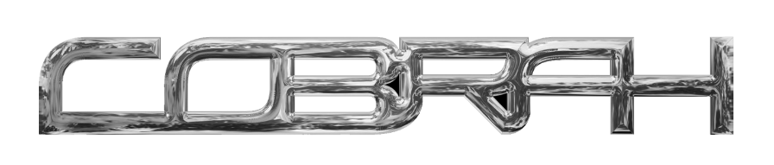
DOWNLOAD HI-RES ARTWORK

Electro-pop sensation COBRAH has shared her new club anthem, “SUCK”, available now everywhere HERE. An equally sensual official companion video premieres today – watch HERE.

“SUCK” arrives just as COBRAH wraps up her first-ever US live run, THE ICON TOUR, which has been making hugely successful stops across the US – including a pair of sold-out dates at Los Angeles, CA’s historic El Rey Theatre – and culminates tonight, June 16, with the second of two sold-out headline shows at Brooklyn, NY’s Elsewhere. Along the way she made a stop to give an incredibly iconic set for Boiler Room. Upcoming dates include a top-billed performance at San Francisco, CA’s Portola Festival set for September 30-October 1. Additional dates will be announced. Visit www.cobrahcore.com for more details.

Five years ago, Clara, aka COBRAH, for the first time squeezed herself into a black latex catsuit. On top of it she added a corset, cinched tight. Really tight.

In this moment, she says, she’d “never been so thrilled about anything. It was like falling in love.”

It wasn’t just about the thrill of skintight fetish wear. It was that in this moment, Clara fully transformed into COBRAH, the experimental electronic artist that’s since become not only her alter-ego, but a globally celebrated vocalist, producer, fashion iconoclast and cultural boundary-pusher whose sleek, playful, often subversive views of sexuality and female power emanate from every note, every purred vocal and every clothing stich. The multidisciplinary artist grew up in Gothenburg, Sweden’s second largest city, but soon moved to her country’s capitol. It was there COBRAH became immersed in Stockholm’s fetish scene, which inspired and shaped her already ambitious creativity.

2019 saw the arrival of her debut EP, ICON, highlighted by the lead single, “U KNOW ME,” which saw featured placement on EA’s blockbuster FIFA 22, as well as the breakout hit, “IDFKA,” joined by a stunning companion video later honored with a “Music Video of the Year” nomination from the Swedish Grammis.

The self-titled COBRAH EP arrived in 2021, self-released on the artist’s own GAGBALL label. Hailed by NME as “a self-assured slab of sexy, celebratory wonky-pop,” the EP saw COBRAH’s star ascend via bangers like “GOOD PUSS,” which earned more than 25M worldwide streams and a prestigious Grammis nod for “Electro/Dance of the Year.” Moreover, the irresistible track was featured in the trailer to A24’s acclaimed 2022 film, Bodies Bodies Bodies, and was recently remixed by like-minded Chicago rapper CupcakKe (streaming HERE).

In addition to international press attention spanning Out to i-D, COBRAH – who recently lit up stages in London and Stockholm alongside Charli XCX – has seen worldwide support from such top dance playlists as Spotify’s “mint” and “Dance Rising,” along with dynamic collaborations with high fashion brands like Jean Paul Gaultier.

“’SUCK’ started out as a gag that grew with time. It was my first day back in the studio after the COBRAH EP and I just wanted to have fun with music! It feels very symbolic releasing it as the start of something new and I’ve been carrying the idea of using suction cups foreverrrr so to finally give birth to this world I’ve created is amazing! (also the song makes me feel really sexy which is hot).“ “SUCK” now heralds what is sure to be a breakthrough year for COBRAH, with an array of new music and visuals to come.
‘SUCK’ is COBRAH’s first release after signing with Big Beat Records. “Happy to have sold my soul to a record label that will make sure I go to hell when I die by making my depraved dreams come true.”

# # #

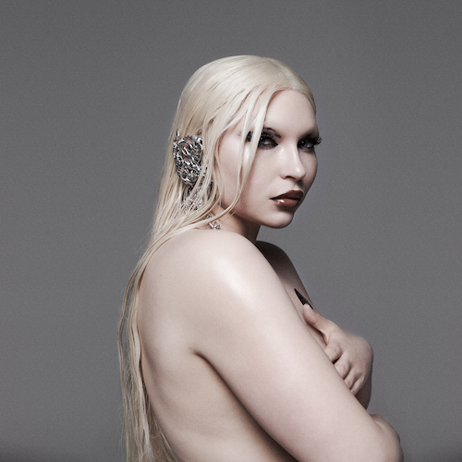
DOWNLOAD HI-RES IMAGE // PHOTO CREDIT: NINJA HANNA

# # #

COBRAH
TOUR 2023

JUNE
16 – New York, NY – Elsewhere

SEPTEMBER
30 – San Francisco, CA – Portola Festival 2023 (Pier 80)

OCTOBER
1 – San Francisco, CA – Portola Festival 2023 (Pier 80)

# # #

CONNECT WITH COBRAH
OFFICIAL | FACEBOOK | INSTAGRAM | TIKTOK | TWITTER | YOUTUBE

FOR MORE INFORMATION ON COBRAH:
Paige Rosoff – Atlantic Records
Paige.Rosoff@atlanticrecords.com

