Robin Schulz releases new single “Killer Queen”

BUY/STREAM HERE

The producer’s new track is a rework of FIL BO RIVA’s song of the same name, which was released in 2016

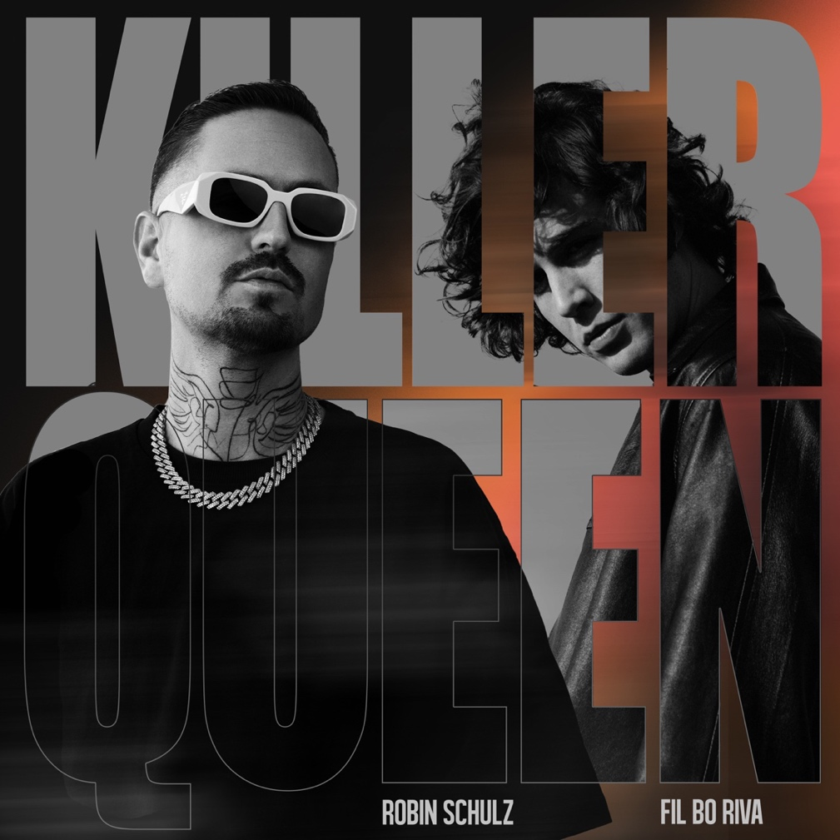

May 19, 2023 – Robin Schulz is an international superstar – this fact is nothing new, but was once again impressively underlined a few weeks ago: During the Coronation concert for King Charles at Windsor Castle, he took to the stage for a performance with Take That and Calum Scott, which was broadcast around the world by BBC television. Now, the German DJ and producer is ready to present his new track “Killer Queen,” a rework of FIL BO RIVA’s song of the same name, which was released in 2016.

FIL BO RIVA’s voice – deep, soulful, sonorous – made the original a track to be remembered. It was his first single and rightfully marked his breakthrough. Robin Schulz has proven again and again that great songs are not an argument against a rework, but instead, a valid reason to create one. There’s hardly any other producer who knows how to highlight the strengths of a song as well as Schulz does, while at the same time putting his unmistakable stamp on it.

This applies to today’s release of “Killer Queen.” In his version, Schulz slightly picks up the tempo as he covers the rough character of the original with his unmistakable Deep House coating, anchored by a gently driving beat and yearning guitar. “It's alright if you're my lady, you're a killer queen,” FIL BO RIVA sings, “I don't mind you make me crazy.”

There’s no doubt this song will make its mark on the dancefloor in the coming months, including at Schulz’s upcoming festival dates: Tomorrowland (BE), Sputnik Springbreak (GER), Echelon Festival (GER), Glücksgefühle (GER), FM4 Frequency (AT), and Tecate Pa’l Norte (Mexico).

“Killer Queen” by Robin Schulz feat. FIL BO RIVA is released via Warner Music Central Europa and is available now – listen HERE.

About Robin Schulz:
10 years after his initial remix smash “Waves” (originally by Mr. Probz), Robin Schulz has easily become international House/Dance royalty – with more than 20 million records sold, 450+ Gold/Platinum/Diamond certifications (in 30 countries), 4 German ECHO Award wins, and a GRAMMY® nomination for “Best Remixed Recording.”

Known for his iconic collaborations with musical greats including David Guetta, James Blunt, Justin Bieber, and Sam Martin, which also made him an airplay #1 sensation in his native Germany [a pinnacle he’s reached 14 times], Schulz’s tracks have topped the charts in more than 20 countries.

With over 4 billion streams to his name, Robin Schulz is one of the most streamed artists on the planet.

His latest single “Sweet Goodbye” was released in February 2023.

About FIL BO RIVA:
FIL BO RIVA is an Italian singer, songwriter, and musician, currently based in Berlin. His music merges melancholic singer-songwriter pop with elements of folk and soul. It is also characterised by his distinctive voice.

From a young age, he played in various bands, and in 2019, he released his debut album, Beautiful Sadness. The same year, he was nominated for the Music Moves Europe Talent Award.

FIL BO RIVA has supported acts like AnnenMayKantereit and Joan As Police Woman live. His latest single, “Everything’s Illusion,” was released at the end of April, and this September, he will release his new album, Modern Melancholia.

