JOEL CORRY & RON CARROLL LACE UP TIGHT FOR STREET-READY NEW SINGLE “NIKES”

Listen HERE

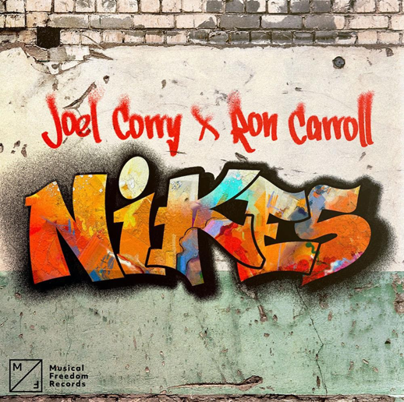

Sporting one of the freshest looks of the year, Joel Corry & Ron Carroll are finally unboxing their newest single “Nikes.” Offering a contemporary take on Ron Carroll’s silky smooth “Walking Down The Street,” the new release pairs a succulent and swaggy house beat with an undeniably contagious hook. Listen HERE!

The new single sees UK tastemaker Joel Corry continue his meteoric rise to the top, building on the momentum from his game changing 2022– a year that saw him debut on the mainstage of Tomorrowland, enter DJMag’s coveted Top 100, and conquer the charts through head turning releases like “HISTORY” with Becky Hill, "What Would You Do" alongside David Guetta & Bryson Tyler, and even a remix of Elton & Britney's smash "Hold Me Closer." Now amping up for his debut at the sun-soaked Ultra and Miami Music Week, Joel Corry continues to bring the beat, this time in the form of the bass-heavy beat, “Nikes.”

Commenting on the upcoming release, Joel Corry says: "’Nikes’ has been a weapon in my club sets for months and I'm buzzing to officially release it! Ron Carroll's original 'Walking Down The Street' is a banger and I hope people love my spin on it."

In addition to radiowaves and streaming platforms, "Nikes" will also be available in Web3 through an official partnership with Elynxir, a cross platform game powered by their distinguished music verse OS. The new single will coincide with the release of the first of its kind Astral quest system, ultimately letting players influence an AI-generated remix of “Nikes.”

A proper follow up to his late 2022 hit “Lionheart,” his new release sees Joel flip the script yet again, switching focus from stadium anthems to fan-favorite DJ weapon.

Connect with Joel Corry
Instagram | Spotify | TikTok | Twitter | Facebook | Website

US press contact: gabrielle.reese@atlanticrecords.com

