Global superstar Robin Schulz and Scottish singer-songwriter Tom Walker make the sun shine on new track

BUY/STREAM “SUN WILL SHINE” HERE

(download hi-res photo of Robin Schulz here; Courtesy Warner Music Group)

July 29th, 2022 – DJ and producer Robin Schulz has become a global star because of the way he can emotionalize melodies and beats. On top of that, his special knack for collaboration is another quality distinguishing the Osnabrück native from the crowd. After recently teaming up with Dennis Lloyd from Israel (“Young Right Now”), Justin Quiles from Puerto Rico (“AEIOU”) and his good friend from France, David Guetta (“On Repeat“), his new single “Sun Will Shine“ features one of the most striking singer-songwriter voices of our time: Tom Walker from Scotland. Walker’s scratchy, warm voice perfectly complements Schulz’s production. Yet at the start of the song, which is co-written by Steve Mac (Ed Sheeran, BTS, Tones And I, Biffy Clyro) there’s not much sun to be seen…

“It feels like we're falling apart / Just a little unstable / We’re both half asleep at the wheel / Yeah we're struggling to save us,” Tom Walker sings of a relationship that’s dangerously faltering. But when something has grown over the years, you don’t give up that easily – especially if the last words haven’t been said yet: “So we both get drunk / And talk all night / Pour out our hearts / Try to make it right.”

As the two lovers make amends and try to get closer to each other again, the song also changes. Having started with floating piano chords, gentle clapping and soft bass beats make room for grander production that builds until the song culminates into a glistening, beautiful drop, anchored by Schulz’s inspiring production and the chorus statement “It will be alright.”

Schulz describes his single as “the perfect soundtrack for a sunset.” Of collaborating with Tom Walker, Schulz shares: “I’m a huge fan of his and finally it worked out that we could release a single together. That fact that Steve Mac co-wrote the track is also a big honor.”

Walker adds: “I originally wrote this song as a ballad for my album. It’s about whatever problems you are having today, tomorrow will bring a new day with new possibilities and hopefully some sunshine. Robin is a dance legend and I’m buzzing to be collaborating with him on this song and how he has transformed it into a feel-good summer banger.”

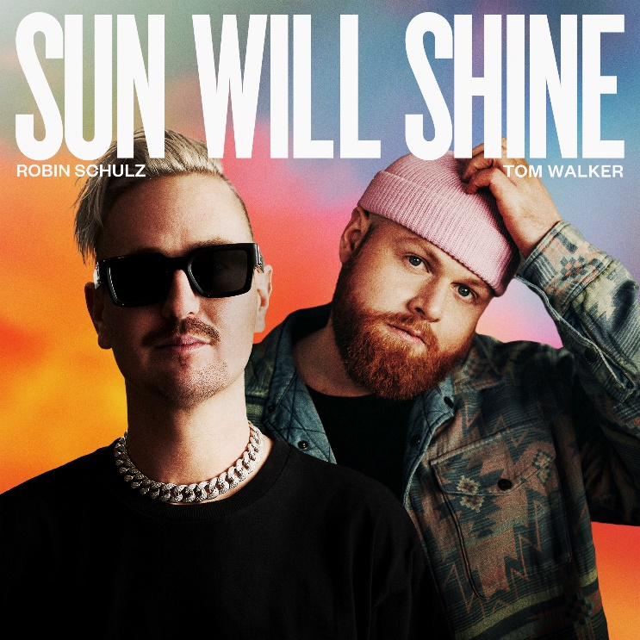
(download hi-res artwork here)

About Robin Schulz:

Boasting more than 450 gold, platinum, and diamond awards in 30 countries and clocking in over 20 million sales and 10.5 billion streams globally, Robin Schulz is the most successful German artist of all time, internationally. The GRAMMY® Award-nominated, four-time ECHO award-winner was also honored in 2016 with the Spotify award for "Most Viral Track Of The Year" for his smash "Sugar."

Schulz also made a personal dream come true in 2017 with the launch of his own clothing line, created in collaboration with fashion brand Q/S. That same year, a feature film about the DJ and producer premiered at German movie theatres: 'Robin Schulz – The Movie' documents his rise from talented newcomer to internationally acclaimed superstar and offers a fascinating glimpse behind the scenes.

In February of 2021, Robin Schulz released his fourth studio album, 'IIII,' which reached the top 10 in Germany and Switzerland. He's since released more singles, most recently his collaboration with David Guetta, "On Repeat." Next month, his mega hit "Sugar (feat. Francesco Yates)" will break the 1 billion stream mark on Spotify and move into the prestigious 'Billions Club.' After Zedd and Felix Jaehn, he is only the third German to do so.

This summer, Schulz is playing a residency at PACHA in Ibiza and performing at festivals such as Tomorrowland in Belgium and Lollapalooza Berlin.

About Tom Walker:

Tom Walker, whose global streams have passed three billion and who has sold over two million albums worldwide, was the biggest selling UK-signed artist of 2019 and is currently working on the follow up to his No.1 platinum debut What A Time To Be Alive. Since bursting onto the charts with his international breakthrough single “Leave A Light On” in 2018, Walker has gone on to sell out shows across the globe, support artists such as Jake Bugg and George Ezra on tour, and even capped off 2021 with a truly special performance with The Duchess Of Cambridge from Westminster Abbey, who joined Walker on piano for a memorable version of his track, “For Those Who Can’t Be Here.”

