100 GECS ANNOUNCES NORTH AMERICAN TOUR DATES

ARTIST PRE-SALE JAN 25TH & GENERAL ON-SALE JAN 27TH

﻿10,000 GECS OUT MARCH 17TH VIA
﻿DOG SHOW RECORDS / ATLANTIC RECORDS

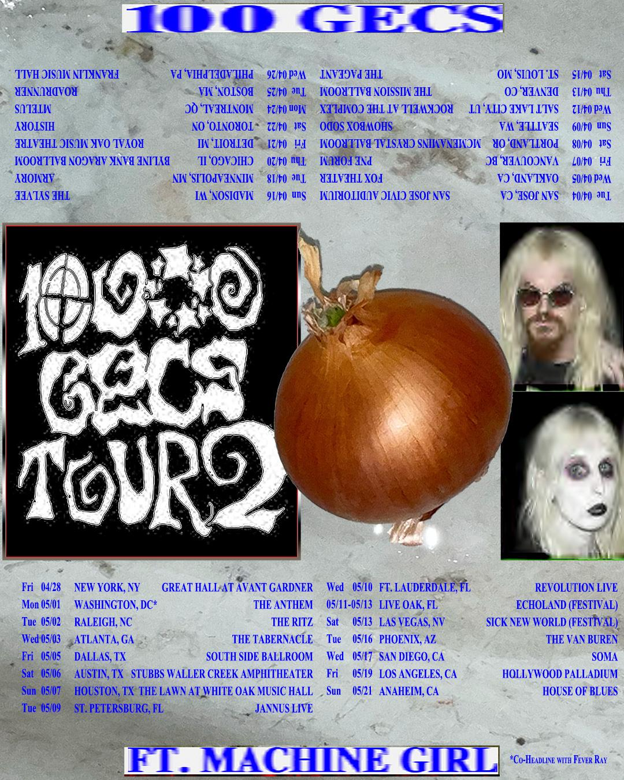
TOUR PRE-SALE ACCESS 100gecs.com/tour
ALBUM PRE-ORDER 100gecs.com

WHAT THE PRESS ARE SAYING ABOUT 100 GECS LIVE:

"a duo on the precipice of something great, even groundbreaking, the energy at the show was near-indescribable"
The Daily Cal

"electrifyingly, disorientingly great."
The Guardian

"waste time trying to decipher what it means, or embrace the absurdity and jump around."
Rolling Stone

"a pungent medley of vape smoke, Gen Z mosh-sweat, and hundreds of spilled drinks — was the lingering effect of gecs"
The Boston Globe

(JANUARY 19, 2023) -100 gecs announce an upcoming North American tour in conjunction with the release of their highly anticipated sophomore album, 10,000 gecs. The album will arrive on March 17th, 2023, via Dog Show Records / Atlantic Records with the tour tailing the release beginning April 4th until May 21st, performing shows in Chicago, Montreal, New York, Atlanta, and Los Angeles. The dates are part of the 10,000 gecs tour, which included a sold out North American leg in 2021, a successful European leg last year, and high profile appearances at festivals such as Coachella, Primavera, Lollapalooza, and Bonnaroo. They kick off their sold out Australian shows later this month before starting the tour again in April with support from Machine Girl and Fever Ray. Their tour featured unreleased 10,000 gecs album songs "Hollywood Baby," "757," and "what's that smell?" These songs have been widely circulated through obscurely grainy videos that circulated throughout the tour, and fans have been eagerly waiting for them to be released. The group was also handpicked to support Nine Inch Nails and My Chemical Romance last year.

Sign up for pre-sale access at 100gecs.com/tour. Pre-sale tickets will go on sale on Wednesday, Jan 25th at 10am local time and general sale on Friday, Jan 27th at 10am local time here.

Following their breakout debut album, 1,000 gecs, the anticipation of their next body of work has been high and the band’s teases have been plentiful. They recently released a surprise EP, Snake Eyes. The EP features 3 unreleased tracks including “Torture Me” featuring Skrillex and “Hey Big Man” which has been a crowd favorite as the show opener on their tour. They detailed the early 10,000 gecs creation process in an illuminating 2021 Pitchfork Cover Story that took fans into the studio with the duo for the first time. The forthcoming album is set to include previously released single “mememe” which was described in the story as "an ebullient carnival of ska-inflected verses that bounce off a chorus of thrash guitars and a squiggling synth line" along with the 90’s Alt Rock-inspired “Doritos & Fritos,” which The FADER noted as "unlike any other Gecs track before it.” 10,000 gecs is available for pre-order now.

For those yet initiated: 100 gecs planted their flag on the proverbial pop culture moon with their 2019 debut album 1000 gecs, which was heralded by The New Yorker as, “an impressively precise maximalist exercise with no rules” and “utterly unhinged in the best way possible” by GQ. The innovative project captured the hearts of fans and critics alike - selling out all of their live shows to date along with The New York Times calling it, “some of the savviest pop music of the year,” and Rolling Stone dubbing it “one of 2019’s most exciting debuts.” In just a few months following the release of 1,000 gecs, the band went from playing their first concert from inside the video game Minecraft to selling out shows across the country, proving that their rabid, rapidly multiplying fanbase doesn't only exist in the far corners of the internet. After their world tour was postponed in the summer of 2020, Brady and Les kept rolling with the release of 1,000 gecs and The Tree of Clues, a rework of the original album featuring collaborations from the likes of A. G. Cook, Fall Out Boy, Charli XCX, Rico Nasty, as well as crowd sourced contributions by fans. The transformative release was described by The NME as a “brain-melting, genre-crushing vision of pop’s future.” Their subsequent international touring over the past two years has sent the unlikely wizard-cloaked pied pipers jumping from sold-out show to sold-out show, seemingly two steps ahead of the zeitgeist, not to mention having a blast while doing it.

As a band that has kept followers and the music scene as a whole guessing at every turn, we never know what to expect is coming next from the duo, but one unknown thing that has been on the mind of all of their die-hard fans for three years now is known.

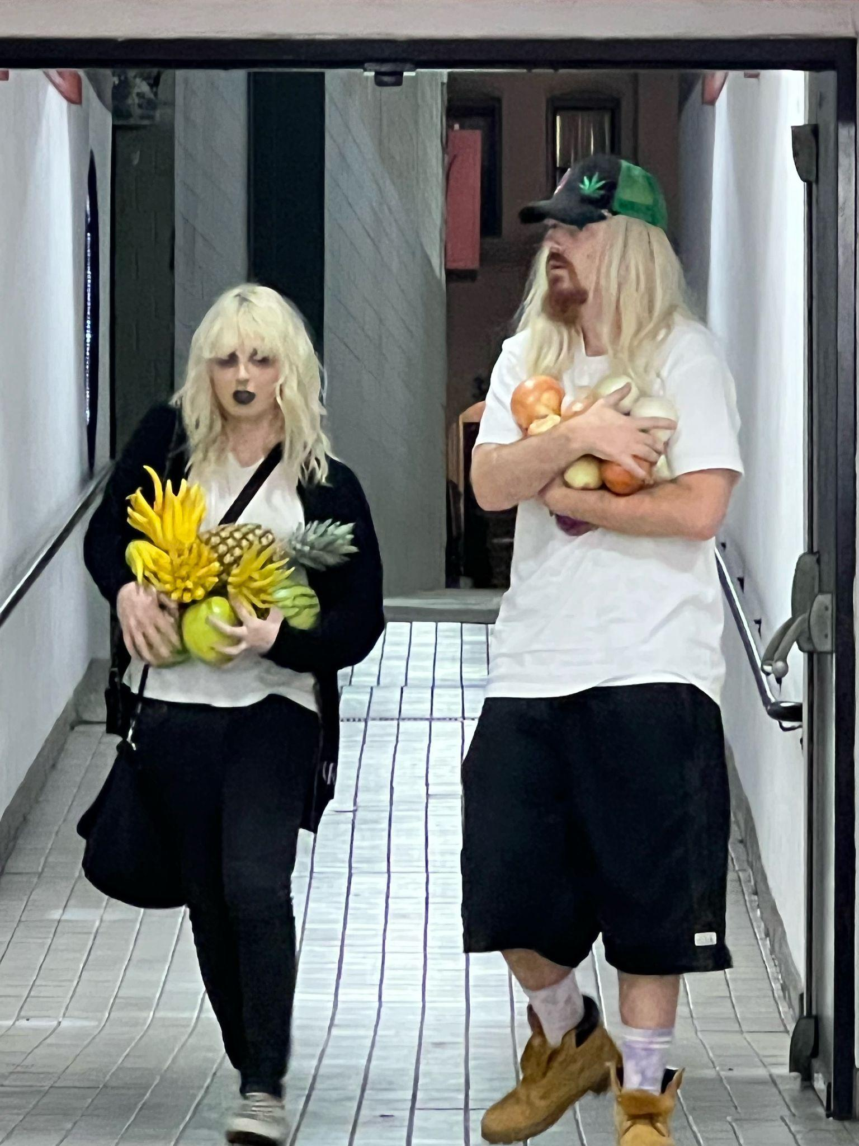
﻿100 GECS TOUR DATES:

1/29 - Auckland, NZ @ Laneway pre-party
1/30 @ Auckland, NZ @ Laneway Festival Auckland
1/31 - Wellington, AU @ San Francisco Bath Club
2/3 - Sydney, AU @ Metro Theatre
2/4 - Fortitude Valley, AU @ Laneway Festival Brisne
2/5 - Sydney, AU @ Laneway Festival Sydney
2/9 - Melbourne, AU @ Northcote Theathre
2/10 - Adelaide, AU @ Laneway Festival Adelaide
2/11 - Melbourne, AU @ Laneway Festival Melbourne
2/12 - Perth, AU @ Laneway Festival Perth

4/4 - San Jose, CA @ San Jose Civic Auditorium
4/5 - Oakland, CA @ Fox Theater
4/7 - Vancouver, BC @ PNE Forum
4/8 - Portland, OR @ McMenamins Crystal Ballroom
4/9 - Seattle, WA @ Showbox SoDo
4/12 - Salt Lake City, UT @ Rockwell at The Complex
4/13 - Denver, CO @ The Mission Ballroom
4/15 - St. Louis, MO @ The Pageant
4/16 - Madison, WI @ The Sylvee
4/18 - Minneapolis, MN @ Armory
4/20 - Chicago, IL @ Byline Bank Aragon Ballroom
4/21 - Detroit, MI @ Royal Oak Music Theatre
4/22 - Toronto, ON @ HISTORY
4/24 - Montreal, QC @ MTelus
4/25 - Boston, MA @ Roadrunner
4/26 - Philadelphia, PA @ Franklin Music Hall
4/28 - New York, NY @ Great Hall at Avant Gardner
5/1 - Washington, DC @ The Anthem
5/2 - Raleigh, NC @ The Ritz
5/3 - Atlanta, GA @ The Tabernacle
5/5 - Dallas, TX @ Southside Ballroom
5/6 - Austin, TX @ Stubbs Waller Creek Amphitheater
5/7 - Houston, TX @ The Lawn at White Oak Music Hall
5/9 - St. Petersburg, FL @ Jannus Live
5/10 - Ft. Lauderdale, FL @ Revolution Live
5/11 - 5/13 - Live Oak, FL @ Echoland Festival
5/13 - Las Vegas, NV @ Sick New World Festival
5/16 - Phoenix, AZ @ The Van Buren
5/17 - San Diego, CA @ Soma
5/19 - Los Angeles, CA @ Hollywood Palladium
5/21 - Anaheim, CA @ House of Blues

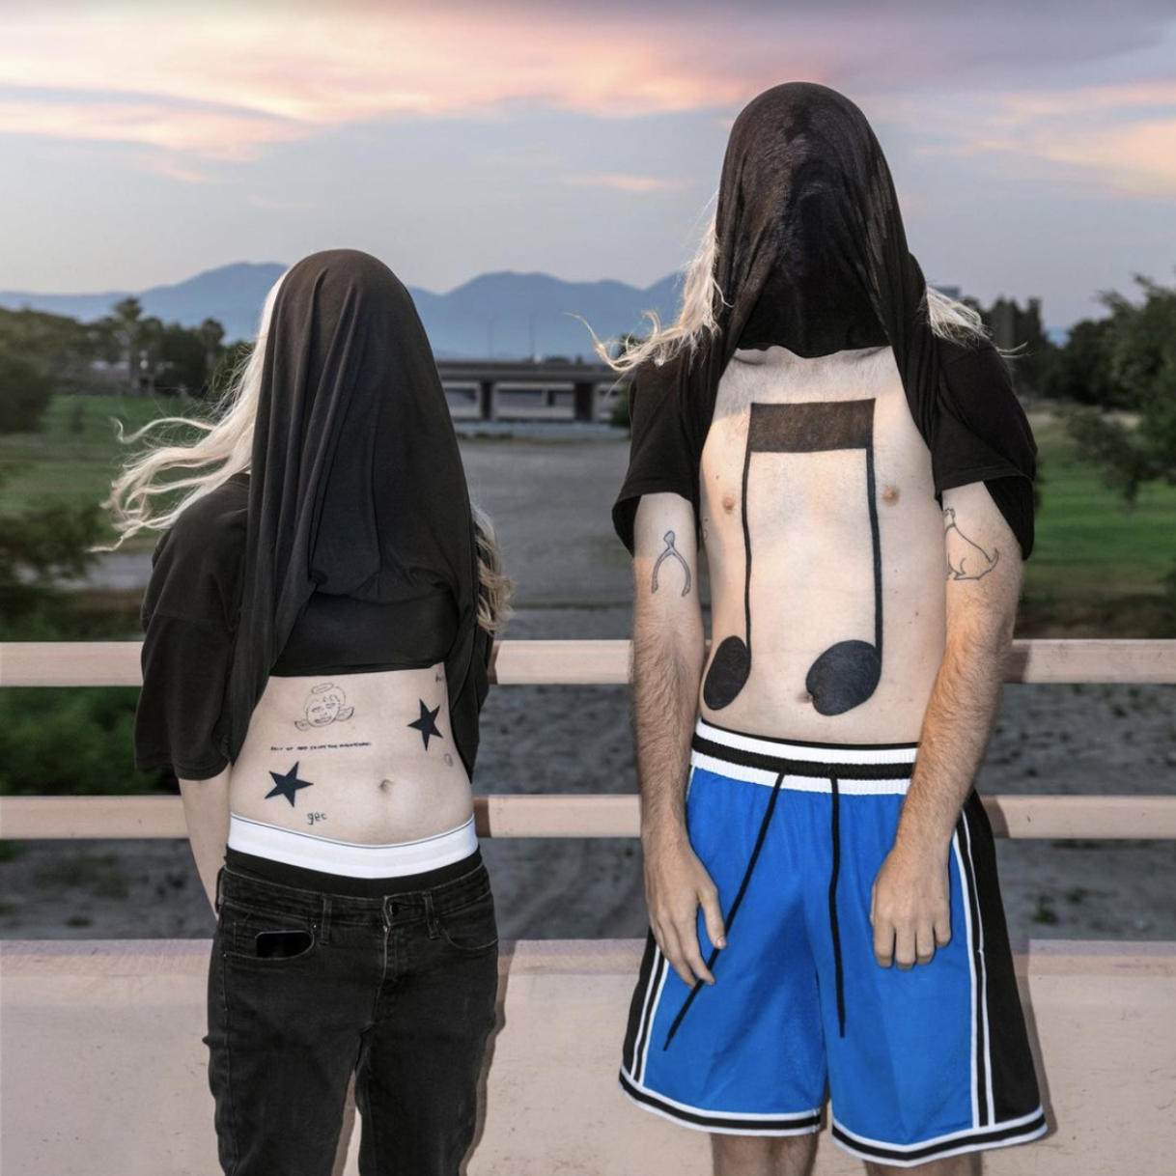
10,000 gecs album art﻿
﻿
﻿100 gecs:
TWITTER | INSTAGRAM | SOUNDCLOUD

DYLAN BRADY:
TWITTER | INSTAGRAM | SOUNDCLOUD | YOUTUBE

LAURA LES:
TWITTER | INSTAGRAM | SOUNDCLOUD

DOG SHOW RECORDS:
TWITTER | INSTAGRAM | WEBSITE

﻿(DOWNLOAD HI-RES ASSETS HERE)
FOR MORE INFORMATION:
Paige Rosoff
Paige.Rosoff@atlanticrecords.com
Atlantic Records | Big Beat Records

Bradley Bledsoe
bradley@orienteer.us
Orienteer

