ELDERBROOK ANNOUNCES MASSIVE 2023 US + CANADIAN HEADLINE TOUR

HIGHLY ANTICIPATED RUN KICKS OFF FEB 23 IN VANCOUVER; CULMINATES APRIL 8 IN DALLAS

BUY TICKETS HERE

SOPHOMORE ALBUM LITTLE LOVE ARRIVING FEBRUARY 24

NEW SINGLE “BEAUTIFUL MORNING” OUT NOW

Buy/Stream “Beautiful Morning” Here | Watch Official Visual Here

“…gorgeous new single… flickering cut…” – VARIANCE

“Elderbrook is back, and he’s got some big plans.” – THIS SONG IS SICK

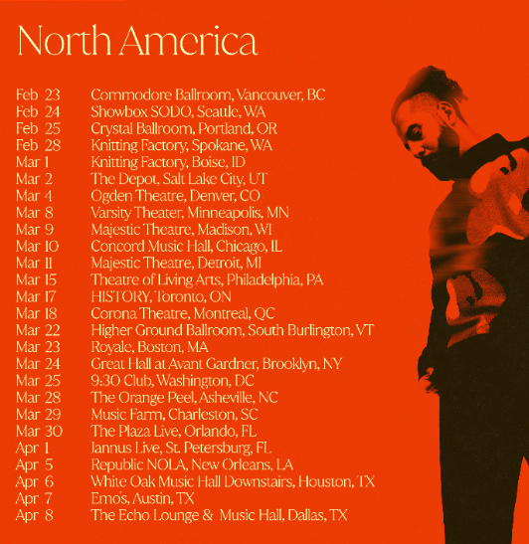
download hi-res admats here

Today, Grammy-nominated UK electronic artist Elderbrook has announced a massive US + Canadian tour, set for early 2023. The run of dates will kick off on February 23 in Vancouver and culminate in Dallas on April 8, with stops in Seattle, Chicago, Boston, Toronto and many more cities in between – including a much-anticipated Brooklyn, NY show in the Great Hall at Avant Gardner [full routing below].

Presales for all dates begin today, Wednesday, November 2 at 10am (local). General on-sale begins at 10am (local) this Friday, November 4 (info + tickets here).

Today’s news comes on the heels of Elderbrook’s announcement last week that his forthcoming sophomore album, Little Love, is due out February 24 via Big Beat Records.

New single “Beautiful Morning” (buy/stream here) was unveiled alongside the announcement. Featuring Elderbrook’s signature combination of flickering synths, poignant breakdowns, and powerful lyrics, “Beautiful Morning” was co-produced by Harrison Mills and Clayton Knight. The song arrived accompanied by a striking official visual (watch here). Variance praised “Beautiful Morning” as a “gorgeous new single,” while This Song Is Sick proclaimed, “Elderbrook is back, and he’s got some big plans.”

In September, Elderbrook released the first track off the forthcoming album – standout single “Howl” – a euphoric collaboration with Grammy-winner Tourist that Dancing Astronaut praised as, “an emotional electronica offering… Elderbrook makes the world want to dance all night, ensconced in the resounding visceral energy he radiates in each release.”

This past summer, fans were able to experience “Howl” live as Elderbrook traversed the US and Canada, supporting ODESZA on tour in major cities across both countries. He will return to many of those markets, as well as make additional stops, on his headline tour next year.

download hi-res press images here

UPCOMING TOUR DATES:

NOVEMBER
26-27 – Art With Me Festival – Miami, FL

DECEMBER
3 – Žalgirio Arena – Kaunas, Lithuania

JANUARY 2023
13 – Metro Theatre – Sydney, NSW, Australia

FEBRUARY 2023
23 – Commodore Ballroom – Vancouver, BC
24 – Showbox SODO – Seattle, WA
25 – McMenamins Crystal Ballroom – Portland, OR
28 – Knitting Factory – Spokane, WA

MARCH 2023
1 – Knitting Factory – Boise, ID
2 – The Depot – Salt Lake City, UT
4 – Ogden Theatre – Denver, CO
8 – Varsity Theater – Minneapolis, MN
9 – Majestic Theatre – Madison, WI
10 – Concord Music Hall – Chicago, IL
11 – Majestic Theatre – Detroit, MI
15 – Theatre of Living Arts – Philadelphia, PA
17 – HISTORY – Toronto, ON
18 – Corona Theatre – Montreal, QC
22 – Higher Ground Ballroom – South Burlington, VT
23 – Royale – Boston, MA
24 – Great Hall at Avant Gardner – Brooklyn, NY
25 – 9:30 Club – Washington, DC
28 – The Orange Peel – Asheville, NC
29 – Music Farm – Charleston, SC
30 – The Plaza Live – Orlando, FL

APRIL 2023
1 – Jannus Live – St. Petersburg, FL
5 – Republic NOLA – New Orleans, LA
6 – White Oak Music Hall Downstairs – Houston, TX
7 – Emo’s – Austin, TX
8 – The Echo Lounge & Music Hall – Dallas, TX

download hi-res artwork here

ABOUT ELDERBROOK:
A live phenomenon, multi-instrumentalist, producer, singer-songwriter, and father-of-two Elderbrook has an innate flair for creating emotive music that explores the sensitive and introspective themes of identity, mental wellbeing and, more recently, parenthood.

Over 1.5 billion global streams, Grammy and Ivor Novello nominations, tours with Jungle, Rüfüs Du Sol and Odesza, and collaborations with Camelphat, Diplo, Bob Moses and Rudimental have earned him a revered reputation as a dynamic, multi-faceted, forward-thinking talent who is confident and comfortable exploring a range of genres.

As Elderbrook prepares for the release of his sophomore album Little Love, he delves into the life-changing impact of fatherhood. His outlook is focused on the bigger picture, appreciating the little moments and the deep connection with his beloved children. The result is a positive and uplifting dance-focused LP full of Elderbrook magic.

# # #

For more information on Elderbrook, please visit:
Website | Instagram | Twitter | Facebook | Spotify

FOR ALL PRESS INQUIRIES, PLEASE CONTACT:
Libby Kober | Libby.Kober@atlanticrecords.com

